Nurse scheduling

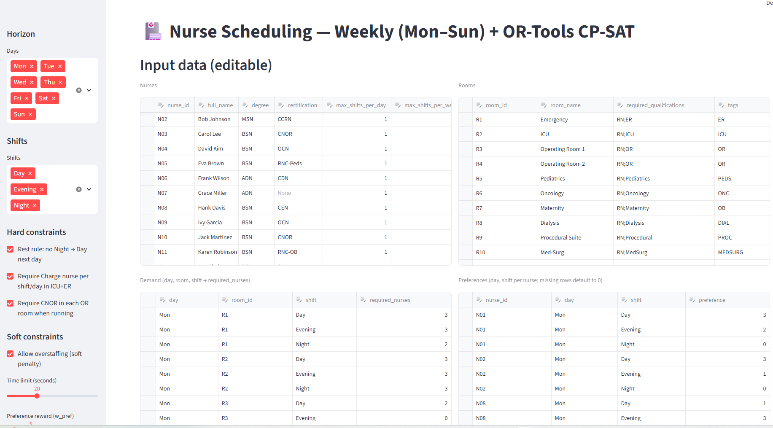

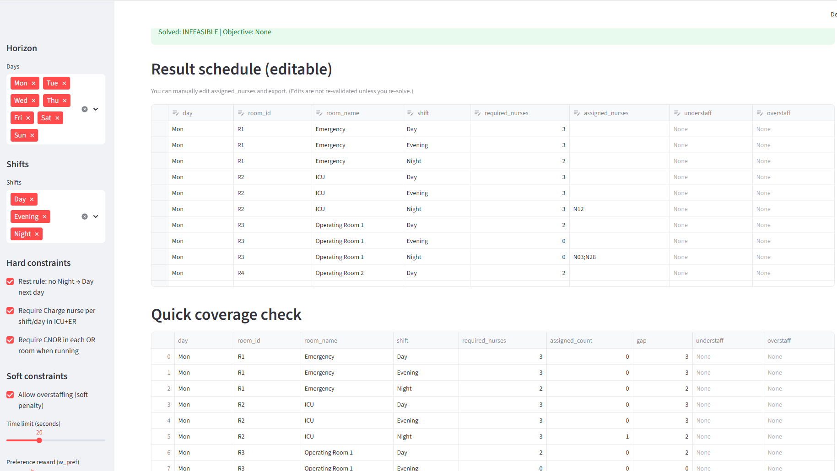

Modern nurse scheduling (often called nurse rostering) systems typically combine hard constraints (must be satisfied) with soft constraints (preferences, fairness, continuity) that are optimized via a penalty/reward objective. A canonical formulation assigns nurses to shifts over a planning horizon (often 1–4 weeks) while enforcing feasibility rules such as coverage demand per unit/shift, qualification/skill requirements, contractual limits, and rest regulations. Hard vs. soft constraint separation is now standard: hard constraints define feasibility, while soft constraints encode quality (e.g., honoring requests, balancing weekends, smoothing night duties) and are traded off in a weighted objective. ScienceDirect+1
A large body of research evaluates algorithms on shared benchmarks, most notably NSPLib, which provides standardized nurse scheduling instances and encodes common constraint families (coverage, consecutive work limits, assignments per shift type, etc.) to support reproducible comparison across methods. NSPLib was created specifically to address the prior lack of consistent testbeds and provides instance files plus guidance on evaluation/stop criteria for metaheuristics. Project Management+2Project Management+2 Alongside NSPLib, the International Nurse Rostering Competition problem variants (e.g., INRC-style formulations) have shaped “realistic” constraint sets, emphasizing mixed hard/soft constraints and solution quality scoring—driving implementations that mirror hospital practice (coverage and legality first, then preference satisfaction and fairness). Patat Conference
On the solver/technology side, many practical systems use integer programming (IP/MIP), constraint programming (CP), or hybrids. Hybrid models are common because pure IP can struggle with complex logical constraints (e.g., sequence rules), while CP handles combinatorial structure well; hybrid IP+CP approaches explicitly model hard constraints while optimizing penalty costs for soft constraint violations. ScienceDirect+1 In recent applied work, hospital deployments frequently adopt IP-based or hybrid approaches for department-specific rosters (e.g., oncology) and report measurable operational benefits—typical of the “case study” style of nurse rostering research. PMC
Open-source optimization stacks have also made nurse scheduling more accessible. Google OR-Tools (CP-SAT) provides workforce scheduling patterns and examples that can be adapted to nurse rostering: decision variables for assignments, coverage constraints, and objective terms for preference/fairness are modeled directly and solved with a state-of-the-art CP-SAT engine. Google for Developers+1 OR-Tools-based nurse rostering writeups commonly extend baseline “employee scheduling” templates by adding realistic constraints—e.g., limits per nurse, coverage per shift, and even distribution of burdens—illustrating how open-source CP-SAT can serve as the core of a practical scheduler. Medium+1
Finally, many “system-like” nurse rostering solutions emphasize human-in-the-loop workflows: planners want to lock assignments, adjust demand, and re-optimize—so interactive interfaces (spreadsheets, dashboards, or web UIs) sit on top of the solver. This aligns with common OR practice: keep the model flexible, expose weights/penalties and rules, and support incremental changes without rebuilding the entire pipeline. The OR-Tools ecosystem (and CP-SAT modeling idioms) is particularly aligned with this style because it supports explicit hard constraints plus a weighted soft objective—exactly what nurse rostering scoring frameworks and benchmarks require. Google for Developers+2d-krupke.github.io+2
- Vanhoucke, M. “NSPLib – A Nurse Scheduling Problem Library.” (PDF). Project Management
- Ceschia, S., et al. “Second International Nurse Rostering Competition (INRC-II): Problem Description and Rules.” arXiv PDF (2015). arXiv
- Ceschia, S., et al. “The Second International Nurse Rostering Competition (INRC-II).” Annals of Operations Research (RePEc entry). IDEAS/RePEc
- Lü, Z., Hao, J.-K. “Adaptive neighborhood search for nurse rostering.” European Journal of Operational Research (2012). ScienceDirect
- Rahimian, E., et al. “A hybrid integer and constraint programming approach” for nurse rostering (ScienceDirect abstract page, 2017). ScienceDirect
- Rahimian, E. “A Hybrid Constraint Integer Programming Approach to Solve Nurse Scheduling” (conference paper PDF, 2015). Strathprints
- Google Developers. “Employee Scheduling | OR-Tools (CP-SAT examples).” Google for Developers
- Google Developers. “Scheduling Overview | OR-Tools.” Google for Developers
- Krupke, D. “The CP-SAT Primer: Using and Understanding Google OR-Tools’ CP-SAT Solver.” (includes nurse scheduling-style modeling examples). d-krupke.github.io
- Abdalkareem, Z. A., et al. “Healthcare scheduling in optimization context: a review.” (PMC, 2021). PMC
- Burke, E. K., De Causmaecker, P., Vanden Berghe, G., Van Landeghem, H. “The state of the art of nurse rostering.” Journal of Scheduling (referenced within a nurse rostering CP paper PDF). people.cs.nott.ac.uk
- Stølevik, M., et al. “A Hybrid Approach for Solving Real-World Nurse Rostering.” Springer chapter (industrial case-study style).

