Ops Portal: Six Primary Areas

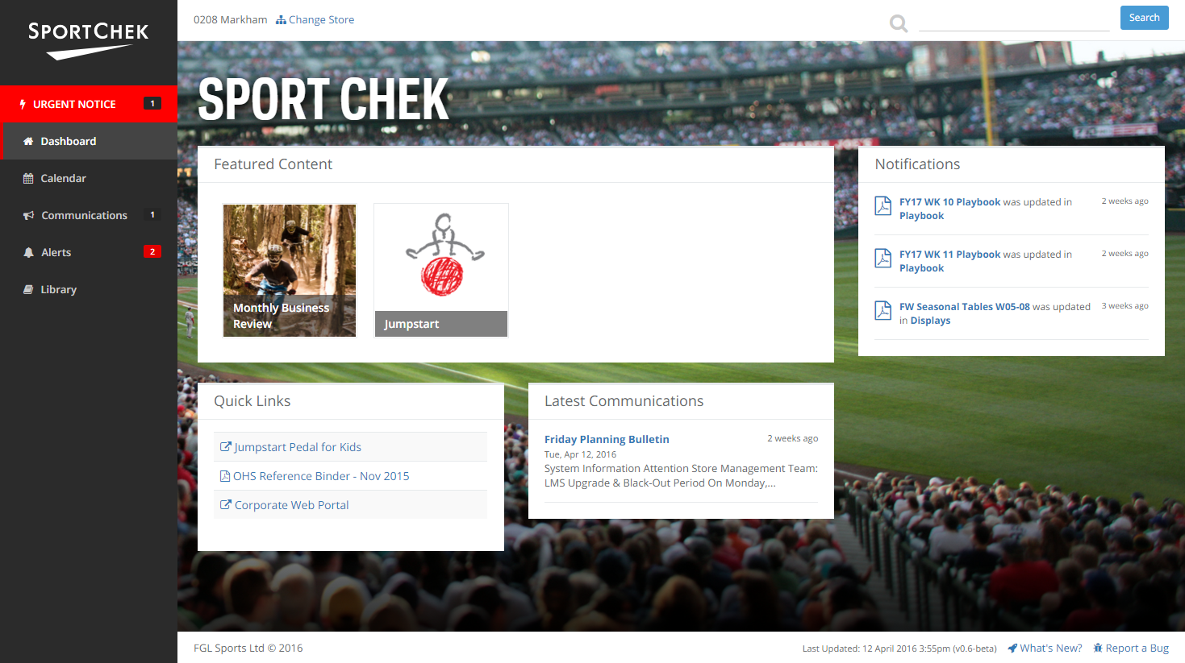

**Dashboard**  
Employee-facing Homepage  
*Links to*

* Featured Content: Collections of documents/folders within the Library organized differently depending on need (e.g. Back to School-only content)
* Quick Links: Shortcuts to sites, documents or folders

**Calendar**  
Simple Calendar with custom events that will include attachments in the form of documents already uploaded to the Library

**Communications**

“Email-like,” one-way communications which can include attachments (e.g. Weekly Planning Bulletin)

**Alerts**  
documents flagged as being a tactically-relevant, user-defined/managed “type” (e.g. Footwear Launch)

**Library**  
Core repository of all uploaded documents

**Urgent Notices**  
Only visible in the main navigation when active