# ManagerWeb 1.0 QA-UX Review

## Overview

### Overarching Principles

* Feedback
  + Errors
    - feedback should be as close to immediate (e.g. on blur) whenever possible.
    - feedback should be obvious without undue workflow interruption (i.e. unnecessary/gratuitous clicks)
  + Success
    - feedback should not cause undue workflow interruption
  + Work in progress
    - when changes have been made, but not saved, this should be obvious to the user
* Functional copy should be:
  + Concise
  + Clear
  + Consistent throughout the application
  + Friendly (as appropriate), not casual
  + Buttons
    - Should be labeled according to the principles above
* Affordance
  + When possible, established interaction patterns should be consistently adhered to.
    - When buttons don’t/won’t do anything, they should be disabled and this state should be visually obvious.
    - Required fields should consistently be labeled as such (e.g. use * on field label).
* Visual Language
  + Icons should be consistently associated with particular actions. The below set of buttons is representative, but not exhaustive and is subject to change.  
    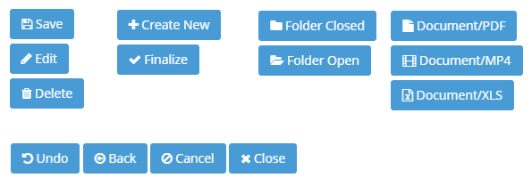

## Admin Area

### Dashboard

1. Form Sections
   1. Section order should be as follows:
      1. Branding (see below)
      2. Featured Content
      3. Quicklinks
      4. Notification Preferences
   2. Dashboard Section: Dashboard Title and Branding
      1. Merge these two sections into the **Branding** section, with 3 fields:
         1. Title
         2. Subtitle
         3. Background
      2. Title and Subtitle
         1. **Title** field needs **\*** appended as it is required
         2. **Subtitle** field should not be required. (i.e. Layout on the front end should adjust accordingly.)
         3. Removing focus from either the **Title** field when it’s empty should:
            1. cause the field to be outlined in red
            2. cause the Save changes button to be disabled
      3. Background Image selection
         1. thumbnail should be much smaller (constrain to ~200px wide)
         2. background selection should not use file upload.
            1. Images should be selected from assets have already been uploaded to the Document Library.
         3. Add functional copy adjacent to background selection:  
            For best results, background images should have an aspect ratio of X:Y and be at least XXX pixels wide.
      4. Controls
         1. Rename button **Cancel** to **Undo changes** and change its icon from cancel/close to the undo icon.
            1. **Undo changes** should be disabled when no changes have been initiated
            2. Undo changes functionality otherwise unchanged (i.e. clicking it restores the last saved Title, Subtitle and background image values)
         2. Button **Save changes** should use a Save icon.
         3. Button **Save changes** should be disabled:
            1. when no changes are pending (i.e. on page load and/or immediately following
            2. when changes are invalid (e.g. either/both required fields are empty)
         4. Saving changes should not generate a modal. Instead:
            1. display “Changes saved.” just above the button
            2. button reverts to disabled state
            3. message fades out after 5 seconds, OR
            4. if any fields change within less than 5 seconds
      5. Updated Form Layout as follows:  
         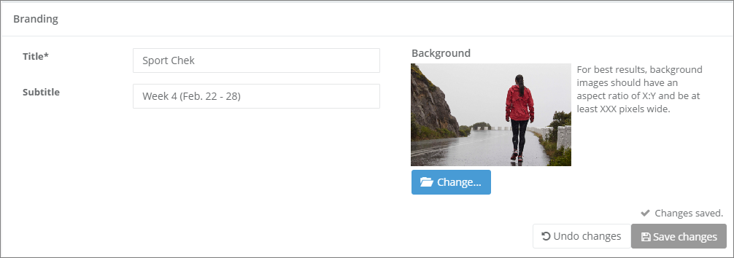  
         source file: Admin-Dashboard-Form-Title_plus_Branding.png
   3. Dashboard Section: Quicklinks
      1. Create New Quicklink
         1. **Name** field needs * as it is required
         2. Remove <hr> tags
         3. **Quicklink Type**
            1. Rename as **Quicklink type** (remove capital T)
            2. field needs * as it is required
            3. Rename *file* to *document*
            4. should default to *document*
            5. reorder as: *document, folder, external*
            6. fields/selectors should be adjacent to their respective radio buttons

if a field’s respective radio button is active, its action button (see below) is disabled

selecting a radio button should not trigger a selection modal

types **folder** and **file**

readonly field displaying selected folder name/path or the file name

adjacent **Select…** button which triggers the folder/file select modal

type external

editable field which validates as URL

adjacent **Test** button which opens the entered URL in a new tab/window when clicked (disabled for empty field and/or badly-formed URL)

* + - * 1. Folder selection modal

The icon next to an expanded folder should always be the open folder icon.

Clicking on the folder icon should expand/collapse that folder.

Clicking on a selected folder checkbox or name should de-select it and vice versa.

When a folder is selected, the full path of the selected folder should be indicated within a readonly *Selected:* field at the bottom left of the modal.

When no folder is selected, the *Selected:* field should be empty.

Rename button **Select Folder** as **Select folder** (consistency)

button Select folder should be disabled unless a folder is selected.

Rename **Close** button as **Cancel** and add cancel icon.

Successfully selecting a folder should close the modal.

Updated folder selection modal layout as follows:  
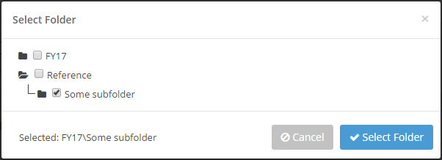  
source file: Admin-Dashboard-Form-Create-Quicklinks-Folder-Select.png

* + - * 1. Document selection modal

the icon next to any expanded folder should always be the open folder icon

Folder selection and the files within and given folder need to be displayed/interacted with separately (see updated layout below).

When users select a folder on the left, files within that folder are displayed on the right.

Clicking on a selected file checkbox or name should de-select it and vice versa.

Clicking on a folder icon should select that folder and toggle it expansion state.

Clicking on a folder name should only select it (i.e. list its files on the right)

When a file is selected, the file name and its folder path should be displayed within a readonly *Selected:* field at the bottom left of the modal (see updated layout below).

When no file is selected, the *Selected:* field should be empty

Updated document selection layout as follows:  
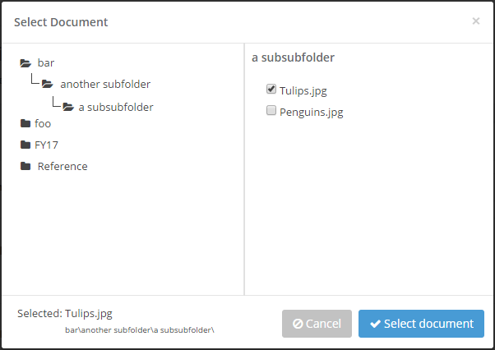  
source file: Admin-Dashboard-Form-Create-Quicklinks-Document-Select.png

* + - 1. Remove **Quicklink URL** field
      2. Controls
         1. Move Create/Cancel buttons to bottom right of section (consistency)
         2. Button **Create New Quicklink** should be disabled until all required fields have a valid selections
         3. Upon success, the modal should read as follows:  
            [Document/Folder/External] Quicklink created  
            [ document name | folder name | external URL ]

Buttons should be:

**Back to Dashboard** with left-arrow (back) icon

**Create another Quicklink** with + icon

* + - 1. Created Quicklinks must always be added to the bottom of the current Quicklink listing
      2. Updated Layout as follows:  
         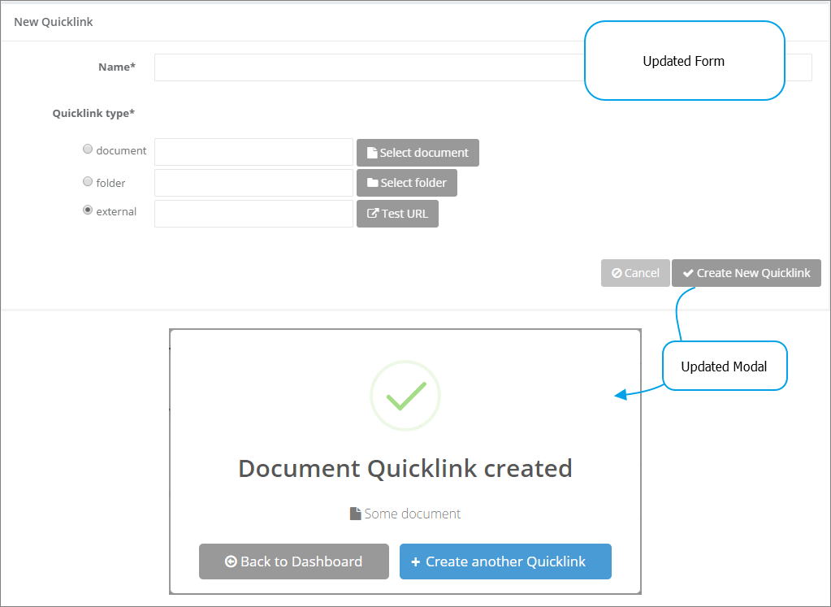  
         source file: Admin-Dashboard-Form-Create-Quicklinks.png
    1. Quicklink Management
       1. Rename section **Quicklinks Management**
       2. Rename button **Create New Quicklink** as **Create new** **Quicklink** (consistency)
       3. Add functional copy above Quicklink listing:  
          Drag Quicklinks to reorder.
       4. reordering should not auto-save
          1. Add controls like those for **Branding:**

**Save changes** should not be enabled unless changes have been made

**Undo changes** should revert to the currently saved order

* + - 1. Removing items should not auto-save
         1. Replace the trashcan delete triggers with “Remove” checkboxes.
         2. If any Remove checkboxes are checked when Save changes is clicked, prompt to confirm, listing each affected item. Copy to read as follows:  
            Really delete the following Quicklinks?  
            Quicklink A  
            Quicklink B  
            …
         3. Clicking **Undo changes** should:

return listed Quicklinks to their original order

uncheck any Quicklinks checked as Remove

disable the **Save changes** button

* + - 1. Updated Layout as follows:  
         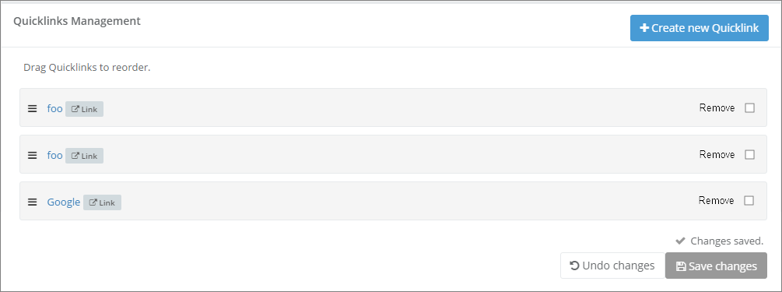  
         source file: Admin-Dashboard-Form-Quicklink-Management.png
  1. Dashboard Section: Order Featured Content  
     **\*\*\* NOT TESTED*** See notes in Featured Content section**
  2. Dashboard Section: Notification Preferences
     1. Tidy Layout (see updated layout below)
     2. Do not clear field values when switching between Days/Documents (i.e. save the value even it that mode is inactive)
     3. Change Save changes icon to save icon
     4. Rename Cancel button Undo changes
     5. No modal when saving changes (same as other controls described above).
     6. Updated layout as follows:  
        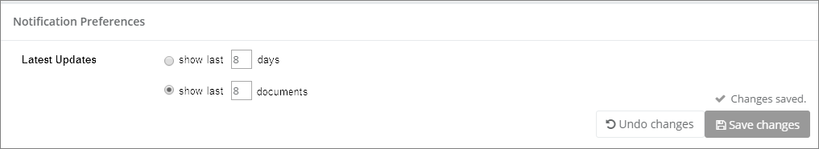  
        source file: Admin-Dashboard-Form-Notification-Preferences.png

### Featured Content

** NOT TESTED **

Preliminary testing has shown that the implementation deviates enough from the requirements such that further testing would be pointless. Specifically:

1. A core requirement is missing: users should be able to create “container” folders within Package/Feature structures at arbitrary points within its hierarchy.
2. Saving a Feature doesn’t seem to work at all. The application does not indicate to the user why the failure is occurring.

### Calendar

Review pending

### Communications

Review pending

### Documents

1. This functionality has unnecessarily been broken into two components. Redesign is in order.
2. Manage Folders
   1. When a user is in this area, the left nav should reflect this:
      1. the Documents tab should be expanded
      2. The Manage Folders item should be highlighted/active
   2. Folder Interaction
      1. The folder icon should consistently reflect whether a folder is expanded or not
      2. The edit icon for any folder should be visible 100% of the time
      3. Editing folders
         1. Edit Folder modal
            1. Rename field *Folder Name* to *Folder name* (consistency)
            2. Remove **Tags**. No request was made for this functionality.
            3. Remove readonly **Child Folders** field
            4. Remove **Add folder** functionality (see below for revised implementation).
            5. Rename **Delete Folder** button to **Delete folder** (consistency)
            6. Enable **Delete folder** functionality at all times, with a warning/confirmation modal whenever it’s clicked.

the modal should indicate whether the folder is empty, or

the number of folders and files within it that will be impacted.

Modal copy:  
Really delete folder [ folder name ]?  
This folder is empty. [ or ]  
This folder contains [ x ] subfolders and [ y ] total files.  
Cancel | Yes, delete

* + - * 1. Change **Save changes** button icon to a save icon
        2. Change **Cancel button** icon to fa-ban
        3. Enlarge top-left close icon and reposition (see revised layout below)
        4. Revised layout as follows:  
           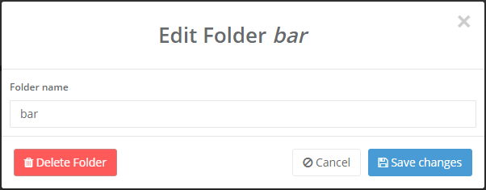  
           source file: Admin-Documents-Manage-Folders-Edit-Folder.png
      1. Adding subfolders
         1. Add a placeholding, uneditable, top-level folder for the banner (e.g. Sport Chek).
         2. By default, this root/banner folder should be expanded so all its first-level child folders are visible.
         3. Add subfolder

Adjacent to each folder icon, name, and edit icon, add an **Add subfolder** button

this new button triggers a modal where a folder name is entered and the user simply confirms or cancels this

**Add subfolder** modal layout as follows:  
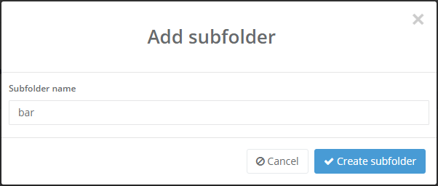  
source file: Admin-Documents-Manage-Folders-Add-Subfolder.png

* + 1. Revised **Manage Folders** layout as follows:  
       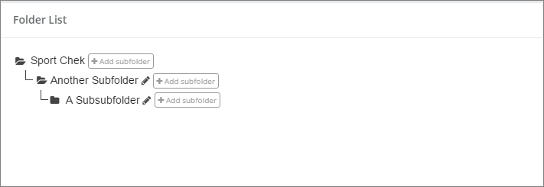  
       source file: Admin-Documents-Manage-Folders.png

1. Document Manager