# ManagerWeb 1.0 QA-UX Review in progress

## Overview

### Overarching Principles

* Feedback
  + Errors
    - for minro (single-field) interactions, feedback should be as close to immediate (e.g. on blur) whenever possible.
    - feedback should be obvious without undue workflow interruption (i.e. unnecessary/gratuitous clicks). In other words, modals should only be used for problems with (or successful completion of) significant/multi-step workflows
  + Success
    - feedback should not cause undue workflow interruption
  + Work in progress
    - when changes have been made, but not saved, this should be obvious to the user
* Functional copy should be:
  + Concise
  + Clear
  + Consistent throughout the application
  + Friendly (as appropriate), but not overly casual
  + Buttons and form fields
    - Should be labeled according to the principles above
* Affordance
  + When possible, established interaction patterns should be consistently adhered to.
    - When buttons don’t/won’t do anything, they should be disabled and this state should be visually obvious.
    - Required fields should consistently be labeled as such (e.g. use * on field label).
* Visual Language
  + Icons should be consistently associated with particular actions. The below set of buttons is representative, but not exhaustive and is subject to change.  
    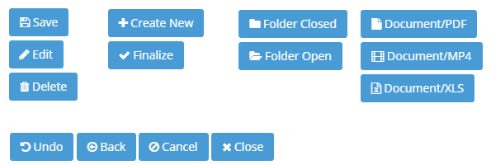

## Admin Area

### Dashboard

1. Form Sections
   1. Section order should be as follows:
      1. Branding (see below)
      2. Featured Content
      3. Quicklinks
      4. Notification Preferences
   2. Dashboard Section: Dashboard Title and Branding
      1. Merge these two sections into the **Branding** section, with 3 fields:
         1. Title
         2. Subtitle
         3. Background
      2. Title and Subtitle
         1. Required field **Title** field needs **\***
         2. **Subtitle** field should not be required. (i.e. Layout on the front end should adjust accordingly.)
         3. Removing focus from either the **Title** field when it’s empty should:
            1. cause the field to be outlined in red
            2. cause the Save changes button to be disabled
      3. Background Image selection
         1. thumbnail should be much smaller (constrain to ~200px wide)
         2. Move the button below the background image thumbnail
         3. background selection should not use file upload.
            1. Images should be selected from assets have already been uploaded to the Document Library.
            2. Replace **Browse…** button with **Change…** Button that brings up the document selection modal used elsewhere

Only image files should be selectable within this instance of the modal

* + - 1. Add functional copy to the right of the thumbnail:  
         For best results, background images should have an aspect ratio of X:Y and be at least XXX pixels wide.
    1. Controls
       1. Rename button **Cancel** to **Undo changes** and change its icon from cancel/close to the undo icon.
          1. **Undo changes** should be disabled when no changes have been initiated
          2. Undo changes functionality otherwise unchanged (i.e. clicking it restores the last saved Title, Subtitle and background image values)
       2. Button **Save changes** should use a Save icon.
       3. Button **Save changes** should be disabled:
          1. when no changes are pending (i.e. on page load and/or immediately following
          2. when changes are invalid (e.g. either/both required fields are empty)
       4. Saving changes should not generate a modal. Instead:
          1. display “Changes saved.” just above the button
          2. button reverts to disabled state
          3. message fades out after 5 seconds, OR
          4. if any fields change within less than 5 seconds
    2. Updated Form Layout as follows:  
       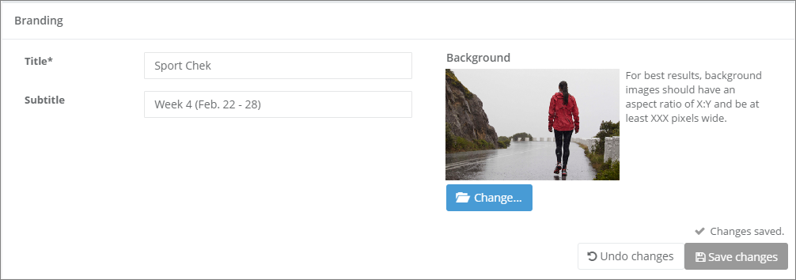  
       source file: Admin-Dashboard-Form-Title_plus_Branding.png
  1. Dashboard Section: Quicklinks
     1. Create New Quicklink
        1. **Name** field needs * as it is required
        2. Remove <hr> tags
        3. **Quicklink Type**
           1. Rename as **Quicklink type** (remove capital T)
           2. field needs * as it is required
           3. Rename *file* to *document*
           4. should default to *document*
           5. reorder as: *document, folder, external*
           6. fields/selectors should be adjacent to their respective radio buttons

if a field’s respective radio button is active, its action button (see below) is disabled

selecting a radio button should not trigger a selection modal

types **folder** and **file**

readonly field displaying selected folder name/path or the file name

adjacent **Select…** button which triggers the folder/file select modal

type external

editable field which validates as URL

adjacent **Test** button which opens the entered URL in a new tab/window when clicked (disabled for empty field and/or badly-formed URL)

* + - * 1. Folder selection modal

The icon next to an expanded folder should always be the open folder icon.

Clicking on the folder icon should expand/collapse that folder.

Clicking on a selected folder checkbox or name should de-select it and vice versa.

When a folder is selected, the full path of the selected folder should be indicated within a readonly *Selected:* field at the bottom left of the modal.

When no folder is selected, the *Selected:* field should be empty.

Rename button **Select Folder** as **Select folder** (consistency)

button Select folder should be disabled unless a folder is selected.

Rename **Close** button as **Cancel** and add cancel icon.

Successfully selecting a folder should close the modal.

Updated folder selection modal layout as follows:  
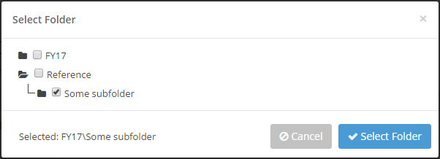  
source file: Admin-Dashboard-Form-Create-Quicklinks-Folder-Select.png

* + - * 1. Document selection modal

the icon next to any expanded folder should always be the open folder icon

Folder selection and the files within and given folder need to be displayed/interacted with separately (see updated layout below).

When users select a folder on the left, files within that folder are displayed on the right.

Clicking on a selected file checkbox or name should de-select it and vice versa.

Clicking on a folder icon should select that folder and toggle it expansion state.

Clicking on a folder name should only select it (i.e. list its files on the right)

When a file is selected, the file name and its folder path should be displayed within a readonly *Selected:* field at the bottom left of the modal (see updated layout below).

When no file is selected, the *Selected:* field should be empty

Updated document selection layout as follows:  
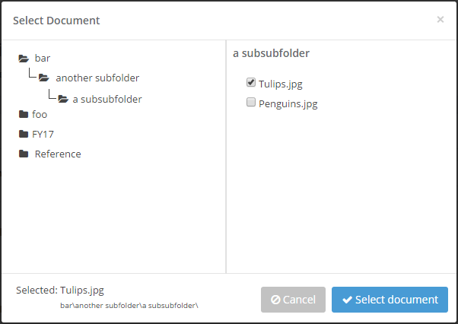  
source file: Admin-Dashboard-Form-Create-Quicklinks-Document-Select.png

* + - 1. Remove **Quicklink URL** field
      2. Controls
         1. Move Create/Cancel buttons to bottom right of section (consistency)
         2. Button **Create New Quicklink** should be disabled until all required fields have a valid selections
         3. Upon success, the modal should read as follows:  
            [Document/Folder/External] Quicklink created  
            [ document name | folder name | external URL ]

Buttons should be:

**Back to Dashboard** with left-arrow (back) icon

**Create another Quicklink** with + icon

* + - 1. Created Quicklinks must always be added to the bottom of the current Quicklink listing
      2. Updated Layout as follows:  
         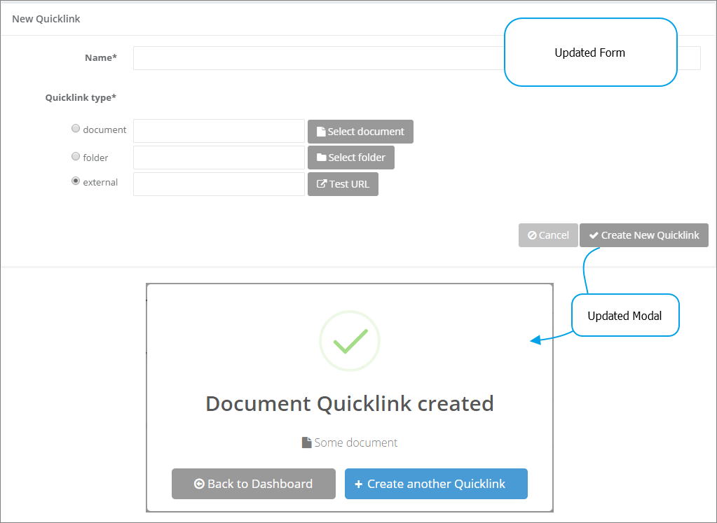  
         source file: Admin-Dashboard-Form-Create-Quicklinks.png
    1. Quicklink Management
       1. Rename section **Quicklinks Management**
       2. Rename button **Create New Quicklink** as **Create new** **Quicklink** (consistency)
       3. Add functional copy above Quicklink listing:  
          Drag Quicklinks to reorder.
       4. reordering should not auto-save
          1. Add controls like those for **Branding:**

**Save changes** should not be enabled unless changes have been made

**Undo changes** should revert to the currently saved order

* + - 1. Removing items should not auto-save
         1. Replace the trashcan delete triggers with “Remove” checkboxes.
         2. If any Remove checkboxes are checked when Save changes is clicked, prompt to confirm, listing each affected item. Copy to read as follows:  
            Really delete the following Quicklinks?  
            Quicklink A  
            Quicklink B  
            …
         3. Clicking **Undo changes** should:

return listed Quicklinks to their original order

uncheck any Quicklinks checked as Remove

disable the **Save changes** button

* + - 1. Updated Layout as follows:  
         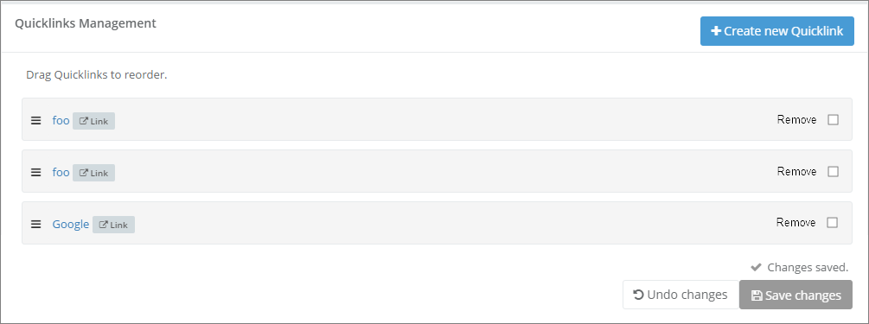  
         source file: Admin-Dashboard-Form-Quicklink-Management.png
  1. Dashboard Section: Order Featured Content  
     **\*\*\* NOT TESTED*** See notes in Featured Content section**
  2. Dashboard Section: Notification Preferences
     1. Tidy Layout (see updated layout below)
     2. Rename filed *Get Latest Updates* to *Latest updates\** (consistency and required field)
     3. Do not clear field values when switching between Days/Documents (i.e. save the value even it that mode is inactive)
     4. Change Save changes icon to save icon
     5. Rename Cancel button Undo changes
     6. No modal when saving changes (same as other controls described above).
     7. Updated layout as follows:  
        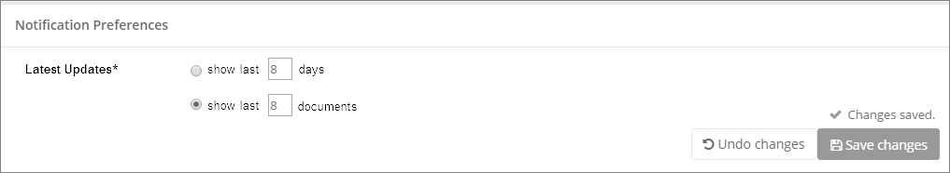  
        source file: Admin-Dashboard-Form-Notification-Preferences.png

### Featured Content

** NOT TESTED **

Preliminary testing has shown that the implementation deviates enough from the requirements such that more thorough testing is delayed. Specifically:

A core requirement is missing: users should be able to create “container” folders within Package/Feature structures at arbitrary points within its hierarchy.

### Calendar

Review pending

### Communications

Review pending

### Documents

1. **Manage Folders**
   1. When a user is in this area, the left nav should reflect this:
      1. the Documents tab should be expanded
      2. The Manage Folders item should be highlighted/active
   2. Folder Interaction
      1. The folder icon should consistently reflect whether a folder is expanded or not
      2. The edit icon for any folder should be visible 100% of the time
      3. Folder names should exactly reflect the capitalization used when entered (i.e. do not apply CSS rules like capitalize to folder names in any context).
      4. Editing folders
         1. Modal: Edit Folder
            1. Rename field *Folder Name* to *Folder name\** (consistency and required field)
            2. Remove **Tags**. No request was made for this functionality.
            3. Remove readonly **Child Folders** field
            4. Remove **Add folder** functionality (see below for revised implementation).
            5. Rename **Delete Folder** button to **Delete folder** (consistency)
            6. Enable **Delete folder** functionality at all times, with a warning/confirmation modal whenever it’s clicked.

the modal should indicate whether the folder is empty, or

the number of folders and files within it that will be impacted.

Modal copy:  
Really delete folder [ folder name ]?  
This folder is empty. [ or ]  
This folder contains [ x ] subfolders and [ y ] total files.  
Cancel | Yes, delete

* + - * 1. Change **Save changes** button icon to a save icon
        2. Change **Cancel button** icon to fa-ban
        3. Enlarge top-left close icon and reposition (see revised layout below)
        4. Revised layout as follows:  
           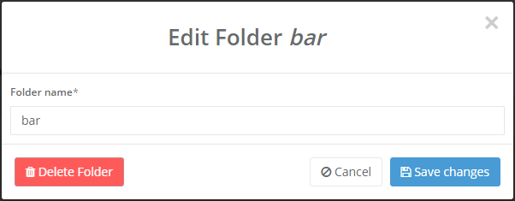  
           source file: Admin-Documents-Manage-Folders-Edit-Folder.png
      1. Adding subfolders
         1. Add a placeholding, uneditable, top-level folder for the banner (e.g. Sport Chek).
         2. By default, this root/banner folder should be expanded so all its first-level child folders are visible.
         3. Add subfolder

Adjacent to each folder icon, name, and edit icon, add an **Add subfolder** button

this new button triggers a modal where a folder name is entered and the user simply confirms or cancels this

After a new subfolder is added, the redrawn folder tree should be expanded to the point where the newly created subfolder is visible.

**Add subfolder** modal layout as follows:  
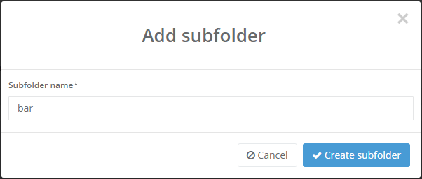  
source file: Admin-Documents-Manage-Folders-Add-Subfolder.png

* + 1. Revised **Manage Folders** layout as follows:  
       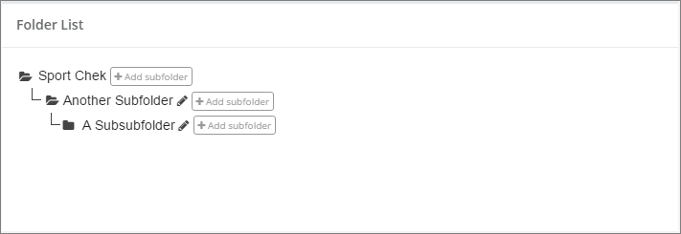  
       source file: Admin-Documents-Manage-Folders.png

1. **Document Manager**
   1. When a user is in this area or any of its sub-areas, the left nav should explicitly reflect this.
      1. At a minimum, while within Documents > Document Manager, it should be visually distinguished from Documents > Manage Folders. Simply changing the font to white should accomplish this:  
         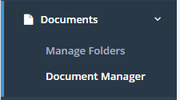
      2. This interface should be housed within a fixed width container with min-width: 1040px (i.e. intentionally unresponsive)
      3. Folder Interactions (left column)
         1. Add the top level, placeholding, banner folder (e.g. Sport Chek) at the top of the tree.
            1. The banner folder should be expanded by default, so the top-level folders are visible.
         2. If a folder is expanded/collapsed, its folder icon should always reflect this.
         3. Clicking on a folder icon should toggle its expand/collapse state.
         4. Clicking on a folder name should list the folder’s contents in the right-hand column of the interface.
      4. File Interactions (right column)
         1. File Listing
            1. Remove buttons **Add Sub Folder** and **Edit this Folder**.
            2. Rename button **Add Files** to **Add documents**
            3. Remove File listing column *Description*.
            4. The title for any listed document should be clickable, triggering either a modal/view of the document (e.g. video, image, PDF) or a download (e.g. XLSX, DOCX).
            5. The title string should use CSS ellipsis when its width is constrained.
            6. Rename column *Uploaded At* to *Uploaded* (consistency)
            7. If an date/time value is null/undefined, simply display a dash ( - ) instead of an all-zeroes timestamp
            8. The *Action* column requires a fixed width so the action icons never wrap.
         2. Add documents
            1. This interface/workflow should have a min-width set to ~1100px.
            2. When a document is added, upon returning to the Document Manager page, the folder tree should be expanded to show the currently open folder. (i.e. the folder to which documents have just been added)
            3. Add documents

Rename header *Upload Files* to *Upload Documents: File Selection*

Update breadcrumbs to read *Home \ Document Manager \ Upload Documents*

* + - * 1. Start Upload

After selecting files (either by drag-and-drop or system file select), clicking Start upload generates some sort of error:  
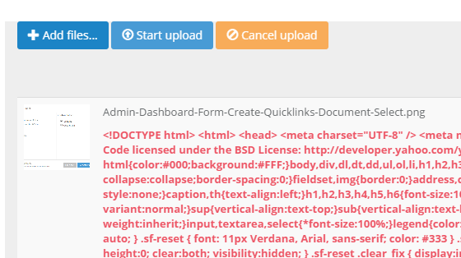

* + - * 1. Review documents

**Bug:** If you abandon the workflow at this point without clicking Done, the documents are not assigned a folder in the database, which breaks things on the front end.

Replace header copy *Update Meta Data* with *Upload Documents: Review*

Update breadcrumbs to read *Home \ Document Manager \ Upload Documents*

Replace Functional copy *View or Edit files just uploaded* with *Optionally edit document Title and Start/End* and remove bolding.

Shift table to line up underneath the lead-in copy above.

Remove *Description* column/fields

Filename strings should use CSS ellipsis when constrained (and the containing element should use a title tag so users can hover to see the whole file name)

Filenames should be in bold.

Auto-population of Document Title rules as follows:

starting with the original file name:

replace dashes and underscores with spaces

remove file extension (already working)

Remove single line **Update** buttons and the **Update All** button.

Clicking **Done** will apply the pre-populated and changed values within the form to the affected documents.

**Done** button should be disabled if any title/start fields are empty.

Add checkmark icon to **Done** button and change its colour to the blue we use elsewhere.

Revised layout as follows:  
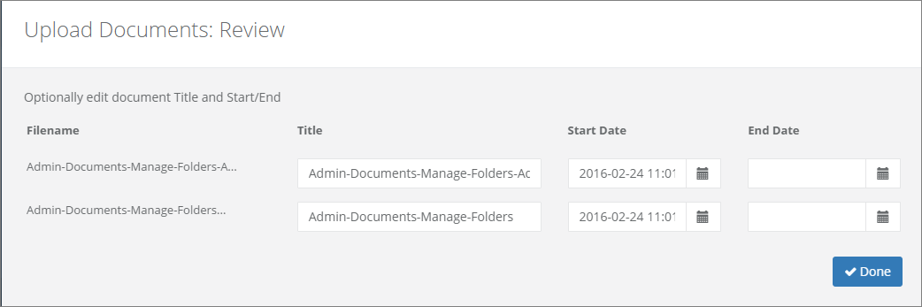  
source file: Admin-Documents-Manage-Docs-Add-Files-Review.png

* + - 1. Edit Document
         1. When a document is edited, upon returning to the Document Manager page, the folder tree should be expanded to show the currently open folder (i.e. the folder to which the edited document belongs)
         2. Header should read *Edit Document*
         3. Breadcrumbs should reflect both the function (Edit) and the document title (prior to editing).
         4. Edit Document

Rename section *Edit Document* to *Document details*

*Title* field label needs an asterisk.

Replace *Description* field with a readonly field labeled *File name* (which displays the original upload filename).

the filename displayed in the File name field should be a link which triggers either the viewing modal (PDF, MP4, PNG, JPG) or initiates a download (XLS, DOC)

Start/End Date/Time controls are missing the date/time widget used elsewhere.

* + - * 1. Mark Document as Alert

Merge this section into the above section as follows.

Target Stores [ Revisions not final - discussion required ]

Rename field label *Target Stores* to *Stores*

Rename *Or select all stores* checkbox to *All stores*

Move *All stores* checkbox above the store selection field

Add a **Clear** button to the right of the store selector that empties the field when clicked.

Constrain the Stores field to a max height of ~100px, with a vertical scroll bar as needed

Rename field *This document is an alert* to *Alert*

Alert field should be a radio button with options *Yes* and *No*

*No* is selected by default

Rename *Alert Type* to *Alert type\** (consistency and required field)

The **Alert type** field should be hidden unless **Alert** is set to Yes

Remove field **Start & End**

* + - * 1. Controls

Move **Cancel** and **Save changes** buttons to right side (consistency)

Change **Cancel** button icon to fa-ban

Change **Save changes** button icon to save icon

**Save changes** button should be disabled until useable:

Title field value has changed and is not empty

Start or End have changed

Stores selected has changed AND at least one store is selected OR **All Stores** is checked

Alert is set to Yes AND Alert type is selected

* + - * 1. Revised layout as follows:  
           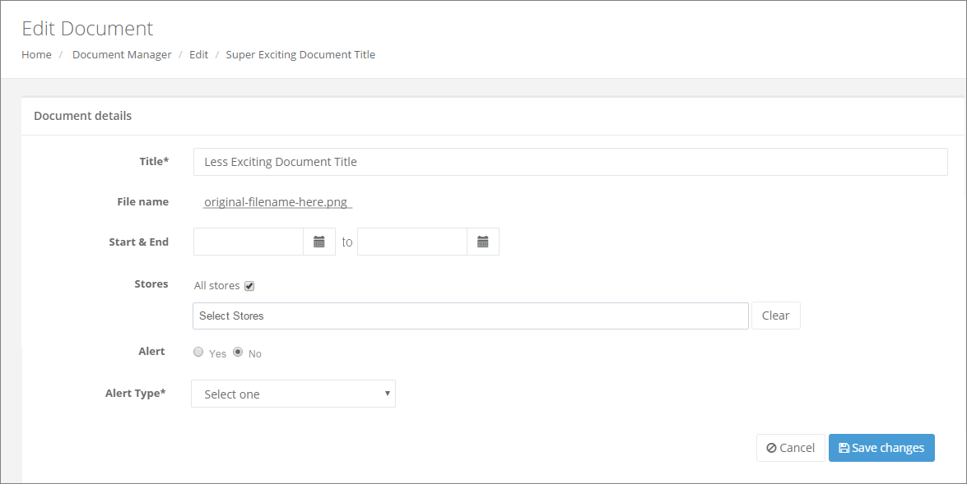  
           source file: Admin-Documents-Manage-Docs-Edit-Document.png
      1. Delete File
         1. The warning dialog is currently using a JS alert box. It should be a modal. (consistency)

### Alerts & Notices

1. Manage Alerts
   1. Navigation
      1. Ensure the left nav consistently reflects that the user is within Manage Alerts:  
         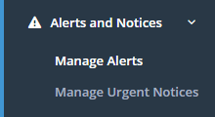
   2. Work Area
      1. Header area
         1. Rename header **Alerts** to **Manage Alerts**
         2. Remove or breadcrumbs or change to Home \ Manage Alerts
      2. Alerts List
         1. Rename Alerts List to Alert Listing
         2. Column headers
            1. Rename Document as Alert
            2. Reorder columns

Alert

Type

Stores

Start

End

[ Action ]

* + - 1. Listing data
         1. Alert document title should be shown (not filename)
         2. Document title should have an icon in front of it (file, image, etc.)
         3. Clicking on the Alert title should just display/download the document as appropriate
         4. Start/End date/time stamps should display date and time
      2. Action(s)
         1. The trashcan icon should trigger a modal confirming that this alert is canceled:  
            Really cancel this Alert?  
            The associated document will not be deleted.  
            No thanks | Yes, cancel this Alert
         2. Once the user confirms: [ Revision not final - discussion required ]

The associated document will have the removal of its Alert status saved.

Any (visible) reference to the Alert document should be removed from the Latest Updates feed.

1. Manage Urgent Notices  
   Review/Discussion Pending: this functionality was never clearly defined

## Front End

### Dashboard

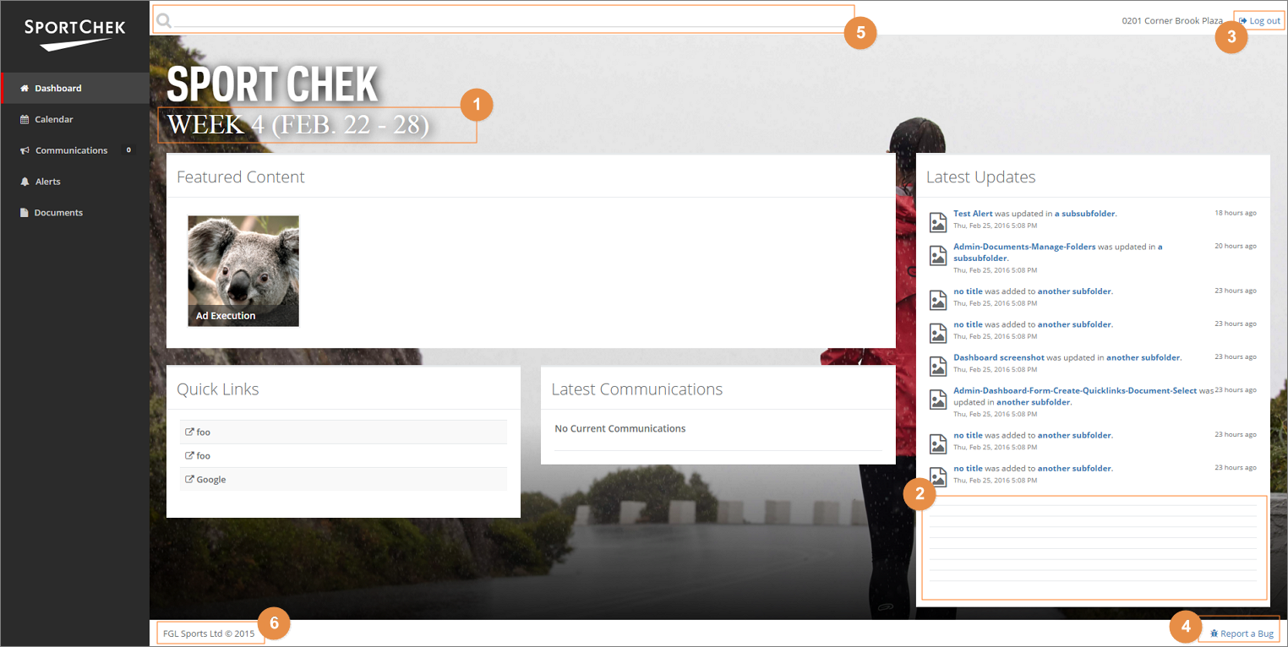  
source file: User-Dashboard.png

1. Subtitle is using the wrong font (should be Polaris Book?)
2. Items in Latest Updates generating additional bottom borders (single item code had redundant container element)
3. button **Log out** should be renamed **Change Banner/Store…** and its icon changed to Sitemap
4. Report a Bug [ revisions not final - discussion required ]
   1. link **Report a Bug** should be changed to feedback
   2. appropriate Feedback form modal TBD.
5. Search [ revisions not final - discussion required ]
   1. Search field needs explicit Search button (even though Enter will trigger the Search as well)
6. Copyright
   1. Should read: © 2016 FGL Sports Ltd.
   2. Year value should be dynamic