Burrito Masala – Font Families

**Nexa Rust**

From Font Squirrel

I like to boldness of this font for header text. It will contrast nicely against my body font (Open Sans). I can definitely see this ‘Burrito Masala’ across the top of the page in a beautiful bold statement.

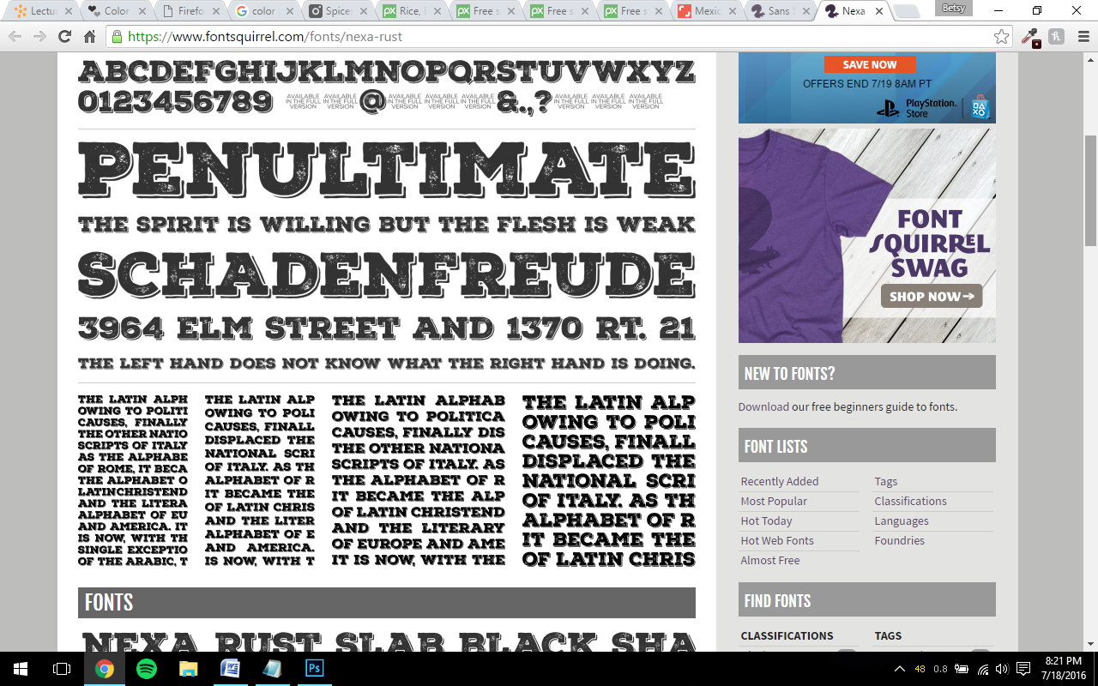

**Open Sans:**

From Google Fonts

I like this one for its simplicity and readability. It’s thinner and will go nicely against the Nexa Rust header font.

