

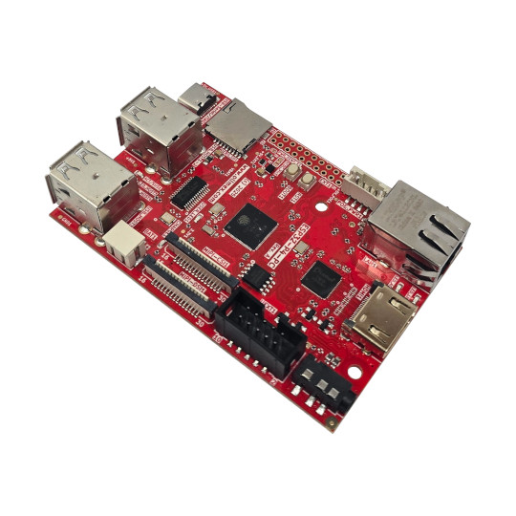

ESP32-P4-PC
User Manual
Rev.1.0 February 2026 olimex.com
Table of Contents
What is ESP32-P4-PC 3
Order codes for ESP32-P4-PC and accessories: 4
HARDWARE 5
ESP32-P4-PC layout: 6
UEXT connector: 7
ESP32-P4-PC UEXT connectors: 8
SD-card interface: 9
MIPI CSI and DSI connectors: 10
Audio connector: 11
USB-C connector: 12
Power supply path 13
ESP32-P4-PC schematics: 14
SOFTWARE: 15
Revision History 16

What is ESP32-P4-PC

ESP32-P4-PC is complete all in one computer based on ESP32-P4NRW32 Dual core RISC-V processor from Espressif.

The features of ESP32-P4-PC are:
- Espressif ESP32-P4NRW32 processor:
- Dual core 400Mhz RISC-V
- 768KB RAM
- 32MB PSRAM
- SPI Flash 16MB
- USB JTAG for programming and debugging
- Ethernet MACPHY and connector with POE option via extension
- Camera CSI interface
- LCD Display DSI interface
- HDMI converter and output
- Audio output 3.5mm jack
- LiPo battery charger and step up for Lipo battery operation
- MicroSD card
- Boot and Reset buttons
- UEXT connector
- All free GPIOs available on 0.1″ 2.54 mm 20 pin connector
- Three mounting holes 3.3mm diameter
- Dimensions: (90 x 60)mm
ESP32-P4-PC is Open Source Hardware, all CAD files and firmware and available, so people can study and modify.
+ Important notice: If ESP32-P4-PC is not mounted in box be careful to not place it on metal surface, nor drop metal objects on top of the PCB! This will lead to damage.

Order codes for ESP32-P4-PC and accessories:

ESP32-P4-PC ESP32-P4 all in one computer with 4 USB hosts and HDMI display
CAMERA-OV5647-5MPIX MIPI CSI compatible camera
MIPI-LCD2.8-640x480 MIPI DSI compatible display
POEv3 POE module compatible with ESP32-P4-PC
CABLE-IDC10-15CM UEXT cable
USB-KEYBOARD-PS2 USB keyboard which is compatible with ESP32-P4-PC
USB-CABLE-AM-USB3-C High speed, High current cable for power supply and programming
CABLE-HDMI-50CM HDMI cable
UEXT modules many UEXT modules which can connect to Neo6502 UEXT connector
BATTERY-LiPo1400mAh LiPo battery compatible with RP2350pc

HARDWARE

ESP32-P4-PC layout:

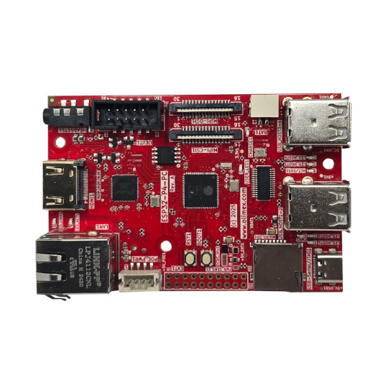
Camera MIPI
LiPo battery
Audio 3.5mm jack
UEXT
Display MIPI
USB 3-4
USB 1-2
USB-C
Micro SD card
GPIO extension
Boot button
Reset button
POE connector
Ethernet 10/100Mb
HDMI

UEXT connector:

UEXT connector stands for Universal EXTension connector and contain +3.3V, GND, I2C, SPI, UART signals.
UEXT connector can be in different shapes.
The original UEXT connector is 0.1” 2.54mm step boxed plastic connector. All signals are with 3.3V levels.
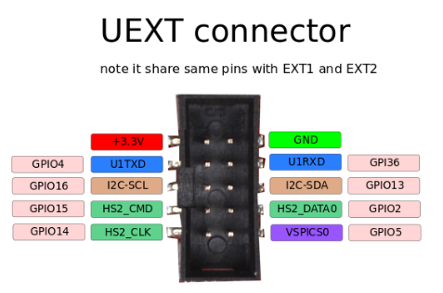

Olimex has developed number of MODULES with this connector. There are temperature, humidity, pressure, magnetic field, light sensors. Modules with LCDs, LED matrix, Relays, Bluetooth, Zigbee, WiFi, GSM, GPS, RFID, RTC, EKG, sensors and etc.

ESP32-P4-PC UEXT connectors:

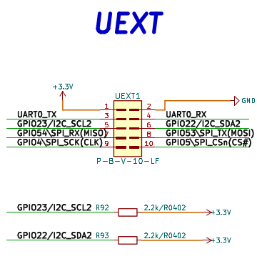

SD-card interface:

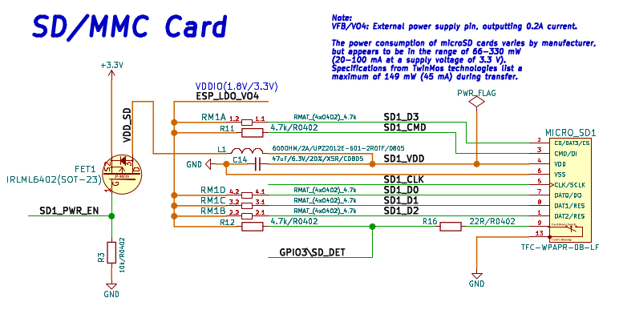

MIPI CSI and DSI connectors:
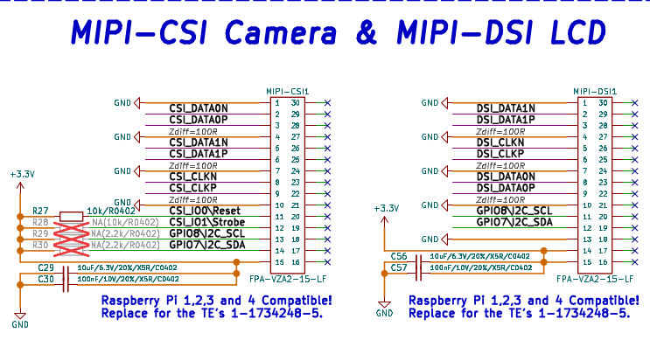

Audio connector:

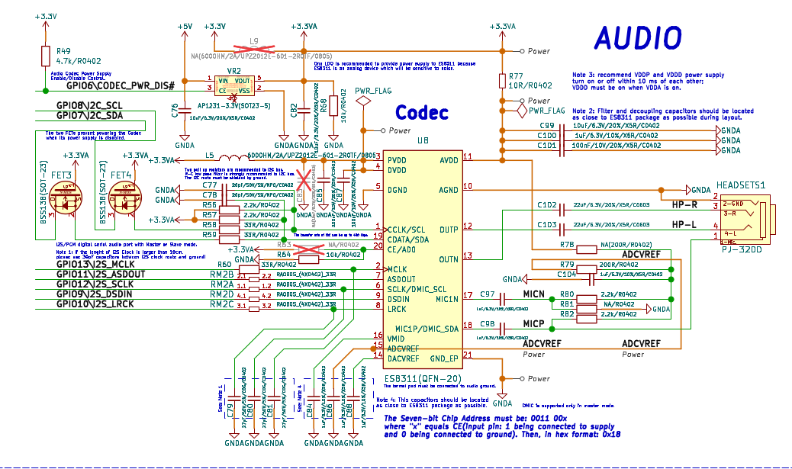

USB-C connector:

It’s used for power supply, serial port programming and JTAG/debugging:

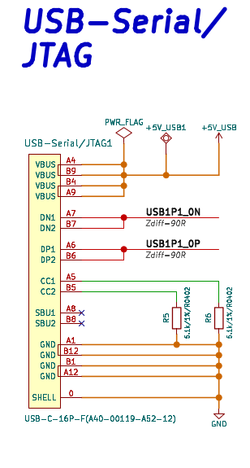

Power supply path

ESP32-P4-PC can be powered by USB-C connector or Ethernet POE, the USB-C connector have priority i.e. if both are present the power will be taken from USB-C connector.
The voltage is labeled +5V-EXT and is used to charge LiPo battery.
There is option to detect this voltage with GPIO32 via voltage divider, this is not connected by default to keep GPIO32 free for other apps if the external power sense is not necessary.

The LiPo battery is used only if not External 5V power supply. In this case step up with U14 power all 5V peripherals. So everything is working even with no external power supply is present.
GPIO20 can be used to measure the battery charge. By default this port is not connected so GPIO20 is free for other applications if no battery sense is necessary.

ESP32-P4-PC schematics:

ESP32-P4-PC latest schematic is on GitHub

SOFTWARE:

ESP32-P4-PC can be programmed with Espressif IDF. On Product web page there is demo code.

Revision History
Revision 1.0 February 2026

