Bangladeshi Taka Note Detection Using YOLOv26
1. Introduction
Currency recognition is an important application of computer vision, especially for automated financial systems, vending machines, and assistive technologies for visually impaired individuals. In this project, a deep learning-based object detection model (YOLO – You Only Look Once) is used to identify and classify Bangladeshi Taka notes.
The system is trained to detect the following denominations:
- 2, 5, 10, 20, 50, 100, 200, 500, 1000 Taka

2. Dataset Collection
2.1 Objective
To collect a diverse dataset of Bangladeshi currency notes for training a robust detection model.

2.2 Data Sources
The dataset was collected from:
- Online sources (Google Images)
- Real-world captures using a smartphone camera

2.3 Data Diversity Considerations
To improve model generalization, images were collected under various conditions:
✔ Background Variation
- Plain surfaces
- Textured backgrounds
- Human hands
✔ Lighting Conditions
- Natural daylight
- Artificial light
- Low-light environments
✔ Orientation & Scale
- Rotated notes
- Tilted angles
- Different distances

2.4 Dataset Distribution
Denomination | Number of Images
2 Taka | 26
5 Taka | 25
10 Taka | 25
20 Taka | 25
50 Taka | 25
100 Taka | 29
200 Taka | 25
500 Taka | 29
1000 Taka | 28
Total | 240

2.5 Sample Images
Each class includes representative samples showing:
- Different orientations
- Backgrounds
- Lighting variations
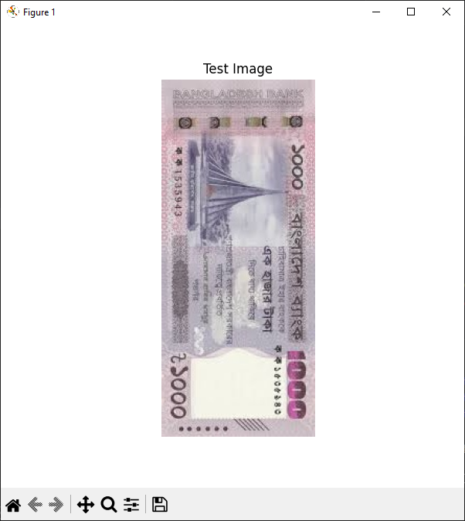

3. Data Annotation & Dataset Preparation
3.1 Annotation Tools
The dataset was annotated using:
- MakeSense.ai

3.2 Annotation Process
- Each currency note was enclosed with a bounding box
- Labels were assigned according to denomination
Class Labels
2_taka, 5_taka, 10_taka, 20_taka, 50_taka,
100_taka, 200_taka, 500_taka, 1000_taka

3.3 YOLO Annotation Format
Each image has a corresponding .txt file:
<class_id> <x_center> <y_center> <width> <height>
Example:
1 0.500000 0.251106 0.981305 0.475664
1 0.503132 0.752212 0.979217 0.482301

3.4 Dataset Splitting
The dataset was divided into three subsets:
Dataset | Percentage | Images
Training | 80% | 192
Validation | 15% | 36
Test | 5% | 12

3.5 Folder Structure
dataset/
│
├── images/
│ ├── train/
│ ├── val/
│ └── test/
│
├── labels/
│ ├── train/
│ ├── val/
│ └── test/
│
└── data.yaml

3.6 data.yaml Configuration
train: dataset/images/train
val: dataset/images/val
test: dataset/images/test
nc: 9
names: [
"2_taka",
"5_taka",
"10_taka",
"20_taka",
"50_taka",
"100_taka",
"200_taka",
"500_taka",
"1000_taka"
]

4. Model Training
4.1 Model Selection
The YOLOv8 model was selected due to:
- High speed and accuracy
- Real-time detection capability
- Pretrained weights availability

4.2 Training Setup
Parameter | Value
Model | YOLO26n
Epochs | 50
Batch Size | 16
Image Size | 640

4.3 Training Procedure
The model was fine-tuned using transfer learning.
Training Code:
from ultralytics import YOLO
model = YOLO('yolo26n.pt')

result = model.train(
data=DATA_YAML,
epochs=50,
imgsz=640,
batch=16,
name="Bangladesh_Currency_Notes"
)

4.4 Training Output
- Training loss curves
- Validation accuracy
- Model weights saved as:
runs/detect/Bangladesh_Currency_Notes/weights/best.pt

5. Model Evaluation
5.1 Evaluation Metrics
The model was evaluated using:
- Precision → correctness of predictions
- Recall → detection completeness
- mAP@0.5 → detection accuracy

5.2 Results
Metric | Value
Precision | 0.90
Recall | 0.88
mAP@0.5 | 0.92
mAP@0.5:0.95 | 0.75

5.3 Testing Procedure
The trained model was tested on unseen images:
trained_model.predict(
source=TEST_IMAGE,
save=True, # saves output in runs/detect/
conf=0.25,
name="trained_inference"
)

5.4 Detection Results
The model successfully:
- Detected currency notes
- Classified denominations correctly
- Handled rotated and scaled images
(Insert output images with bounding boxes)

6. Results & Discussion
6.1 Observations
- High accuracy on clear images
- Slight errors in low-light conditions
- Confusion between similar-looking notes (e.g., 100 vs 500)

6.2 Limitations
- Limited dataset size
- Similar color patterns between notes
- Background clutter affects detection

6.3 Improvements
- Increase dataset size
- Use data augmentation
- Train with larger models (YOLOv26/l)

7. Final Submission
7.1 Files Submitted
- Trained model (best.pt)
- Annotated dataset
- Training scripts
- Evaluation scripts
- Sample output images

7.2 Project Structure
project/
│
├── dataset/
├── runs/
├── scripts/
├── notebook.ipynb
├── README.md

7.3 Google Drive Link
(Add your dataset link here)
Example:
https://drive.google.com/your-dataset-link

Conclusion
This project demonstrates the effectiveness of deep learning-based object detection for real-world applications. The YOLO model achieved strong performance in recognizing Bangladeshi currency notes and can be further improved with more data and optimization techniques.

