The folder structure of the exercise programs is given below:

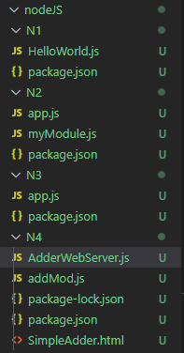

# Exercise N1

// package.json

{

  "name": "n1",

  "version": "1.0.0",

  "description": "Node JS Exercise N1",

  "main": "HelloWorld.js",

  "scripts": {

    "test": "echo \"Error: no test specified\" && exit 1"

  },

  "author": "Berhanu",

  "license": "ISC"

}

// HelloWorld.js

let http = require("http");

const PORT = 8080;

http

  .createServer(function (req, res) {

    res.writeHead(200, { "Content-Type": "text/html" });

    res.end("Hello World!");

  })

  .listen(PORT);

console.log(`Server Listening on port ${PORT} ...`);

//output

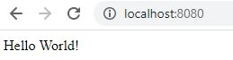

# Exercise N2

//package.json

{

  "name": "n2",

  "version": "1.0.0",

  "description": "Node JS Exercise -  N2",

  "main": "app.js",

  "scripts": {

    "test": "echo \"Error: no test specified\" && exit 1"

  },

  "author": "Berhanu",

  "license": "ISC"

}

// myModule.js

let myDate = function () {

  return Date();

};

exports.myDate = myDate;

// app.js

const http = require("http");

const dt = require("./myModule");

const PORT = 8080;

http

  .createServer(function (req, res) {

    res.writeHead(200, { "Content-Type": "text/html" });

    res.write("The date and time are currently: " + dt.myDate());

    res.end();

  })

  .listen(PORT);

console.log(`Server Listening on port ${PORT} ...`);

//output

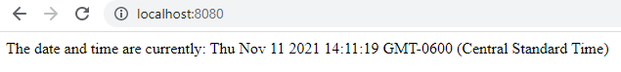

# Exercise N3

// package.json

{

  "name": "n3",

  "version": "1.0.0",

  "description": "NodeJS Exercise - N3",

  "main": "app.js",

  "scripts": {

    "test": "echo \"Error: no test specified\" && exit 1"

  },

  "author": "Berhanu",

  "license": "ISC"

}

// app.js

let http = require("http");

http

  .createServer(function (req, res) {

    res.writeHead(200, { "Content-Type": "text/html" });

    res.write(req.url);

    res.end();

  })

  .listen(8080);

// output

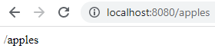

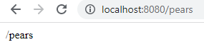

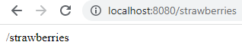

# Exercise N4

//package.json

{

  "name": "n4",

  "version": "1.0.0",

  "description": "NodeJS Exercise - N4",

  "main": "AdderWebServer.js",

  "scripts": {

    "test": "echo \"Error: no test specified\" && exit 1"

  },

  "author": "Berhanu",

  "license": "ISC"

}

// AdderWebServer.js

var http = require("http");

var url = require("url");

var fs = require("fs");

var addmod = require("./addmod.js");

http

  .createServer(function (req, res) {

    var q = url.parse(req.url, true);

    var filename = "." + q.pathname;

    if (q.pathname == "/add.js") addmod.add(req, res, q.query);

    else

      fs.readFile(filename, function (err, data) {

        if (err) {

          res.writeHead(404, { "Content-Type": "text/html" });

          return res.end("404 Not Found");

        }

        res.writeHead(200); // Content-Type not included

        res.write(data);

        return res.end();

      });

  })

  .listen(8080);

console.log("Web Server running on port 8080 ...");

// AdderMod.js

exports.add = function (req, res, vals) {

  var sum = parseInt(vals.first) + parseInt(vals.second);

  res.writeHead(200, { "Content-Type": "text/html" });

  res.write(

    `<!DOCTYPE html>

      <html>

        <head><meta charset=\"utf-8\"/>

        <title>Calculator Web Site</title>

        </head>

        <body>

          <p>The sum is: ${String(sum)}</p>

      </body>

    </html> `

  );

  return res.end();

};

// Output

