**SIMPLE CALCULATOR**

// package.json

{

  "name": "lab09",

  "version": "1.0.0",

  "description": "Simple Calculator",

  "main": "app.js",

  "scripts": {

    "start": "nodemon ./app.js",

    "test": "echo \"Error: no test specified\" && exit 1"

  },

  "author": "Berhanu",

  "license": "ISC",

  "dependencies": {

    "express": "^4.17.1"

  }

}

// app.js

const express = require("express");

const app = express();

const port = process.env.PORT || 3000;

app.use(express.json());

app.use(express.urlencoded({ extended: true }));

app.use(express.static("./public"));

app.get("/calculate.js", (req, res) => {

  let operation = req.query.calculate;

  let num1 = parseFloat(req.query.num1);

  let num2 = parseFloat(req.query.num2);

  let result;

  if (isNaN(num1) || isNaN(num2)) {

    return res.redirect("/");

  } else if (operation === "add") {

    result = num1 + num2;

  } else if (operation === "subtract") {

    result = num1 - num2;

  } else if (operation === "multiply") {

    result = num1 * num2;

  } else if (operation === "divide") {

    result = num1 / num2;

  } else {

    return res.redirect("/");

  }

  res.send(

    `The Answer is: ${result} <br/><br/>

    <div><a href="${req.protocol}://${req.hostname}:${port}">Another calculation</div>`

  );

});

app.get("/*", (req, res) => {

  res.redirect("/");

});

app.listen(port, () => {

  console.log(`Listening on port ${port} ...`);

});

// Sample Output

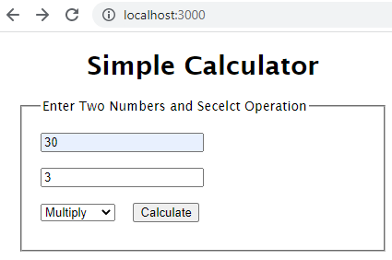

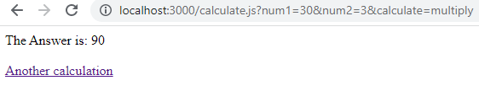

**Note**: that on clicking the ‘Another calculation’ link, it goes to the <http://localhost:3000/>. Also, note that invalid inputs like non-numeric inputs are also handled properly.