Ben Geller

HW4 9/26/2017

MSE 551

1. Ex4: Compute a uniaxial stress vs. strain diagram for aluminum

Attached input and log-file for the run, as well as python notebook used for plotting. Plotted ‘p1’ as stress, which is Pxx in GPa.

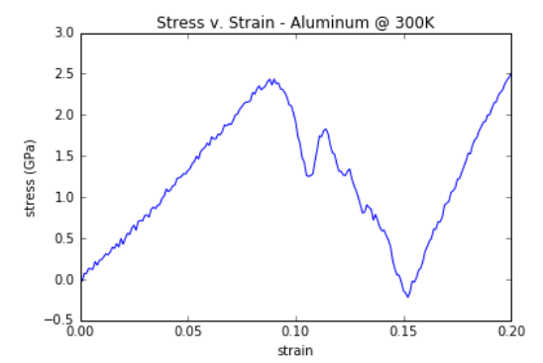

1. Ex5: Compute the energy to form a vacancy and interstitial in aluminum

Attached input and log files.

Evacancy = 0.717eV

Einterstitial = 1.981eV

1. Ex6: Compute the elastic constants of aluminum

Attached input and output file.

Elastic Constant C11all = 90.1467579322679 GPa

Elastic Constant C22all = 90.1467579315305 GPa

Elastic Constant C33all = 90.1467579315257 GPa

Elastic Constant C12all = 70.7253397782658 GPa

Elastic Constant C13all = 70.7253397778527 GPa

Elastic Constant C23all = 70.7253397778157 GPa

Elastic Constant C44all = 33.0823642857352 GPa

Elastic Constant C55all = 33.082364285713 GPa

Elastic Constant C66all = 33.0823642858699 GPa

Elastic Constant C14all = 2.1782374035689e-10 GPa

Elastic Constant C15all = 4.31342422700784e-10 GPa

Elastic Constant C16all = -1.20437375761535e-10 GPa

Elastic Constant C24all = -9.10394825856511e-11 GPa

Elastic Constant C25all = 5.35901806203273e-10 GPa

Elastic Constant C26all = -8.48685251900819e-11 GPa

Elastic Constant C34all = 2.4991079315771e-10 GPa

Elastic Constant C35all = 4.49673659139288e-10 GPa

Elastic Constant C36all = 2.73506036821306e-10 GPa

Elastic Constant C45all = 7.97398718529005e-11 GPa

Elastic Constant C46all = 5.0468884157987e-11 GPa

Elastic Constant C56all = 9.22721822552635e-11 GPa