Bethany George

COSC412

Software Project Management Plan

Preface: Scope and purpose

Scope: The features the website, as requested by the client, will be defined in this document. Both the backend and/or frontend mechanisms involved in each feature will be defined in this document. An explanation for each design and development choice will be provided for each mechanism involved in the project.

Purpose: This document is for the reader to understand the underlying structure of this specific project and the mechanisms at play in this project’s functionality.

Introduction

* **1.1 Project Overview**
  + Project Description: The project entails a website for a small business which builds desktop computers. The features of this site include a Homepage, Catalog, and Shopping cart. The homepage includes a slideshow, information on the business, and a section for reviews. The Catalog will use the Amazon API and have filters to sort products. The shopping cart feature allows for users to pay for and play orders through the site. This is done using the FedEx API and Stripe API. The site will have a database for user accounts and items to be listed in the catalog.
* **1.2 Project Deliverables: All items to be delivered, including delivery dates and location** 
  + Database for Registered and Guest user Accounts (07/17)
  + Database for items (07/17)
    - item variables include weight, base price, Availability, and an array of Images ().
  + Catalog (07/18)
    - Includes a Database for items by item weight, base price, Availability, and an array of Images.
  + Shopping Cart (07/22)
    - Includes a Payment page, confirmation page, and shipping rates.
  + Contact page (07/25)
    - Includes a section for a user to email inquiries.
  + Homepage (07/25)
    - Includes a slider of the store owner’s prior works, information about the service offered, and a review section.
* **1.3 Evolution of the SPMP: Plans for anticipated and unanticipated change**
  + Bi-weekly meetings will be held with the client as the project evolves. A presentation of the site in its current state will be shown to client. A discussion with the client about the process and the impact of changes as well as any problems with the system will be discussed.
* **1.4 Reference Materials: Complete list of materials referenced in SPMP** 
  + L. (2018, September). Waterfall Project Management Template [made in Lucidchart]. Retrieved from https://www.lucidchart.com/blog/waterfall-project-management-methodology
* **1.5 Definitions and Acronyms**
  + A.P.I. – Application programming interface
    - Definition: A programming interface which allows for one software to access another.
  + Web scraper
    - Definition: A web crawler or bot which extracts data from websites.
  + D.B. – Database
    - Definition: A structured collection of data stored electronically.

Project Organization

Part 2:

* **2.1 Process Model: Relationships among project elements**
  + The Development Process will be based on the Waterfall model. This is due to the majority of the subprocess involved occurring sequential.
* 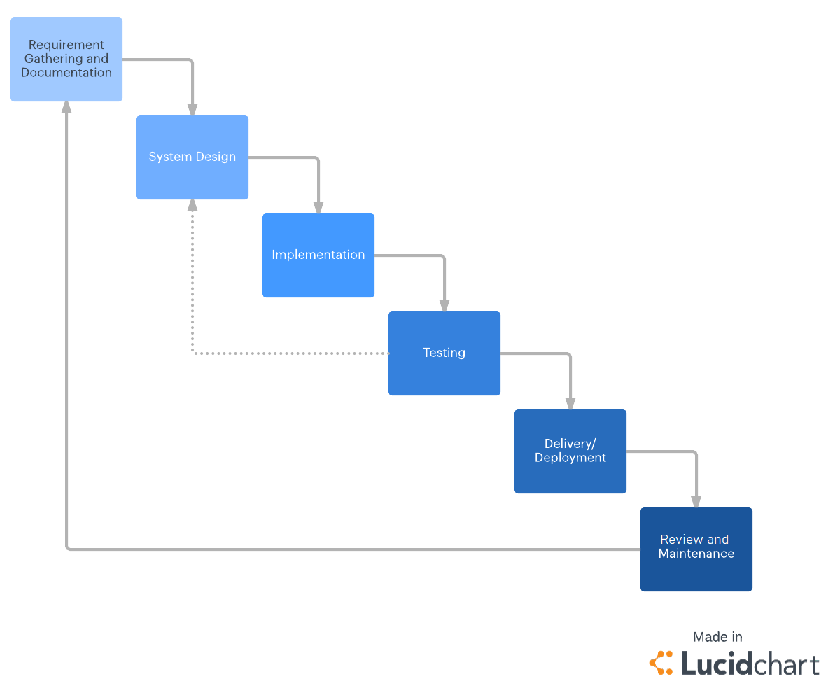
  + The Loop through System from ‘Testing’ to ‘System Design’ occurs to account for any design implementations that fail integration test. It will be re-evaluated to be properly integrated into the system.
* **2.2 and 2.3 Organizational Structure and Interfaces**
  + Most of the software and resources will be non-commercial and used through student discounts until after the date of delivery. The client did not approve the project for commercial use until September.
* **2.4 Project Responsibilities:**
  + Major functions:
    - For the Customer:
      * To browse and shop for parts.
      * To contact the store owner directly through email.
      * To write a review on the site.
    - For the Store Owner:
      * To receive build request and to view customer inquiries sent from the site’s contact page.
  + Most time-consuming project features:
    - A Catalog.
    - A shopping Cart.
    - Database construction.

Managerial Process

Part 3:

* **3.1 Management Objectives and Priorities**
  + To meet each of the requirements by the due date.
  + To adapt to any changes requested by the client as the project evolves.
  + To evaluate changes to the design based on risk and opportunity cost of changes.
* **3.2 Assumptions, Dependencies and Constraints**
  + Constraints under which the project is to be conducted:
    - The cost of tools used is to be kept to a minimum. Free tools will be prioritized more than any other possible alternatives.
    - The client’s requirements initial requirements are how the system will be designed initially. Changes made to the design and fundamental part of the system may be limited due to time constraints.
* **3.3 Risk Management (by case)**
  + Client is disatified with the developed prototype.
    - This will be discussed in a review with the client. Bi-weekly reviews help to prevent dissatisfaction from occurring. Alternatives as well as any of the losses that may come with changing aspects of the system’s design.
  + Requirements are increasing in complexity.
    - Use pre-built tools like APIs and Web-Scrapers when appropriate and legal.
    - Discuss the complexity of certain aspects with the client and evaluate its priorities. As well as suggesting simpler alternatives to the initial requirements. This allows for the client to understand the scope of the project and the opportunity cost for certain choices made in the design.
  + Project size is too large.
    - If the project is too large, then I will evaluate which parts of the system are the costliest in terms of space. This will lead to either simplification of certain aspects of the design. If the System is being simplified it will be evaluated from the heaviest aspects to the lightest.
* **3.5 Monitoring and Controlling Mechanisms**
  + Continuous integration test as tools are merged with the larger system.
    - Certain tools such as MongoDB can track the size and operations in a cluster.
    - GitHub is used to track changes to the overall project.
* **3.5 Managing Change**
  + Change of requirements
    - This can be discussed during bi-weekly reviews with the client. Depending on the scale of the change to the system. Changes that affect fundamentals of the system and push the project past its deployment date may not be applied unless other aspects of the system, which have not been implemented yet, can simplified.
  + Change of tools
    - If a tool being used does not have all the features to meet the current requirements, then a new tool will be immediately selected. Alternatively, a secondary tool may be implemented to meet requirements if possible.

Technical Process

Part 4:

* **4.1 Methods, Tools and Techniques**
  + Front-end tools:
    - Bootstrap – For templates and overall design
    - Visual studio code – Tweaking, Testing and connecting features of the site
  + Backend tools:
    - Stripe API – payment method
    - Amazon API – Catalog, prices and weights of items in catalog
    - FedEx API – Shipping rates and tracking packages
    - MongoDB – Database
    - Name.com – Hosting and Domain (subject to change)
    - Mailgun – handles and verifies email through the sites contact page
  + Methods and Techniques: I will be using, HTML, Java and JavaScript to test the APIs listed in 4.1.
* **4.2 Software Documentation and 4.3 Project Support Functions**
  + Reviews and revisions will occur after bi-weekly meetings with the client. This will allow for Quality assurance and will give the client agency through opportunities to approve, correct, or change aspects of the design. The design prior to each meeting will be documented in case it needs to be referred to in the future.

Work Elements, Schedule, Budget

Part 5:

* **Work Breakdown Structure (WBS):**

Website

Requirements

Designing system

APIs Integration

Further API test

Select tools

Review

Meet with client

Use Cases

SPMP

Design for main functions

Front-end design through bootstrap

Backend design

Set up

Use and review documentation

Integrate

Test current system

Document

Merge with current site

Testing

Review with client

Configure to meet any changes

Review with client

Fix to new standards

Present final product

* **Project Schedule (Gantt Chart)**

