Benjamin Georgakas Treatment Order Appeal

I am writing to revoke my treatment order. I will iterate through the rights outlined in the statement of rights document and show where they do and don’t apply to me.

“A compulsory treatment order means you will be given treatment en=venn if you don’t want it. Treatment can be mdication such as tablets or injections”

“The person/s making the order must think that you meet all four criteria:”

1. “You have a mental illness; and”

When I was initially admitted I think this was the case as I was acting almost entirely on impulse. I am still unsure of the diagnosis but I was clearly unwell. This is demonstrated in my social media usage and spending behaviour as outlined in figure 1 and 2.

However I believe I now have an appropriate level of control of my behaviour which can be seen in the dip in spending and social media usage in figures 1 and 2

2. “Because of this mental illness you need immediate treatment to prevent”
- serious harm to you or another person or
- serious deterioration of your mental or physical health; and

This was definitely the case when I was initially admitted. I was acting purely on impulse which meant there was a possibility of causing harm to my self or others

3. …

Treatment was given to me.

4. There is no less restrictive way, reasonably available, for you to get treatment

Initially this was true, but now I think I could be treated more effectively living at home with my parents and attending sessions regularly

An order should not be made if the possibile harm from it is likely to be more than the harm it is intended to prevent

Initially this was true as there was the possibility of causing harm to my self or others as a result of my impulsivity. But now that I have control over my impulses, see figure 1 and 2, I think being under a treatment order is causing more harm.
There have been a number of incidents which have been highly distressing for me. Firstly, not being able to leave in and of itself is very harmful to my mental wellbeing. Secondly, I was pushed by another patient and although I wasn’t physically harmed I was very distressed as a result of the incident. Thirdly, I am sharing a room with a schizophrenic patient who has written his intrusive thoughts on pieces of paper on his desk. I have managed okay sharing a room with him but it is less than ideal.
The treatment order, although initially valid is now causing more harm than good.
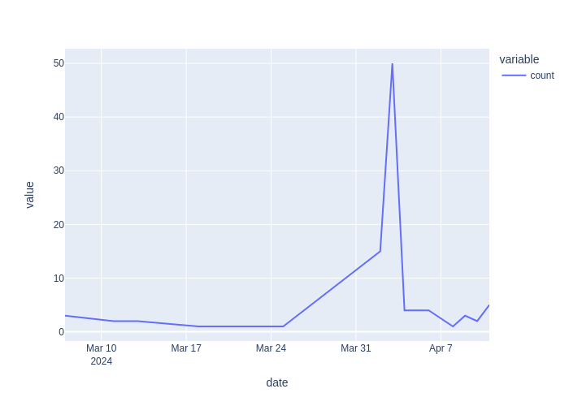Figure 1: Measure of activity on instagram including posts and comments
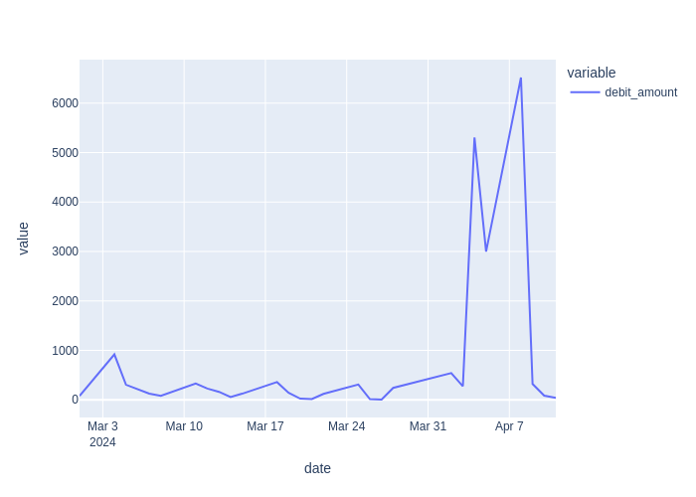Figure 2: Total spending per day

