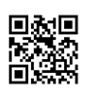

Avoiding Plagiarism

What is plagiarism?
Plagiarism is using another person’s ideas or words without acknowledging or citing the source of that information. You must give credit whenever you use:
- Another person's idea, opinion, or theory.
- Direct quotes from another person's actual spoken or written words.
- Paraphrasing of another person's spoken or written words.
- Any piece of information this is not common knowledge (e.g., fact, figure, statistic, chart)
- Multimedia created by another person (e.g., photo, drawing, film clip, music, etc.)

Why should I cite my sources?
- Avoids plagiarism and gives proper credit to the original author or creator.
- Enables a reader to locate the sources you cited.
- Demonstrates the accuracy and reliability of your information.
- Shows the amount of research you’ve done.
- Strengthens your work by lending outside support to your ideas.

Tips for Avoiding Plagiarism
- Manage your research.
- Keep a research journal to help organize information in one place.
- Use EasyBib in order to keep track of your sources and cite them accurately in works cited.
- Cite paraphrasing and direct quotes in your rough draft.
- Use in-text citations in the body of your paper for any information taken from another person’s work.
- Use quotation marks around the exact words of another person.
- Write out the idea in your own words when paraphrasing. Don’t just change a few words.
- Follow the rules for the citation style specified by your instructor (e.g., APA, MLA, Chicago).
- Make it clear when using someone else’s idea (e.g., According to Smith . . . )
- WHEN IN DOUBT…CITE IT!

When should I cite?
- When directly quoting from another person. Put exact words in quotes!
- When paraphrasing someone else’s ideas. Put it in your own words!
- When using any type of multimedia created by another person.
- When in doubt, cite it.

Still have questions? Ask a librarian! http://library.reynolds.edu

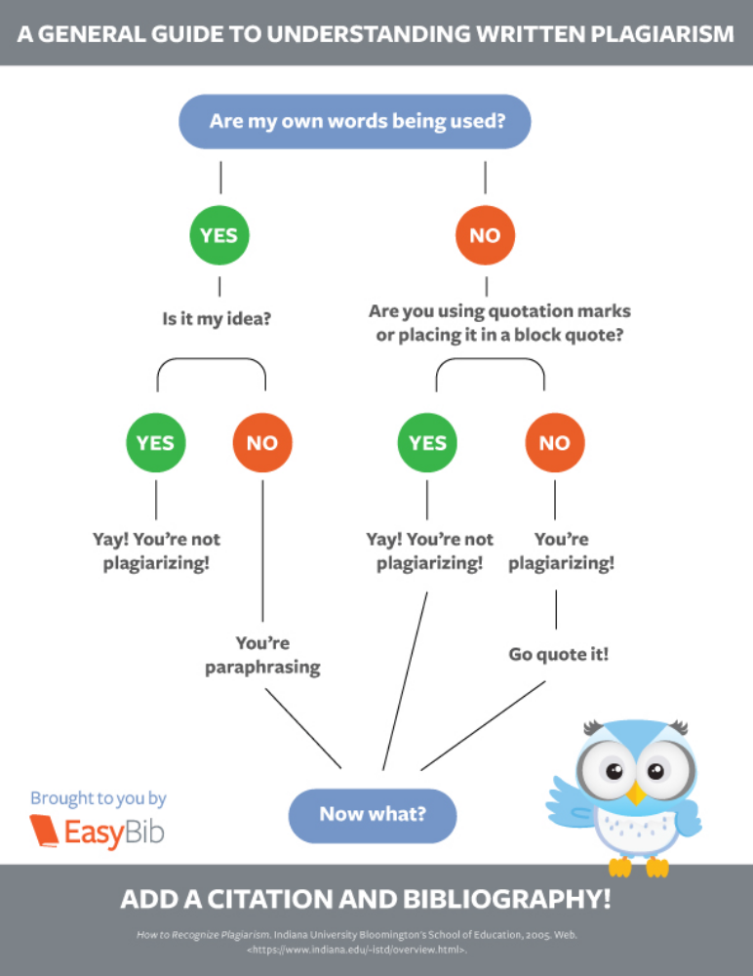

Plagiarism Infographic. Digital image. EasyBib. ImageEasy Solutions, n.d. Web. 13 Aug. 2013.

