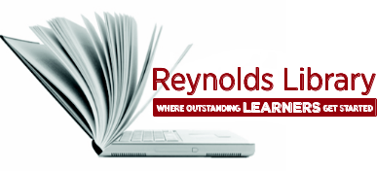 | Use the Library Catalog | 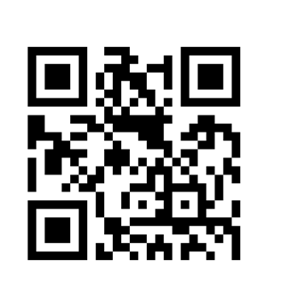
Access QuickSearch
Use QuickSearch to search for items at all three Reynolds campus libraries including:
- books (audio, online, & print)
- articles (online)
- videos (DVDs & online)

To access QuickSearch, type your search terms in the search box on the library’s home page.
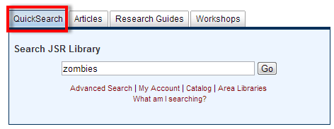
Refine Search Results
When the search results screen appears, you have the option to limit your results to type of resource including online articles, online and print books, and multimedia (e.g., online videos and DVDs) as well as various other options.
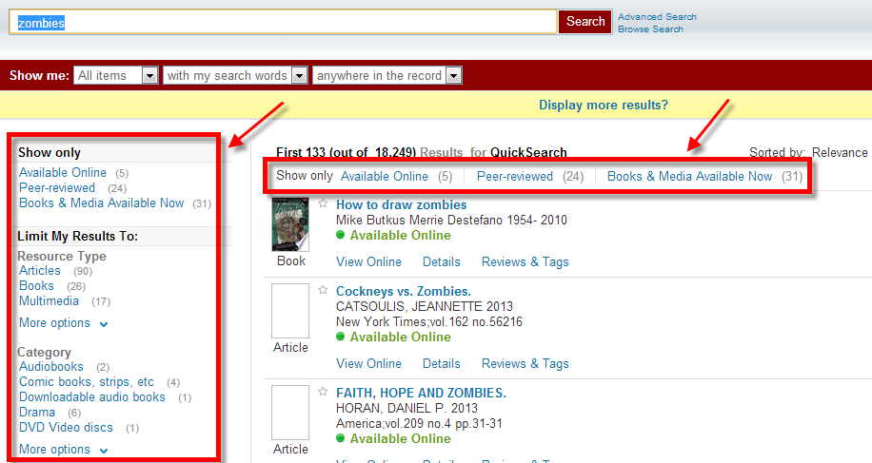

Refine Search Results (cont’d)
To limit results to books only, click on Books from the Limit my Results To menu on the left.
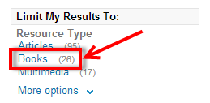
To limit results to print books from a particular campus, click on the specific campus link from the Library menu on the left.
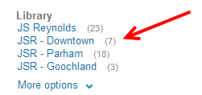
To limit results to books and videos available (not checked out), click on the Books & Media Available Now link located near the top of the results list.
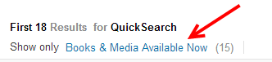
To undo your limiter options, click on the X next to that limiter located near the top of the results list.

You can search for words as author, in the title, or in subject, by using the Show me menu from the basic search screen or using this menu from the Advanced search screen.

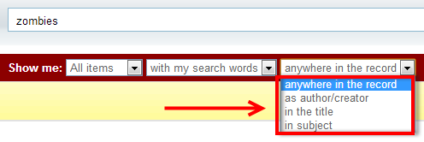
Basic search screen:
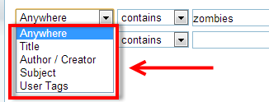
Advanced search screen:

Additional Search Techniques
- Use the Boolean operators - AND, OR, NOT in ALL CAPS to refine your search. For example:
  - zombies vampires – when using only the AND operator, just use a space between your words. The AND operator is assumed and you will retrieve records that include BOTH terms.
  - zombies OR vampires – you will retrieve records that contain AT LEAST ONE of these words.
  - (zombies OR vampires) AND werewolves - use parentheses to keep combination searches in order. If you combine operators AND & OR, you will need to also type the operator AND. You will retrieve records that include at least one of the terms - zombies or vampires, as well as the term - werewolves.
  - zombies NOT vampires – you will retrieve records that include the word, zombies and not the word, vampires.
- “ ” use quotation marks to find an exact phrase – e.g., “world war z”
- ? enter a question mark to perform a single character wildcard search. For example, type wom?n to search for records that contain at least one of these words - woman, women.
- * enter an asterisk at the end of a root word to pick up all forms of the root word including the plural or singular of a word. For example, type the root word teen* to search for records that contain at least one of these words – teen, teens, teenage, teenager, teenagers.
Collections available through Reynolds Library
- Audiobook Collection: Audiobooks on disc available for checkout.
- Available online:
  - Audio Books: OverDrive collection includes books, videos, and music. You will need to login with your – My Reynolds (Blackboard) username and password to checkout this media and download the files from off campus.
  - eBooks: Includes EBL, EBSCOhost, Gale, Oxford, Safari, SciVerse, and Springer eBook collections. You will need to login with your – My Reynolds (Blackboard) username and password to view these eBooks from off campus. EBSCOhost also allows you to checkout and download eBooks from off campus.
  - Videos: Includes Films on Demand video collection. You will need to login with your – My Reynolds (Blackboard) username and password to view these videos from off campus.
- Career & Career Test Collections: Print books available for checkout.
- Circulating Collection: Print books available for checkout.
- ESL Collection: Print books available for checkout.
- Graphic Novel Collection: Print books available for checkout
- Juvenile Collection: Children’s print books available for checkout.
- Media Collection: DVDs and videos available for check out. Educational DVDs and videos are housed at the Downtown Campus Library. You can request a DVD or video to be sent to the Parham Road or Goochland Campus Libraries or you can go in person to the Downtown Campus Library to pick up the DVD or video.
- Popular Titles / Best Sellers: Print books available for checkout.
- Popular Video Collection: DVDs available for checkout.
- Reference Collection: Library use only.

View Online Resources
When viewing the results list, online articles, books and videos will be indicated by Available Online. Click on the View Online link from the result list to view the item.
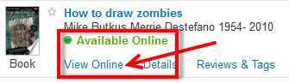
When the View Online window appears, you have the option to Open source in a new window by clicking on this link.
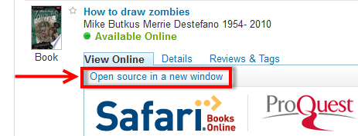

Locate Physical Items in the Library
When viewing the result list, physical items (e.g., print books, DVDs) will include the following information: the specific campus that holds the item, the specific collection where the item is located, and the Library of Congress (LC) call number which indicates where the item is located on the shelf. If items are available (not checked out), they will be indicated by Available at.
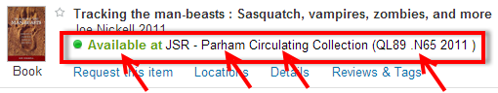
Checked Out Items
When viewing the result list, checked out items will be indicated by Checked out from.
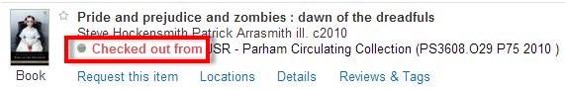
To view the date the item is due back in the library, click on Locations. The date due is under Status.
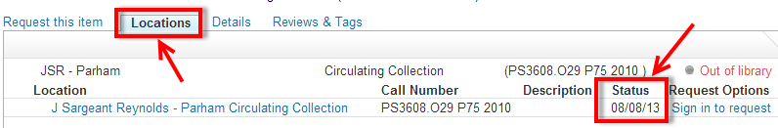

Request Items
If an item is already checked out (indicated by Checked out from), you can request that the item be held for you when it is returned to the library by clicking on Request this item.
You can also use the Request this item option to have an item transferred to another campus library for pickup.
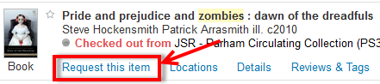
You will be prompted to sign in with your My Reynolds username and password.
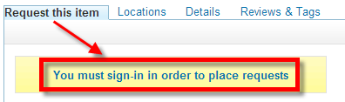 | 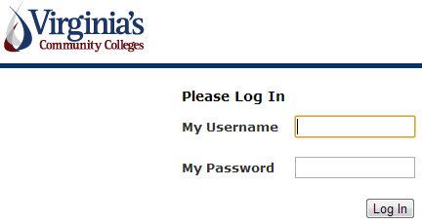
When the Request Options window appears, make sure to select the Pickup Location, then click on the Hold button.
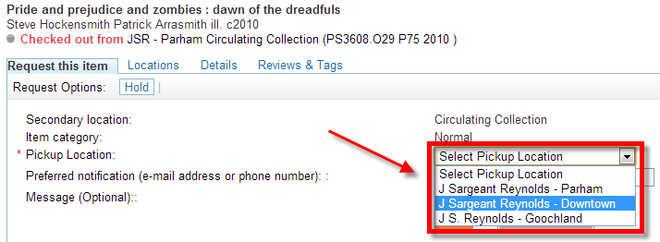

Item Details
When viewing the result list, click on Details to view detailed information for a particular item including: title, author/s, subjects, description (chapter titles), publisher information, and publication date.
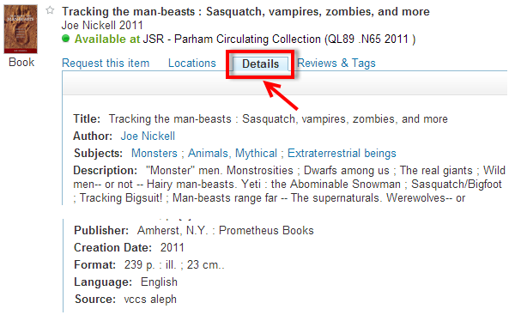

Additional Help
For additional help in using QuickSearch, click on the Help link located in the upper right side of the QuickSearch screen or ask the Reference Librarian for assistance.

