 | Use the Library Catalog  Worksheet | 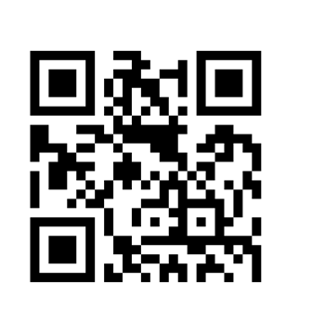

Refer to the corresponding handout, Use the Library Catalog, and follow the instructions below using QuickSearch to help you complete this worksheet.

- Perform a search using QuickSearch on a topic of your choice. What search term/s did you use?

- Limit your search to “books only” by selecting Books from the Limit My Results To menu located on the left.
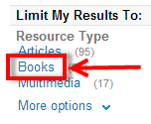
- Next, limit your search to a print book at a specific campus by selecting the JSR - Downtown, JSR – Parham, or JSR – Goochland from the Library menu on the left.
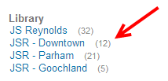

- Select any book from your result list and answer the following:
  - Is this book available? (Select one) Yes No
  - What collection is this book located in?
  - What is the complete Library of Congress (LC) call number?

OVER

- Click on Details to view the detailed information for the book and answer the following:
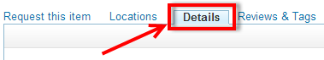

  - Title:
  - Author/s (if any):
  - Subject/s used:

  - Publisher information:
  - Publication (Creation) date:

- From the Details window, select Send to located in the upper right corner of the Details window. When the Send to menu appears, select Print.
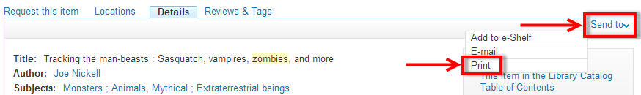

- When your browser Print window appears, PRINT OUT this detailed print record and attach it to this worksheet.

