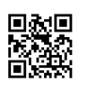

Interpreting Citations

A citation is a reference to a source of information. A citation typically includes enough identifying information, such as the author, title, publisher information, date of publication, database retrieved from, etc. for a reader to be able to locate a copy of the item.

The ability to interpret citations or references from various sources of information is a fundamental research skill. In order to be able to correctly cite an source in a specific style (e.g., MLA, APA), you need to be able to determine what type of source the item is, where the source came from, and identify the various elements of the source.

The following are several examples of the most common types of sources found in the library catalog, databases, and web sites:

Print Book – Record from the Library Catalog

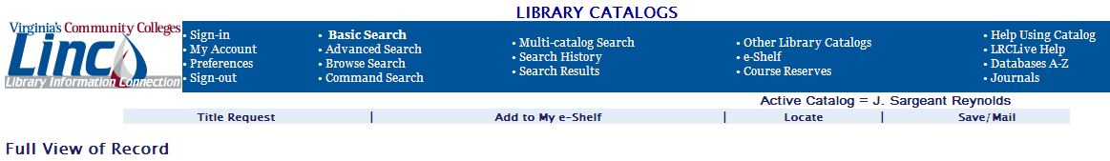
Author

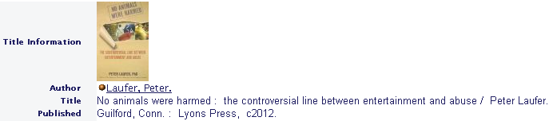
Book Title

Publication Date
Publisher
Publisher Location

Note: If you are using MLA style, include the medium of source consulted at the end of your citation
(e.g., Print).

Chapter/Essay in a Print Book – Record from the Library Catalog


Book Editor
Book Title
Publication Date
Publisher
Publisher Location
Essay in Book
Author of Essay

Notes: You will also need to include the page number range when citing a specific essay within an edited book. Review the actual book to locate the page number range. If you are using MLA style, include the medium of source consulted at the end of your citation (e.g., Print).

Online Journal Article by 4 Authors – Retrieved from a Library Database

Database Name
Article Title

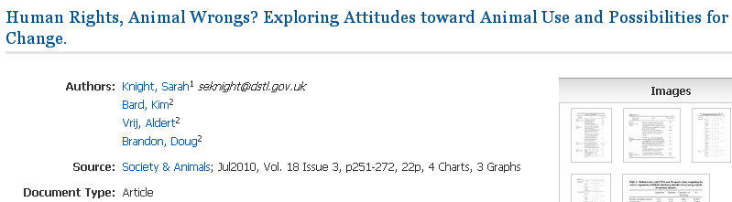
Authors
Volume #
Issue #
Journal Title
Page #s
Year

Notes: Do not include the month or season (e.g., July, Summer) when citing a scholarly journal article in MLA style. If an article has more than 3 authors, provide only the first author, followed by “et al.” For example: Knight, Sara, et al. If you are using MLA style, include the medium of source consulted (e.g., Web) as well as the date of access (e.g., 10 Oct. 2012) at the end of your citation.

Online Magazine Article by 2 Authors – Retrieved from a Library Database


Database Name
Article Title
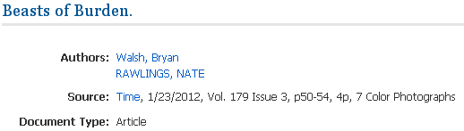
Magazine Title
Authors
Publication Date
Page #s

Notes: Do not include the volume and issue number when citing a popular magazine article in MLA style. If you are using MLA style, include the medium of source consulted (e.g., Web) as well as the date of access (e.g., 10 Oct. 2012) at the end of your citation.

Online Newspaper Article by 2 Authors – Retrieved from a Web Site

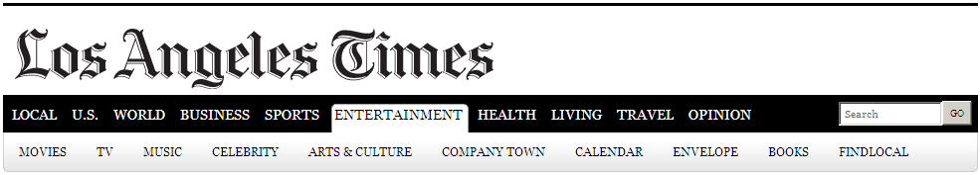
Newspaper Title


Authors
Article Title
Publication
Date
Notes: If you are using MLA style, include the medium of source consulted (e.g., Web) as well as the date of access (e.g., 10 Oct. 2012) at the end of your citation.

Online Government Publication – Retrieved from a Web Site
U.S. Government Department

U.S. Government
Agency
U.S. Government Division of the NAL agency

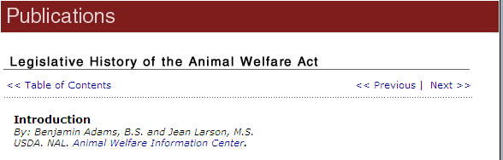
Publication Title
Authors
Date Last Updated

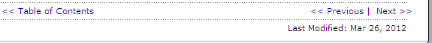

Notes: If you are using MLA style, include the medium of source consulted (e.g., Web) as well as the date of access (e.g., 10 Oct. 2012) at the end of your citation.

