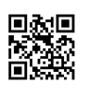

Interpreting Citations Worksheet

Print Book by 2 Authors - Record from the Library Catalog
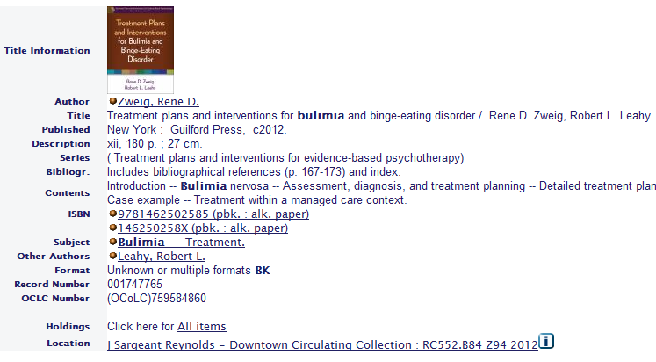

Authors:
Book Title:

Publisher Location:
Publisher Name:
Publication Year:
Format or medium of book:

Online Journal Article by 3 authors – Retrieved from a Library Database
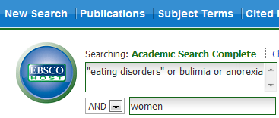
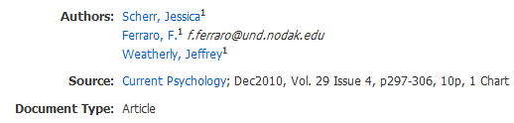
Article Title:

Authors:

Journal Title:
Volume #: Issue #:
Note: Do not include the month or season (e.g., December, Winter) when citing a scholarly journal article in MLA style.
Publication Year:
Starting and Ending Page #’s:
Name of Database:
Format or medium of article:
Access date (day, month, year – use today’s date):

Online Magazine Article by 1 Author – Retrieved from a Library Database
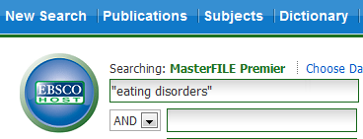

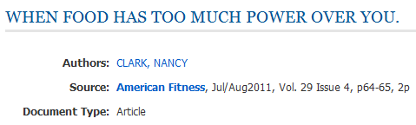

Article Title:
Author:
Magazine Title:
Publication Date (Include month/s and year):
Note: Do not include the volume and issue number when citing a popular magazine article in MLA style.
Starting and Ending Page #’s:
Name of Database:
Format or medium of article:
Access date (day, month, year – use today’s date):

Online News Article from a Web Site




Title of news article:
Author of news article:
Date news article was last updated:
Name of overall web site:
Name of publisher or sponsor the web site (Hint: If a publisher or sponsor is listed, the name is
usually located near the bottom of the screen):
Format or medium of publication:
Access date (day, month, year – use today’s date):

.

