

Library Databases vs. the Web
Worksheet

Use Google and databases to search the topic online dating and compare the type of information found.

- Search Google:
- Go to Google at http://www.google.com.

- Type online dating in the search window. Press the <Enter> key or click on the Google Search button to search.


- When the Google Results screen appears, briefly click on and review the first 5 web sites.

- Print out the first page of any web site from the results and attach it to this worksheet.

- Perform a simple search in the databases for full-text articles.
- Go to the library homepage: http://library.reynolds.edu. Click on the Articles tab above the search box. When Simple search for full-text articles search box appears, type online dating. Press the <Enter> key or click on the Go button.
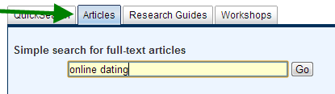

- When the articles search results screen opens in a new window, click on the title of each of the first 5 articles links and briefly review the articles found.

- Print out the 1st page of any article from the results you reviewed and attach it to this worksheet.

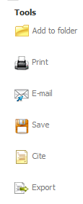
- When reviewing the full articles click on the Cite (yellow page icon) from the Tools menu on the right. Notice each citation
style’s format. (e.g., APA, MLA, etc.)

- Compare Results from Google & the databases.
Answer the following:
- Which resource includes more search options to retrieve more relevant results?
___ Google ___ Database

- Which resource includes ads and sponsored links?
Google Database

- Which resource retrieves more magazine articles?
Google Database

- Did any of the web pages you reviewed from your Google results feature an automatic citation tool like the Cite this Article?
Yes No

- Which resource is best for college level research?
Google Database

