 | Using the EBSCOhost eBook  Collection | 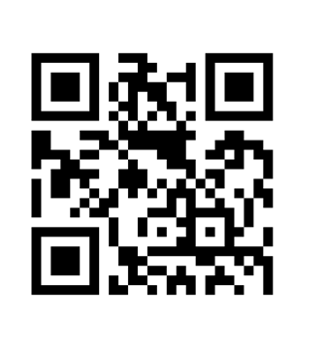

There are several ways to search for eBooks on EBSCOhost:
- Perform a keyword search using the Search window.
- Browse by Category by selecting a category from the column on the left.
- View the Highlights eBooks using the left and right arrows or click View All.
- View Featured eBooks using the left and right arrows or click View All .

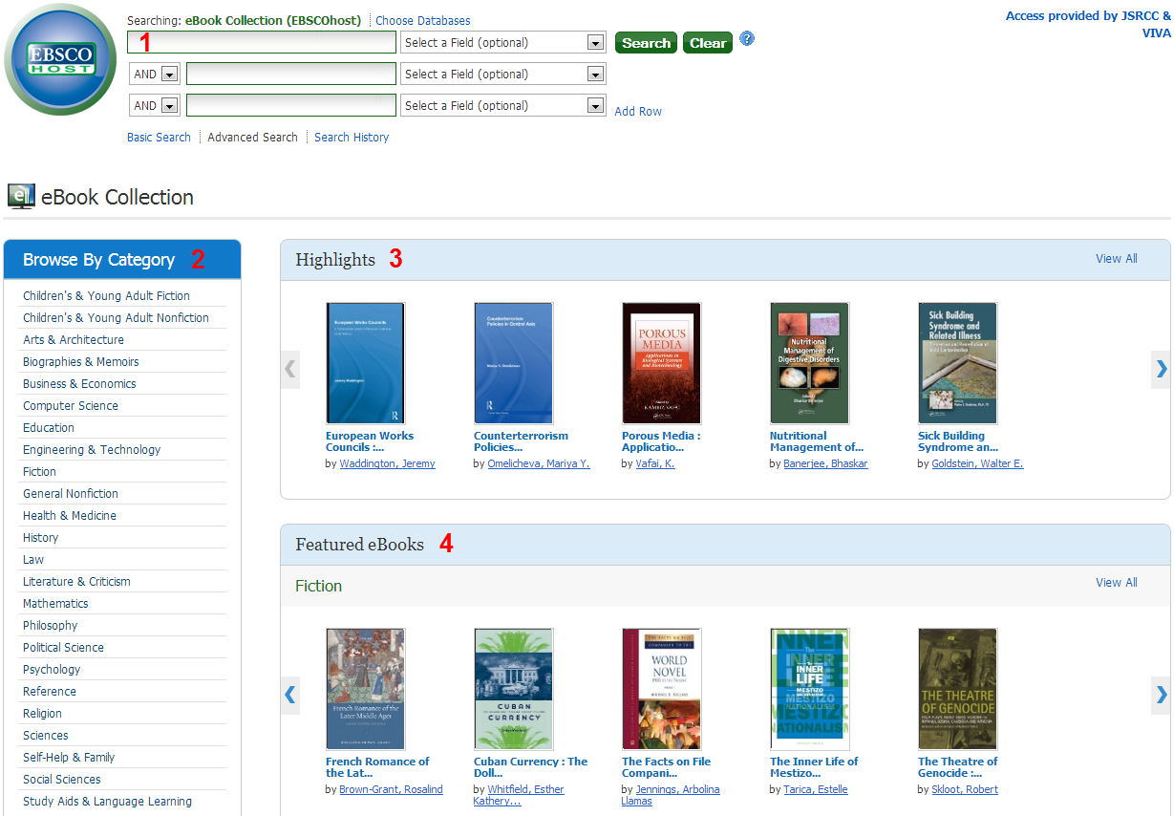

To search for eBooks:
- Enter your search terms in the search window. Press the <Enter> key or click the Search button to execute the search.
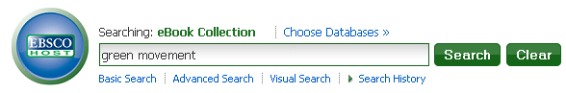

- A result list of eBooks related to your search terms is displayed.
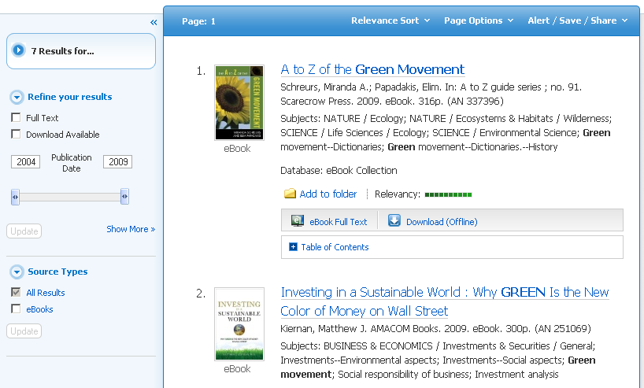

- Click the eBook Full Text link to read the book in the eBook Viewer.
- Click the Download (Offline) link to check out the book and read it on your home computer or mobile device. Adobe Digital Editions is required for viewing on your home computer or laptop. Bluefire Reader is recommended for viewing from your Apple or Android device.
- Click the Table of Contents link to view the chapters of an eBook. You can go directly to a chapter in the eBook Viewer by clicking on a hyperlinked chapter.
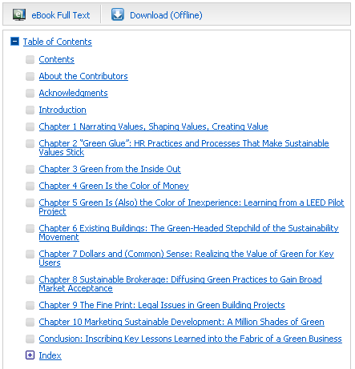

eBook Viewer
eBooks can be read online in the eBook Viewer by clicking the eBook Full Text link. You do not have to checkout the book to yourself.
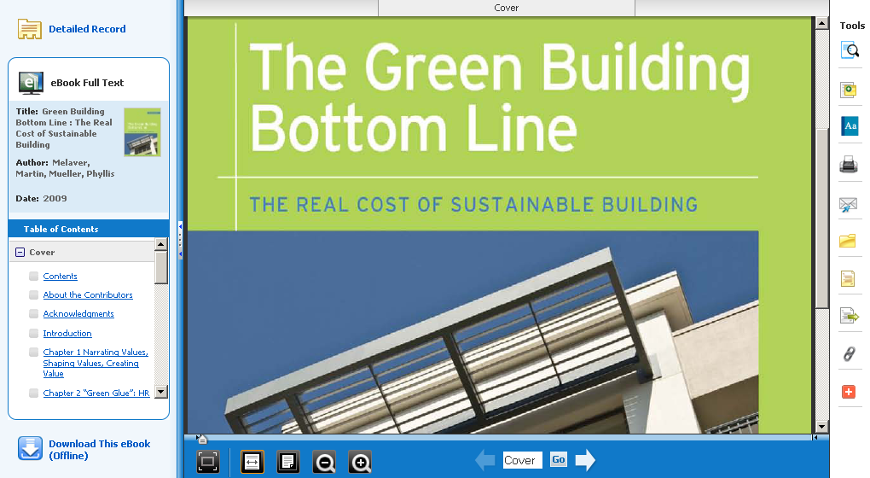
Using the Tools column on the right
- - Click on the magnifying glass icon to search for terms within the eBook.
- - Click on the note icon to create a note about the eBook or a page of the eBook and save it to your personal folder.
- - Click on the dictionary icon to search for definitions of words in the eBook you are reading.
- - Click on the printer icon to print out specific pages of the book.
- - Click on the envelope icon to email specific pages of the book.
- - Click on the folder icon to add a book to the folder.
- - Click on the page icon to cite the book in APA or MLA style.

Using the eBook Viewer Toolbar on the bottom

- Fit Page to Viewport: Click on this icon to fit the entire page into the viewport.
- Fit Page Width: Click on this icon to fit the page by width in the viewing area.
- Fit Page: Click on this icon to view the entire page in the viewing area.
- Zoom Out: Click on this icon to zoom out on the page.
- Zoom In: Click on this icon to zoom in on the page.

1
1
2
3

- The left and right arrows on either side of the slider bar take you to the beginning or end of the eBook. The page number updates in the Page Navigation box as you drag the location slider.
- Location Slider: Drag the location slider right or left to go to a specific page of the eBook.
- Page Navigation: Use the page navigation arrows to move up or down one page at a time or enter a page number in the field provided and click Go.

To download an eBook:
You may choose to download an eBook to your home computer or mobile device and read it offline at a later time. Adobe Digital Editions is required for offline viewing from your home computer or laptop. This free software can be downloaded from http://www.adobe.com/products/digitaleditions. Bluefire Reader is recommended for offline viewing from your Apple or Android device.

- Click the Download (Offline) link for the eBook you would like to download.
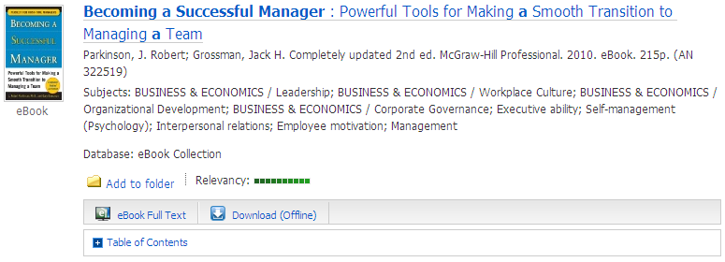

- If you are not signed in, you will be prompted to Sign In to My EBSCOhost.
- If you haven’t yet created a free account with EBSCOhost, you can do so by clicking on Create a new Account.
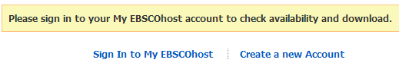

- After you sign in, a Checkout & Download window will appear. Select a Checkout period from the drop-down menu and click the Checkout & Download button.
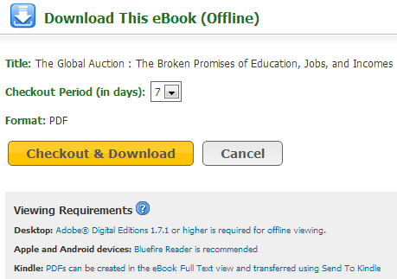

- The eBook is added to your My Checkouts folder which is accessible from the upper-right corner of the EBSCOhost screen. Click on My Checkouts.

- When the My Folder: Checkouts screen appears, click on Download (Offline).
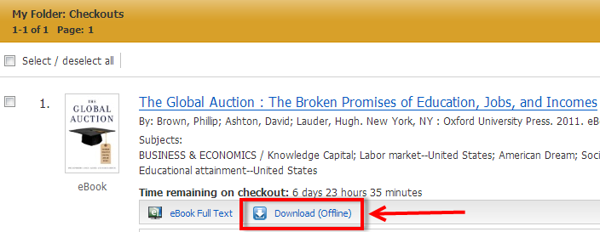

- When the Download This eBook (Offline) window appears, click on the Download button.
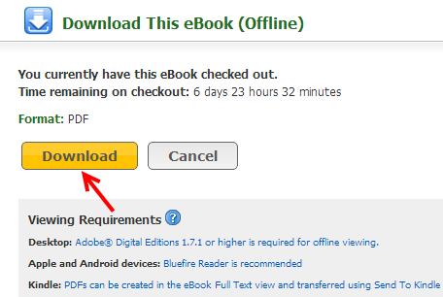
- Depending on what Internet browser you are using, you will be prompted to open or save this eBook.
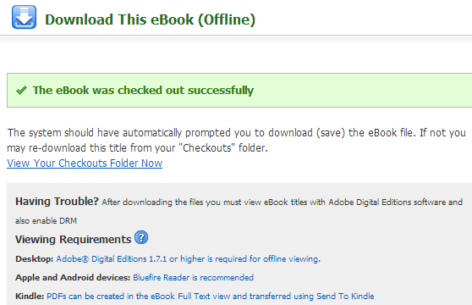

- If you are accessing the downloaded eBook on your home computer or laptop that has Adobe Digital Editions installed, below is a screenshot of how it will display.
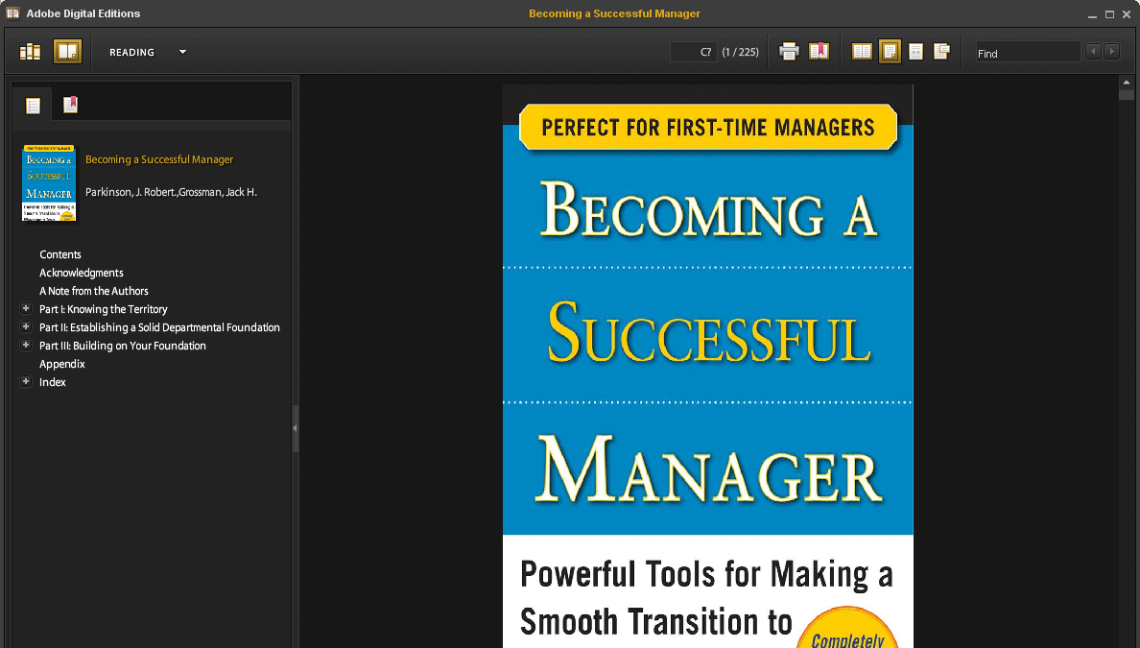

Additional Help
- If you need additional assistance in using the eBook collection, check with a Reference Desk librarian at any Reynolds campus library.
- You can also check out EBSCOhost’s eBook support site at: http://support.ebsco.com/ebooks

