 | Using the EBSCOhost eBook Collection Worksheet | 

- Go to the library’s home page at http://library.reynolds.edu
- When the library’s home page appears, click on > More Databases from the Popular Databases menu on the left.
- When the A-Z Resource List appears, click on the letter E tab near the top of the screen.
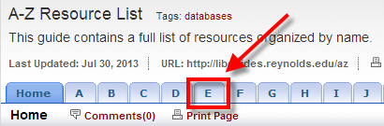
- When the list of databases that begin with E appear, click on eBooks on EBSCOhost.

- When the eBook Collection main search page appears, find a book on any topic by: performing a keyword search using the search windows - or- selecting a book from the Browse by Category, Highlights or Featured eBooks menus.
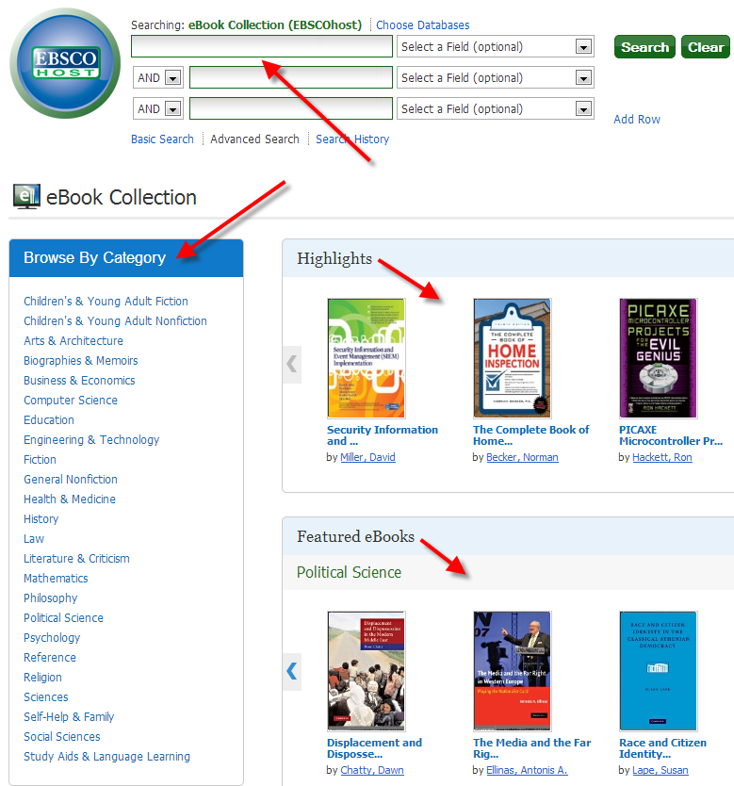

- Select any book from your results by clicking on the title.

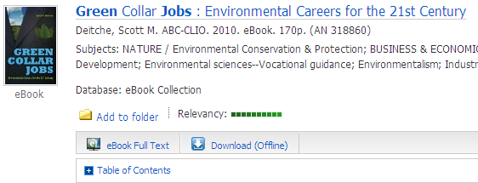

- When the Detailed Record for the book appears, click on the eBook Full Text link from the menu on the left to view the book in the eBook Viewer.

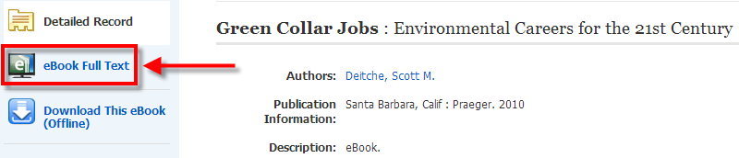

- When the book appears in the eBook Viewer, enter the number 1 in the Page Navigation box and click on Go to navigate to page 1 of the book.

- When page 1 of the book appears, click on the Printer icon from the Tools menu on the right. When the Print PDF window appears, leave Current page selected and click on the Print PDF button. Attach page 1 of this eBook to this worksheet.

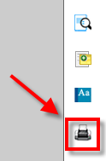 | 