

Evaluating Information
Sources Worksheet

Choose a topic to research. Write some search terms that describe your topic.
Search Terms:
- Google
- Using the search terms you listed above to perform a search using Google at http://www.google.com.
- Select one web site from your Google results to evaluate and provide the following information:
Name of web site:
URL address – http://
- Use the criteria below to evaluate this web site:
- Author/Authority? Who is the author or sponsoring organization of this web site? What makes the author an expert in the field written about? What credentials does the author or organization have? Is there any contact information listed for the author or organization?

- Bias? Why was the work written? Does the author or sponsor have an agenda? Is there an About link? What type of site is it: .com, .gov, .org, .edu? Who is the target audience? Is the information intended to inform, explain, sell, promote, or persuade?

- Content/Currency When was the web site last updated? Is the information up-to-date enough for my topic? Is the information general or comprehensive? Is it relevant to my topic? For what type of audience is the web site written? If there is an issue, are both sides presented?

- Design Is the website user-friendly? What kinds of images are used? Is the navigation menu well-labeled? Are there spelling or grammar errors? Do the pages appear uncluttered? Are there ads or pop-ups on the page? Are links working?

- Would you use this web site for a college level research assignment or paper?
Yes No
- Print and attach the 1st page of this web site to this worksheet.

- Academic Search Complete Database
- Go to the library homepage: http://library.reynolds.edu. From the Popular Databases menu on the left, click on Academic Search Complete. If you are off-campus, you will see a login screen. Type your – My Reynolds (Blackboard) username and password to login.
- In the Academic Search Complete search box, type in the SAME terms you used for your Google search. Check the Full Text box under the Limit your results. Press <Enter> or click on Search.
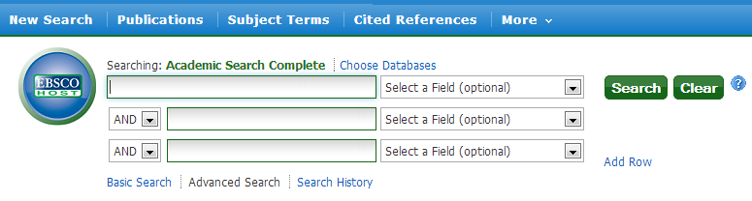
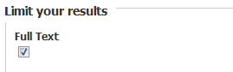
4. From the results, select one article to evaluate. Complete the information below:
Author’s name (if available): ___________________________________________________________
Article title:
5. Use the criteria below to evaluate this web site:
Author/Authority? Who is the author or sponsoring organization? What credentials does the author or organization have? Is there any information listed for the author or organization?
________________________________________________________________________________
________________________________________________________________________________
Bias? Why was the work written? Does the author or sponsor have an agenda? Who is the target audience? Is the information intended to inform, explain, sell, promote, or persuade? If there is an issue, are both sides of the issue presented?
________________________________________________________________________________
_____________________________________________________________________________________
Content/Currency When was the article published? Is the information up-to-date enough? Is it relevant to my topic? Is the information general or comprehensive? What reading level is the article? Are there references or works cited?
_ ______________________________________________________________________________
______________________________________________________________________________

Design Is the article well organized? Are there images? Are there spelling or grammar errors? Do the pages appear uncluttered? Are there ads on the page?
______________________________________________________________________________
______________________________________________________________________________

Would you use this article for a college level research assignment or paper? Yes ____ No_____
6. Print and attach the 1st page of this article to this worksheet.

