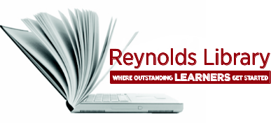 | Finding Books from Other  Libraries Worksheet | 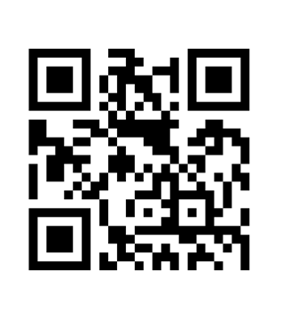

If Reynolds Library does not have particular books in its collections, books can be borrowed from other libraries via our RALC Agreement (Richmond Academic Library Consortium) or our Interlibrary Loan Service.

Search WorldCat:
- From the Library home page, click on the Area Libraries link under the QuickSearch box.
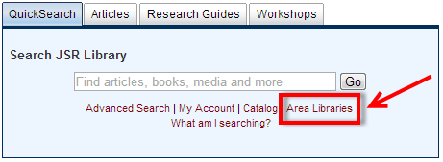
- When the next screen appears, click on the WorldCat link.
- When the WorldCat search screen appears, click on the Books tab then type a title, author, or keywords that describe a topic in the search window. Press the <Enter> key or click on the WorldCat Search books button to execute the search.
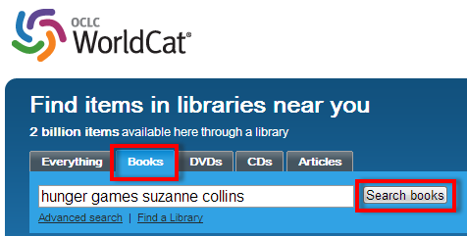
- When the WorldCat search results screen appears, scroll down to review your results.
- Click on any title.

Last updated 3/31/14 - dw OVER

- When the full record appears, fill in the following information:
a. Title:
b. Author/s (if available):
c. Publisher information including year published:

- Enter your zip code in the Enter your location box (may need to scroll down). Press the <Enter> key or click on the Find libraries button to execute the search.

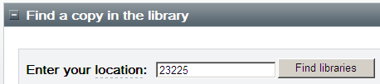

- When the list of libraries is redisplayed, fill in the nearest library below:

- Print out the 1st page of this full record and attach it to this worksheet.

