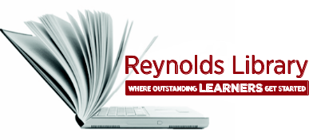 | How to Obtain a Full-Text  Article or Book | 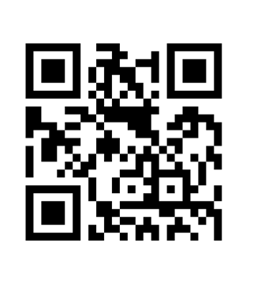

Obtaining Full-Text Articles:
If you would like to obtain the full text article from a journal, magazine or newspaper and have the citation (e.g., author, article title, periodical title, date, etc.), you can:
- Click on the Articles tab from the Library’s home page at http://library.reynolds.edu. When the Articles search box appears, click on Browse by Journal Title under the search box.
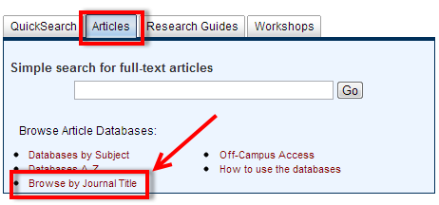

- When the Journal Locators screen appears, enter the name of the journal, magazine or newspaper. The results list will indicate whether the journal, magazine or newspaper is available online through any of the library’s databases or if it’s available in print in the library. Make sure to type in the name of the periodical title (e.g., Newsweek, Psychology Today) and NOT the article title. You can also go directly to http://library.reynolds.edu/find/journals.
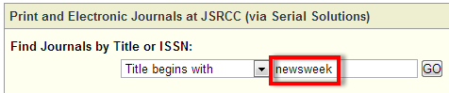

- If a periodical title is not available in print or online, you can fill out an online Interlibrary Loan Request form to see if we can obtain the article through another library. To access the online request form, click on Interlibrary Loan from the Library Services menu on the library’s home page. You can also go directly to the form at: http://library.reynolds.edu/services/forms/ill. Please be aware it takes about a week to obtain your request through ILL.
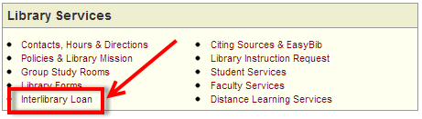

Obtaining Books:
If you would like to borrow a book from another library and have the citation (e.g., author, title, etc.) you can:
- First check to see if Reynolds Library owns the book. Go to the library’s home at http://library.reynolds.edu and enter your search terms in the QuickSearch box.
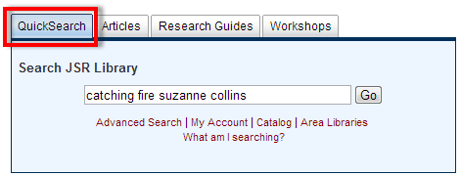
- If Reynolds Library does not own the book, you can check to see if any local libraries own the book by searching their catalogs. Click on the Area Libraries link under the QuickSearch box. When the next screen appears, you can click on WorldCat to find area public and academic libraries that own a particular book. A reference librarian will also be happy to assist you in identifying a close-by library that owns the book.
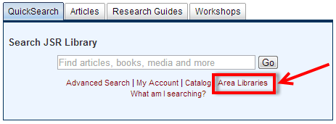
- If the book you want is available through an academic library in Richmond (e.g., VCU, UR), come to the reference desk at any of the three Reynolds campus libraries to get a RALC (Richmond Academic Library Consortium) Pass. This pass will entitle you to personally visit a RALC member library to check out books. You will also need your Reynolds student ID. The RALC web site which lists member libraries is located at: http://library.reynolds.edu/ralc/members.
- If you cannot go in person to check out books from a RALC member library - or - there are no RALC member libraries that own the book, you can fill out an Interlibrary Loan (ILL) Request form by clicking on Interlibrary Loan from the Library Services menu on the library’s home page. You can also go directly to the form at: http://library.reynolds.edu/services/forms/ill. Please be aware it takes about a week to obtain your request through ILL. You may also want to search WorldCat for a list of available libraries that own the book and to verify that you have the correct citation.

