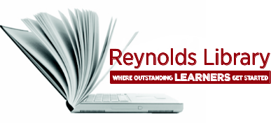 | Introduction to  Library Services | 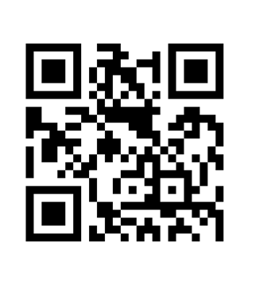
Library’s Web Site
    - http://library.reynolds.edu
    - Access over 180 research databases that provide the full-text of online journal, magazine, and newspaper articles as well as eBooks and videos.
    - Access QuickSearch to find out what books (audio, online, & print) as well as videos (DVD & online) are available at all 3 campus libraries.

Library’s Collections
- Over 90,000 print books including Bestseller, Career, ESL, & Juvenile books.
- Over 40,000 eBooks.
- Over 500 print journals, magazines and newspapers.
- Over 180 research databases provide access to millions of online journals, magazine & newspaper articles as well as thousands of eBooks and videos.
- Over 12,000 videos (educational - DVD & online; popular - DVD)
- Over 1,700 audio books (CD & online)

Use the Library From Home
- Go to library’s web site and use your My Reynolds login to access over 180 research databases from your home computer or any Internet-accessible computer outside campus to search and retrieve the full-text of online journal, magazine, and newspaper articles as well as eBooks and videos.

Library Computers & Wireless Access
    - Computers at all 3 campus libraries provide access to the Internet; My Reynolds services – Blackboard, and Email; and MS Office (Word, PowerPoint, Excel, Access).
    - You can also bring your laptop or other mobile device. All 3 campuses have Internet access via our wireless network.

Need Help with Your Research Assignment?
- Stop by the Reference Desk to receive personalized, one-on-one, expert assistance in finding, evaluating, and citing resources for your upcoming research paper or project.
- If you need in-depth assistance (30-60 minutes), you can also schedule a free research consultation appointment with a Reference Librarian.
- Our LibGuides web site, located at http://libguides.reynolds.edu, offers a wide variety of subject guides that include links to relevant books, article databases, and credible web sites. These guides serve as an excellent starting point for your research needs and will save you valuable time and frustration in finding appropriate resources for your assignments.

Research Workshops
- Register online for a free library workshop by clicking on the Workshops tab from the library’s home page. A variety of workshops are offered every semester at all three campuses.
- Ask your instructor if you can receive extra credit for attending a workshop. If you are enrolled in SDV-100, attending a library workshop counts as one of your required activity assignments.

Circulation Desk
- Check out, renew, and return books and other library materials; check out reserve materials; inquire about loan periods. Standard check out period for books is 4 weeks. You can have up to 15 books checked out at a time.

Borrowing Material
  - Your Reynolds Student ID serves as your library borrower’s card. Students that do not have a student ID are strongly encouraged to obtain their ID to borrow library material. Circulating materials include books, educational DVDs/videos and popular DVDs.

In-Library Use Material
- Print reference books, magazines, newspapers, and reserve materials can be used in the library only.

Borrowing From Other Libraries
- Students may borrow materials from other libraries in the area, state, or region if material is unavailable or insufficient at Reynolds Library.
- Students can go directly to several academic libraries in the area that have cooperative borrowing arrangements with Reynolds Library. Check with the Reference Desk FIRST about participating libraries, policies, and a RALC pass (Richmond Academic Library Cooperative). Students must have a valid Reynolds Library card and no outstanding fines or overdue material.
- Materials can also be requested through Interlibrary Loan. To request material, fill out an Interlibrary Loan Request form from the library’s web site or the Reference Desk.

Study Areas
- You are welcome to study on your own or in groups at our tables or carrels at all 3 campus libraries. Please help to keep the noise level down.
- Group study rooms are available on a “first come, first serve” basis at both the Downtown and Parham Road Campus Libraries. Call 523-5211 (DTC) or 523-5220 (PRC) for more information.

Printing, Copying, & Scanning
- Printing and copying - $.05 per page / Scanning to USB drive (DTC & PRC) - Free
- Libraries and Academic Computing Centers at all three campus libraries have an automatic pay for print system. There is an Equitrac Pay Station located at each campus Library and Academic Computing Center.
- You will need to bring at least two one-dollar bills with you to pay for print and copy jobs on campus. The 1st dollar pays for the card itself and the 2nd dollar will add cash value to the card.
- The Equitrac Pay Station accepts cash only - $1 and $5 dollar bills (no coins, credit/debit cards). The pay station does not give change. Library staff will be happy to assist you.

Ask a Librarian
- Please contact us for more information on any of our services or resources. Our librarians will be more than happy to answer your questions and assist you in locating items or information, provide guidance in researching a topic, or assist you in using any of the print or electronic resources in the library.
- Come in person to the Reference Desk.
- Call the Reference Desk: Downtown: 523-5333; Parham Road: 523-5329; Goochland: 523-5419
- E-mail – Fill out an online form.
- Chat Reference Service (LRC Live) – chat directly with a librarian.

