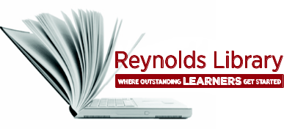 | Introduction to Library  Services Worksheet | 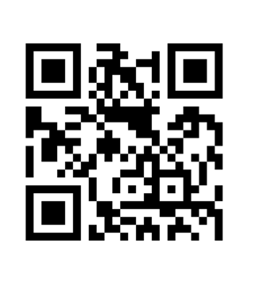

Review the information from the handout, Introduction to Library Services, and answer the following questions:
- Your Reynolds Student ID also serves as your .

- Books may be checked out for weeks.

- You may borrow up to books at any one time.

- Reserve materials, reference books, magazines and newspapers can be used in the library only. (Check one)
True False

- Use to find out what books are available at all three campus libraries.

- Use to find full-text online articles.

- To access library resources from off-campus use your login.

- You may bring your laptop and access library resources via our .
- Students can attend a free to help improve your: research skills, grades, overall academic achievement, and lifelong learning.

- If a specific book is unavailable at Reynolds Library or if the library does not have sufficient material on a particular topic, students can get a at the Reference Desk so they can go in person to several academic libraries in the area that have cooperative borrowing arrangements with Reynolds Library.

- If a student needs in-depth assistance (30-60 minutes), they can schedule a
with a Reynolds reference librarian.

- Students can ask for assistance from a librarian via (Check all that apply):

In person at the Reference Desk
Calling the Reference Desk
Email
Chat Reference Service

- The library’s web site address is .

