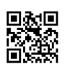

Citing MLA Style Worksheet

Use the sources to create a works cited page in MLA style. Remember to organize sources alphabetically and use hanging indents.

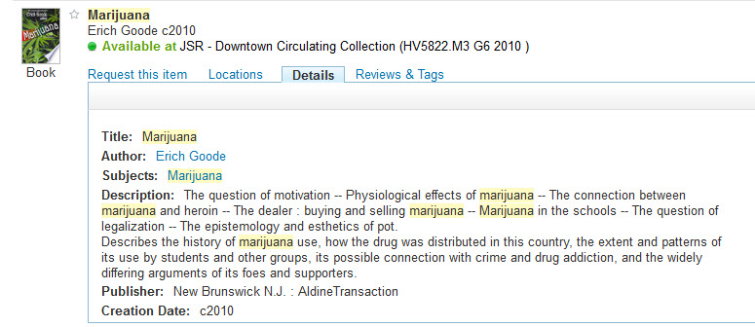
Print Book by 1 author - Record from QuickSearch.

News Article from a Web Site.

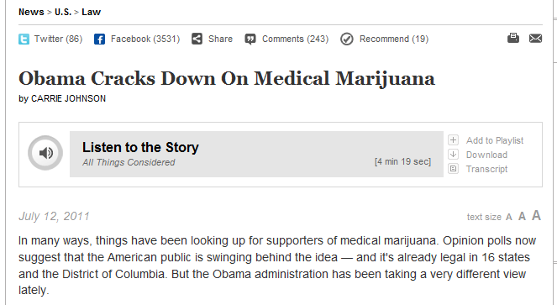


Online Journal Articles Retrieved from a Library Database with One Author.
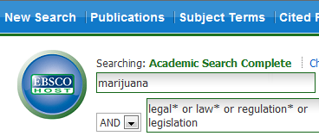

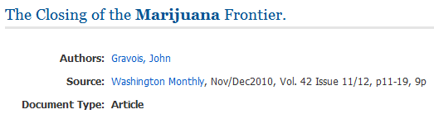

Online Journal Articles Retrieved from a Library Database with Several Authors.
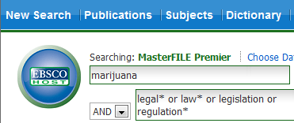

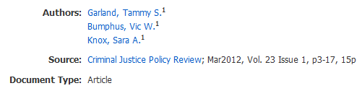
Note* Do not include the month or season (e.g., March, Spring) when citing a scholarly journal article in MLA style.

Works Cited

