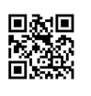
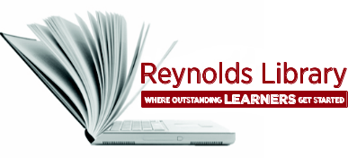
Off-Campus Access to
Library Resources Worksheet

- From your home computer or any Internet-accessible computer off-campus, go to
J. Sargeant Reynolds homepage: www.reynolds.edu.
- Click on the MyJSRCC link.
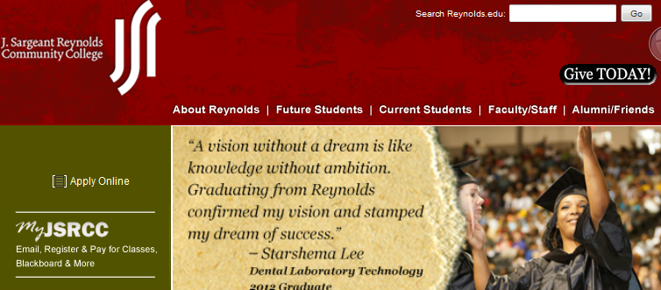
- When the login screen appears, type in your MyJSRCC username and password.
- Under My Tools. Click on Library Services.
- In the QuickSearch box type in any topic and click the search button.
- The search results screen will appear. On the left hand side of the page under Limit My Results To: choose Articles.
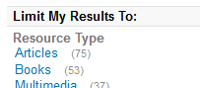

- The results are now limited to articles. Choose an article with the words Available Online.
- Click on the article title. This takes you to the database where the article is found. 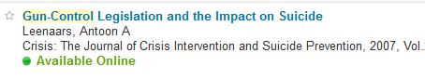
- Find and open the link to the full-text of the article. This link will vary according to the database where the article is located.

- Print the first page of the article. Attach it to this worksheet.
If you can’t access a database from off-campus, check the Frequently Asked Questions section of the Off-Campus Access: http://library.vccs.edu/reference/login.html.
For additional assistance, email: library@reference.edu or call: 371-3000 and ask for the
Computer Center Help Desk.

