 | Scholarly Journals vs.  Popular Magazines  Worksheet | 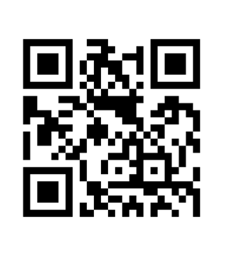

Part I
You will need to use the Academic Search Complete database to complete Parts I & II.
- From the Reynolds Library home page at http://library.reynolds.edu, click on Academic Search Complete from the Popular Databases menu on the left. If you are completing this worksheet from off-campus, a Virginia’s Community Colleges login screen will appear. Use your – My Reynolds (Blackboard) username & password to access the Academic Search Complete database.
- When the Academic Search Complete Advanced Search screen appears, click on the Publications link from the menu near the top of the screen.
- When the Publications screen appears, type american journal of public health in the Browsing: Academic Search Complete - Publications window. Press the <Enter> key or click on the Browse button to execute the search.
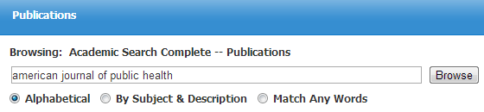

- When the next screen appears, click on the title, American Journal of Public Health.
- When the American Journal of Public Health screen appears, click on any recent year link (e.g., +2013, +2012). You will also need to select an issue for that year.
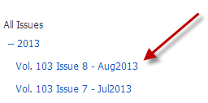

- When the results screen appears, review at least 5 articles from the issue and answer the questions on the next page under the American Journal of Public Health column.
- Perform a Publication Search for Better Nutrition using the same steps you used above. Answer the questions on the next page under the Better Nutrition column.

Last updated 3/31/14 - dw OVER

Part I - (continued)
Select the correct answer for each question for both American Journal of Public Health and Better Nutrition.
American Journal of Public Health  Most of the articles are: | Better Nutrition  Most of the articles are:
Lengthy - or - short articles? | Lengthy - or - short articles?
Author - or - No author  information is provided? | Author - or - No author  information is provided?
Written for scholarly - or - general audience? | Written for scholarly - or - general audience?
List of references - or - no references  at end of article? | List of references - or - no references  at end of article?
Scholarly journal - or - popular magazine? | Scholarly journal - or - popular magazine?

Part II
- Using the Academic Search Complete database, perform any type of search on any topic.
- When the search results screen appears, review the results and select two articles - one scholarly & one popular.
- Print out the 1st page of each article and note whether the article comes from a scholarly journal or popular magazine on the top of each article.
- Attach both pages to this worksheet.

Part III
Review the 2 article citations listed below. Select whether the citation comes from a scholarly journal or a popular magazine.

1. Jagodozinki, Jan. “The Perversity of Reality TV: A Symptom of Our Times.” Journal for the
Psychoanalysis of Culture & Society 8.2 (Fall 2013): p320 (12 pages - 7288 words)
scholarly journal - or - popular magazine

- Zeitchik, Steven. “Back to Reality: You’ve Seen Her Rockin’ Reality Show on MTV. But Could
Cheyenne’s Real Life Be Even Better?” Daily Variety Sep. 18, 2013: 19 (1 page - 291 words)
scholarly journal - or - popular magazine

