

Online Search Techniques

Below are techniques to help you find relevant results when using library databases and when using search engines (e.g., Google or Yahoo).

Identify Keywords
Create a list of keywords associated with your topic; consider synonyms or variant spellings. Use this list to help narrow search terms. Write them down and keep them with you throughout the research process.
Write down your topic: Does television viewing encourage aggressive behavior in children?
Write down the important words from your topic: television, aggressive, behavior, children.
Write down synonyms or related words from your list: television, T.V.; aggressive, fighting, hostile, angry; behavior, action, attitude; children, kids, tweens, teens, etc.
Now you have generated a useful list of keywords for finding resources!
Simple search: television AND aggressive behavior AND children

Exact Phrase Searching
To look for an exact phrase, type your phrase within quotation marks (" "). The results will contain the exact words in the quotation marks.
Example: “attention deficit disorder”

Truncation to Expand Your Search
Using an asterisk (*) or question mark (?) at the end of a root word (known as truncation or stemming), allows you to retrieve results containing any form of the root word.
Example: typing teen* will find teen, teens, teenage, teenager, teenagers

Note:
Most databases, such as the Library Catalog, Academic Search Complete and Factiva, use the asterisk (*) as the truncation symbol. Check the Help screen of the database you are using for the truncation symbol.

Some search engines, such as Yahoo, automatically search for all forms of a keyword (e.g., teenager will automatically find: teen, teens, teenage, teenager, teenagers).

Boolean Operators to Narrow or Broaden Your Search
Boolean searching is based on connecting keywords with three basic operators: AND, OR and NOT.
AND  The database or search engine will only retrieve those articles or web pages that contain both words. This will NARROW your search and DECREASE search results.  Example: school AND crime | 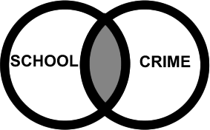
OR  The database or search engine will retrieve those articles or web pages that contain at least one of these words. This will BROADEN your search and INCREASE search results.  Example: baby OR infant | 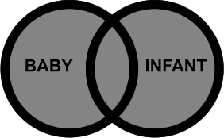
NOT  Type NOT before a keyword to exclude that word from your search. Use NOT when you are searching for a keyword that may have multiple meanings.  Example: bat NOT baseball | 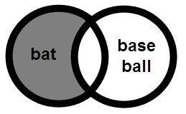
Combining Boolean Operators  Use parentheses ( ) to keep combination searches in order. In the example below, articles or web pages retrieved will contain the word law and at least one of the words in parentheses.  Example: law AND (ecstasy OR mdma) | 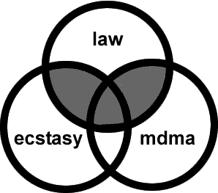

Still need help? Ask a librarian!
library.reynolds.edu

