 | Find Topic Ideas | 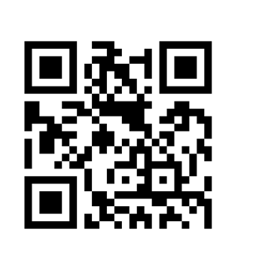

If you are having trouble selecting a topic for a research assignment, check out some of the sources listed below which will give you topic ideas and overviews that can help you formulate your thesis statement. You can also check out additional sources on our 1a - Find topic ideas & overviews page, part of our Research @ Reynolds Library LibGuide located at http://libguides.reynolds.edu/research.

- Library databases:
- CQ Researcher and Issues & Controversies - both databases provide a list of current social issues and objective overall reviews on specific issues.
- Opposing Viewpoints in Context – database provides argumentative essays that present both sides of controversial issues. Viewpoints articles can help you formulate your thesis statement.
- Gale Virtual Reference Library – database includes encyclopedias from the following subject areas: business, history, law, medicine, nation & world, science, social science.
- Today’s Science – database allows you to browse for topics from Need a Research Topic, Subject Index, and Hot Topics menus.

- Open sources on the Internet:
- Hot Topics for Research Papers and Speeches – Northwest Missouri State University Library: http://www.nwmissouri.edu/library/courses/english2/termindex.htm
- Idea Generator - Old Dominion University Libraries
http://www.lib.odu.edu/researchassistance/ideagenerator/
- Pros and Cons of Controversial Issues:
http://www.procon.org/

Browse print book titles and records using QuickSearch:
- Check out our Compact Research, Current Controversies, and Opposing Viewpoints series of books. Use the QuickSearch box from the library’s home page and type the series title within quotations (e.g., “compact research” “current controversies” “opposing viewpoints”). When the result list appears, select “Available in the Library.” Then browse through the search results for topic ideas.

Print Encyclopedias:
Browse encyclopedias in the reference section for topic ideas. Here is just a sampling of titles on our reference shelves:
  - Addiction: A Reference Encyclopedia [PRC Ref - HV5825 .P26 2010]
  - Encyclopedia of American Business [PRC Ref - HF3021 .E53 2011]
  - Encyclopedia of American Law & Criminal Justice [DTC & PRC Ref - KF154 .E528 2012]
  - The Gale Encyclopedia of Mental Health [DTC Ref - RC437 .G36 2012]

Textbooks:
Also browse your textbook chapters for topic ideas.

