 | Types of Information Sources  Worksheet | 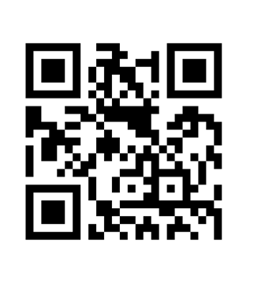

Review the corresponding Types of Sources handout - OR - the Information Sources Table available from the 2b – Information sources - comparison web page from the Research @ Reynolds Library LibGuide at: http://libguides.reynolds.edu/research. Match each Source with its Use by placing the appropriate letter next to each Source.
Source:
1. World Wide Web
2. Newspaper
3. Primary Source
4. Journal
5. Government Source
6. Reference Book
7. Magazine
8. Secondary Source
9. Circulating Book

When to use:
- Need statistics or information from a state or local government department.
- Need a scholarly article on original research or additional references that point to other relevant research on a particular topic.
- Need a brief overview or background information on a topic you are not familiar with.
- Need an article on a popular or recent topic written for a general audience.
- Need an in-depth treatment of a topic that can be checked out of the library.
- Need an up-to-date local news article.
- Need a first hand account of a specific event or original research.
- Need the most current news, opinions on various issues, or company information.
- Need a second hand account of events.

