BOOK
DISCUSSION
SERIES

J. Sargeant Reynolds Community College Presents A Free Public Forum:

Around the World through Books

Parham Road Campus - The Gallery
Thursday, April 20, 2006

1651 E. Parham Road, Building B—Room 101
(7 p.m. – 8:30 p.m.)

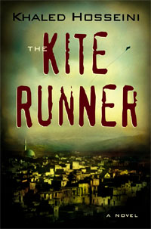

Discussion Leader: Shahwali Arezo

For more information, call
Randy Pittman @ (804) 523-5499, or
Hong Wu @ (804) 523-5329

Or visit: http://www.reynolds.edu/library/bookdiscussion/200506.htm

