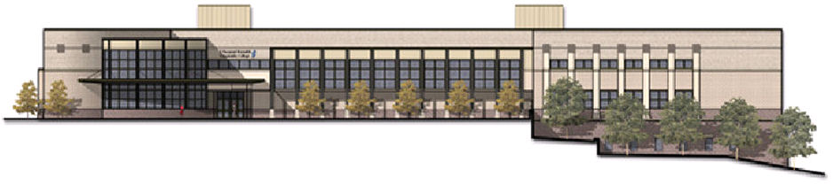
Group Study Rooms in the Massey Library Technology Center
The Library Technology Center on the Parham Road Campus has eight group study rooms, each of which can accommodate six to eight people. All study rooms are equipped with wireless Internet access, white boards, and wall-mounted flat-panel display screens. College faculty, staff and students are welcomed to use the study rooms for academic and college-related activities, such as collaborative learning projects, small meetings, advising or tutoring sessions, etc. The following regulations are designed to provide fair access to the study rooms and to ensure responsible use.

- Group Study rooms are available for currently enrolled JSRCC students, faculty and staff in good standing with the library. A student, faculty or staff ID needs to be presented at the Lower Library Information Desk for obtaining the key to a group study room. Student IDs will be kept at the Information Desk until the key is returned.
- Group study rooms can be reserved by groups or individuals. However, groups of two or more students have priorities over individual users. Individual users will need to vacate the rooms for groups when no other group study rooms are available, unless the individual users have overriding justifications for special accommodations. Please notify the library staff if you have Special Accommodation Needs and provide a copy of your ANF form to the Library staff at the front desk. Individual users can only reserve the Group Study Rooms on a walk-in basis. They may not reserve the rooms in advance.
- Group study rooms can be reserved for academic and college-related activities only. Rooms may not be booked for business or personal use.
- Group study rooms can be reserved through the web (http://teach.reynolds.edu/library/StudyRoomReservation.htm), on the phone at (804)-523-5220 or in person at the Library Circulation Desk or Library Information Desk.
- Rooms should not be used for regularly recurring classes or meetings (for example, a meeting that occurs every Tuesday at 10 a.m.)
- Rooms not used within 15 minutes of the reserved start-time will be considered vacant and may be made available to others on a first-come, first-served basis.
- Reservations by a single group are limited to two hours per day with renewals at the information desk, if there are no other requests for use. Rooms should be locked and room keys returned by the end of the two-hour period. Rooms must be left in clean condition.
- Basic instruction sheets for using the equipment will be kept in each group study room. Equipment that is not working should be reported to the library staff, but the library staff cannot provide operators for the equipment.
- Users must keep the group study room’s door unlocked with the lights on at all times. No covering is allowed on the room’s glass windows.
- Users engaged in inappropriate or disruptive behavior violating the college’s Learning Environment principles will be asked to vacate the room and will be liable for any damage done to the room or equipment.
- All study room should be vacant and keys returned to the Library Information Desk no later than 15 minutes before the library closes.

Enforcement:
- Library employees are authorized to remove users from a group study room for any violation of these policies and may contact Campus Police if necessary to handle disruptive students.

