Follow the steps below for registering again for a Learning Express Library account:

1. Go to the Reynolds Library home page at <http://library.reynolds.edu> and click on **A to Z Databases** from the Quick Search box.

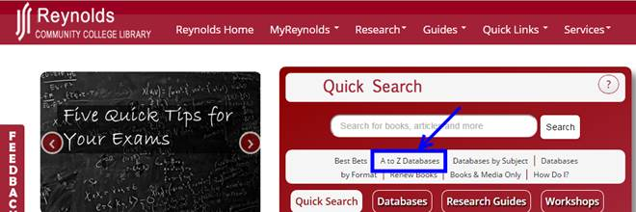

1. When the *Databases A to Z* page appears, click on the letter – **L**.

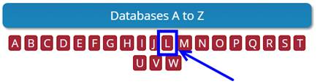

1. When the list of databases that begin with L appear, click on **Learning Express Library**.

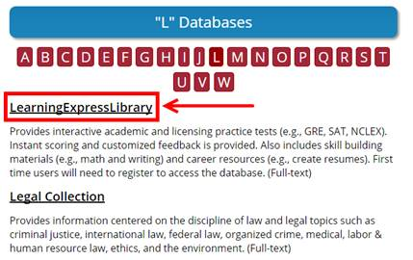

1. If you are accessing this database from off-campus, you will get a *Virginia’s Community Colleges* login screen next.  Login with your **My Reynolds username and Password**.

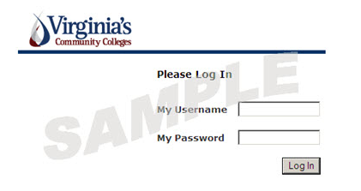

1. When the *Learning Express Library* main page appears, click on either **Register** link located near the top and bottom right of the screen.

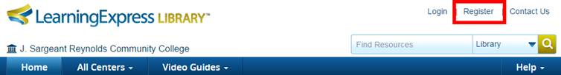

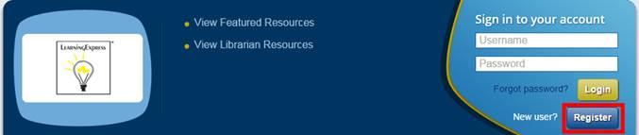

1. When the *Create your account* window appears, fill in the boxes for – **First Name**, **Last Name**, **Email**, **Confirm Email**, **Password**, and **Re-enter Password** (you do not need to enter a student ID # or course section #).  Then click on the **Create Account** button.

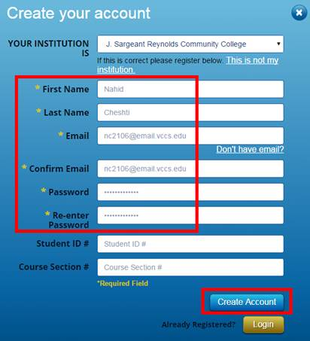

By Denise Woetzel 05.06.15