

**Off-Campus Access to Library Resources**

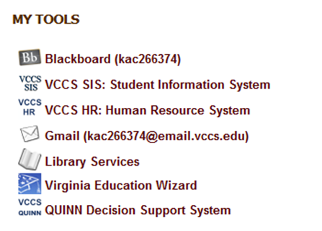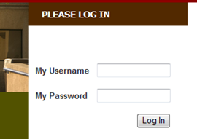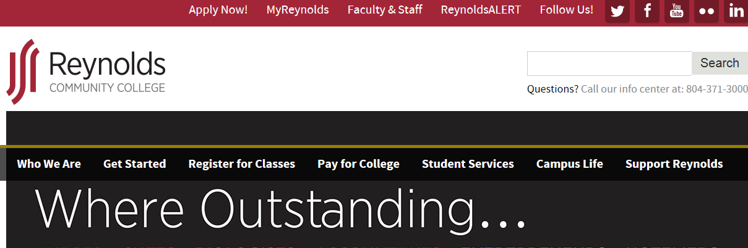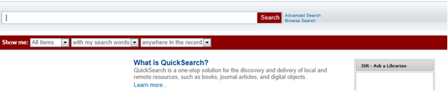**Don’t have time to stop by the library? We’ll come to you!** Reynolds Library provides access to over 40,000 eBooks, 180 research databases with full-text journal, magazine, and newspaper articles, as well as, online movies and audiobooks! You can access these resources off campus with an Internet connection. 

**Click on Library Services link.**

**Login to your MyReynolds account.**

**Type in your keywords and click search!**

**Click on the MyReynolds link link.**

**Go to: *www.reynolds.edu***