**From:** Mohammad Ikhlaque Ansari   
**Sent:** 20 June 2019 13:30  
**To:** Citrakalpa, S. (Swamy) <[Swamy.Citrakalpa@ing.com](mailto:Swamy.Citrakalpa@ing.com)>; Dave, N. (Nishit) <[Nishit.Dave@ing.com](mailto:Nishit.Dave@ing.com)>; Ellens, S. (Sebastien) <[sebastien.ellens@ing.com](mailto:sebastien.ellens@ing.com)>; Gianesin, B. (Benedetto) <[benedetto.gianesin@ing.com](mailto:benedetto.gianesin@ing.com)>; Van Roeyen, T. (Tim) <[Tim.Van.Roeyen@ing.com](mailto:Tim.Van.Roeyen@ing.com)>  
**Cc:** Steenbrugge, I. (Ive) <[Ive.Steenbrugge@ing.com](mailto:Ive.Steenbrugge@ing.com)>  
**Subject:** RE: JavaTraining@ING-May2019

Hello Spartans,

Now it’s time to utilize all the java concept we have learned so far .

Now what you have to do is , just implement the below mentioned problem statement into java.

Step 1 :

* Create the user detail form as mentioned below

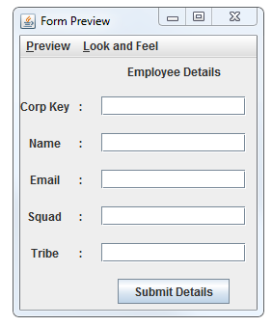

* Insert the values and Click on Submit

On Submit click inserted values must be saved in an Excel **EmployeeDetails.xlsx** , under the sheet **Employee Details**, as mentioned below

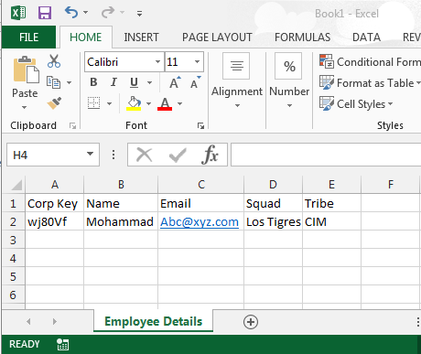

Step 2 :

* Create an employee **Search Employee** form as mentioned below in the same package
* Enter the Corp-Key of employee and click search
* On Search Button click read data from excel we have created earlier,  and show the data of that particular employee in **Search Employee**  as a table.

