HW #8

Bilal Gilani

11/24/2020

## 1.

### a.

x1 <- c(3, 2, 4, 1, 2, 4, 4)  
x2 <- c(4, 2, 4, 4, 1, 3, 1)  
  
colors = c("red", "red", "red", "red", "blue", "blue", "blue")  
  
plot(x1, x2, col = colors, xlim = c(0, 4), ylim = c(0, 4)) ## used the limits because it makes it cleaner, didnt like that it

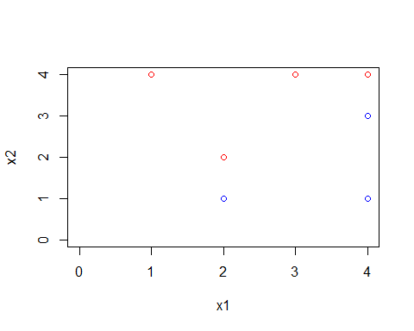

## originally went up by 0.5

### b.

plot(x1, x2, col = colors, xlim = c(0, 4), ylim = c(0, 4))  
abline(-0.5, 1)

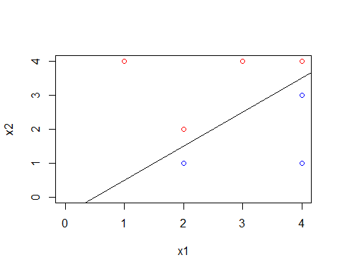 It appears that the points: (2,1) and (2,2) are on one end of where the optimal seperating hyperplane has to be, whereas on the other end the points are (4,3) and (4,4). By subtracting we find that the line must pass through the points (2,1.5) and (4,3.5). The resulting equation is $X_{1}−X_{2}−0.5=0$

### c.

The classifications are:

$ -0.5 + X_1 - X_2 > 0$ is **BLUE** $ -0.5 + X_1 - X_2 ≤ 0$ is **RED**

### d.

plot(x1, x2, col = colors, xlim = c(0, 4), ylim = c(0, 4))  
abline(-0.5, 1)  
abline(-1, 1, lty = 2)  
abline(0, 1, lty = 2)

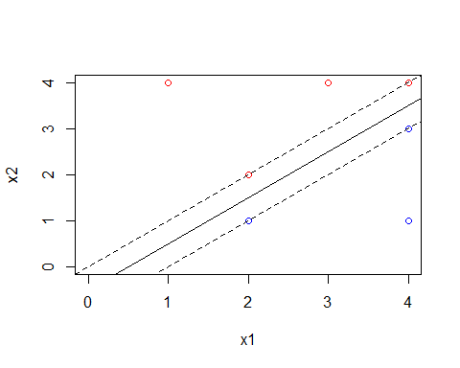

### e.

As previously mentioned, the points are: (2,1), (2,2), (4,3), and (4,4).

### f.

Moving the seventh observation/point (4,1) would not do anything to the hyperplane is it is not relevant to the hyperplane’s position. (4,1) is not a *supper vector* as indicated by the answer in part E.

### g.

plot(x1, x2, col = colors, xlim = c(0, 4), ylim = c(0, 4))  
abline(-0.75, 1)

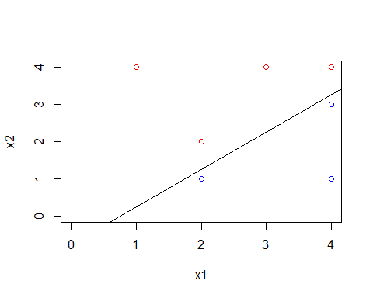 The equation for this hyperplane would be $X_{1}−X_{2}−0.75=0$.

### h.

plot(x1, x2, col = colors, xlim = c(0, 4), ylim = c(0, 4))  
points(c(3), c(1), col = c("red"))

