Exercise 2.1

Idea project diagram

Make a block diagram describing an embedded system you’d like to have or make. Be

imaginative. Reality does not apply here.

When you’re finished, upload your block diagram to the #assignment-submission channel on

Discord.

Due Date: November 28th, 2021 at 11:59pm PT

Brief Description

This is an imaginary embedded device to approximate the final location of a disc golf after being thrown. The system uses Bluetooth to get the initial location (lat/long) of where the disc was thrown from a cell phone app. An inertial measuring unit is used measure acceleration, angular velocity, and disc orientation which are then used to approximate the final location of the disc.

**Hardware Block Diagram**

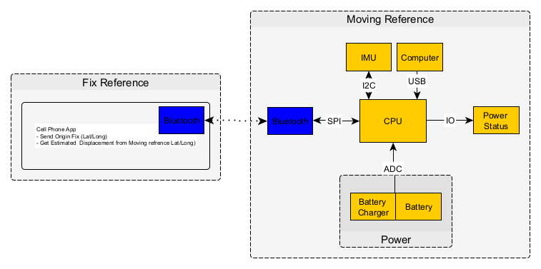

**Software Block Diagram**

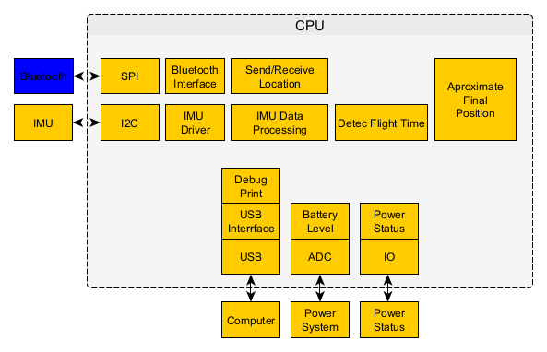

Exercise 2.2

Read mbed code, make diagram   
● Create a sign in and log into the mbed compiler   
● Go to mbed platforms https://os.mbed.com/platforms/   
● Select any platform (hint: search for a processor similar to the one you are considering   
for your final project)   
◆ Read through the platform page   
◆ Add to Mbed Compiler (button on right)   
◆ Load a simple sounding template   
◆ Create a block diagram for this program, briefly explain why you chose the platform   
and template you did, be prepared to talk about this board in Live Class   
When you’re finished, upload your block diagram to the #assignment-submission channel on   
Discord.   
Due Date: November 28th, 2021 at 11:59pm PT

**Reason for choosing:**

*For my final project I would like to use the STM32G4 Series of processors. I have some dev board and actual spare processor that I was planning to prototype with. The reason for choosing the NUCLEO-F410RB is because it was the only dev board with a template code. The other dev board I selected were showing blank template, or very complicated code.*

**Hardware Block Diagram**

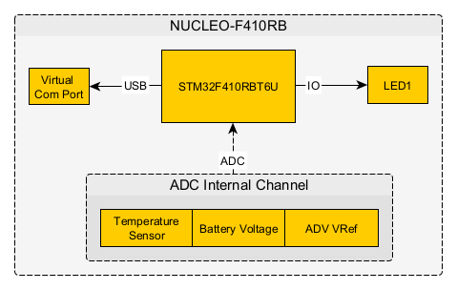

**Software Block Diagram**

