**Exercise 3**

**1. Investigate project board**

Look at the documents for the board you are considering for your final project (or any ST

Discovery Board), draw the hardware block diagram for the board. For peripherals, note the

communication paths (SPI, I2C, etc).

Look at the datasheet for the processor and other documents. Answer these questions:

● What kind of processor is it?

● How much Flash and RAM does it have? Any other memory types?

● Does it have any special peripherals? (List 3-5 that you noted as being interesting.)

● Does it have a floating point unit?

● If it has an ADC, what are the features?

Look at one application note for this processor.

Compile your answers into a google doc or markdown file, and send a link to the

#assignment-submission channel on Discord. Make sure the files are publicly viewable.

Also, be prepared to share what you learned in Live Class.

Due Date: before live class on December 11th, 2021 at 9:00am PT

Hardware Block Diagram

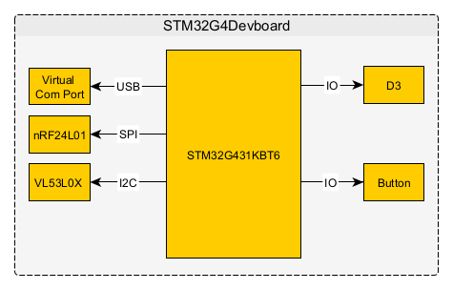

Look at the datasheet for the processor and other documents. Answer these questions:

**● What kind of processor is it?**

STM32G431KT6

**● How much Flash and RAM does it have? Any other memory types?**

Flash:32KB, Ram: 32KB

**● Does it have any special peripherals? (List 3-5 that you noted as being interesting.)**

- Three USARTs, one UART and one low-power UART.

- One FDCAN (Controller Area Network Flexible Data-Rate)

- One SAI (Serial Audio interface)

- UCPD –( USB Type-C™ /USB power delivery controller)

Mathematical hardware accelerators:

CORDIC for trigonometric functions acceleration

FMAC: filter mathematical accelerator

**● Does it have a floating-point unit?**

 The Cortex-M4 core features a single-precision floating-point unit (FPU), which supports all the Arm single-precision data-processing instructions and all the data types.

**● If it has an ADC, what are the features?**

2 x ADCs 0.25 µs (up to 23 channels). Resolution up to 16-bit with hardware oversampling, 0 to 3.6 V conversion range