

Exercise 8

Compile your project code so it prints out the heap pointer and the stack pointer. Print out a global variable address. If you can find it, modify your linker file to swap your uninitialized variables and initialized variables. Verify it is as expected in the memory map. See how that changes your code output.

Turn in your notes on what you found to Discord #assignment-submission by 9am on Jan 29th.

Note: there will be more detailed hints on how to do this as the week goes on. If you get stuck, look in the Discord #homework-help for a Hints thread.

1. prints out the heap pointer: heap addr: 0x20001418

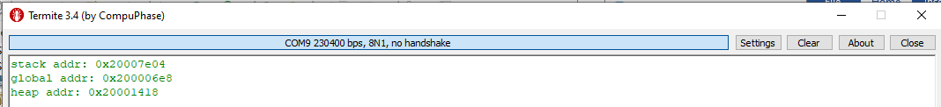

Debugger:

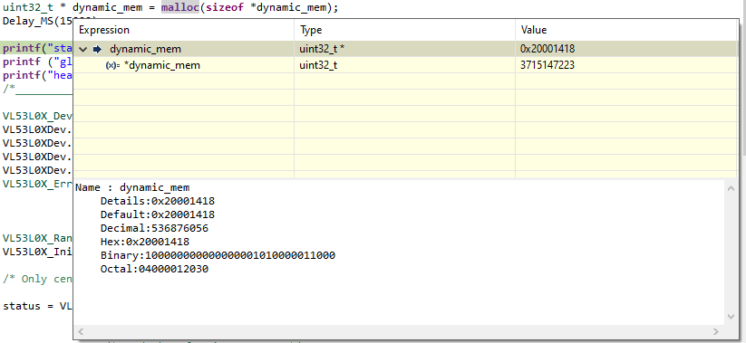

map file address:

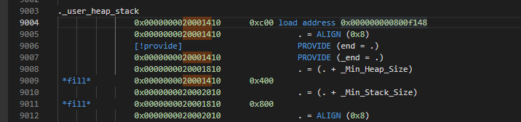

2. prints out the stack pointer: stack pointer address: 0x20007e04



Debugger:

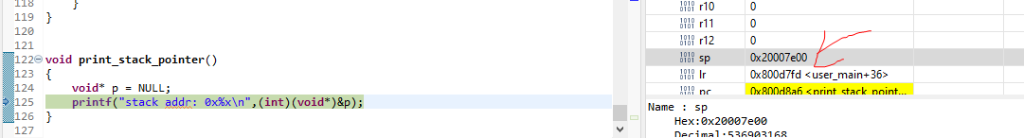

3. Print out a global variable address: global address 0x200006e8



Map file:

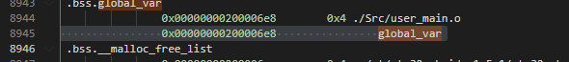

Debugger:

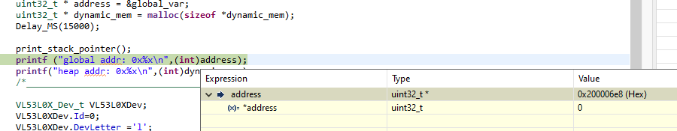

4. If you can find it, modify your linker file to swap your uninitialized variables and initialized variables.

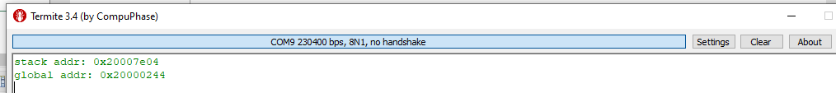

Before:



After modification:

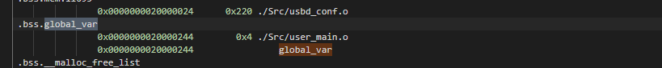

Debugger:

