**lqtmoment v0.1.* Python Package**

A fast, automated program for calculating moment magnitude using full P, SV, and SH energy components with rapid spectral fitting for improved accuracy and efficiency.

**Code Schematic and Flow Chart**

**Prepared by:**

Arham Zakki Edelo

edelo.arham@gmail.com

May, 2025

**Introduction and Overview**

*lqtmoment*is a Python package designed for moment magnitude calculations using pure P, SV, and SH components in the LQT ray coordinate system. It leverages rapid ray tracing to compute incidence angles for component rotation and employs fast spectral fitting to find optimal solution, ensuring high accuracy and efficient automated computation.By leveraging vectorized computing and advanced statistical methods—such as in implementing Shooting Snell’s Method for incidence angle estimation and Quasi-Monte Carlo techniques for spectral fitting—lqtmoment excels at calculating moment magnitudes for batches of earthquakes, handling hundreds to thousands of events in a single run.

*lqtmoment* is written in modern Python and is compatible with Python versions 3.9 through 3.12. It is operating system-independent, meaning it can run on Windows, macOS, and Linux.The program consists of three main components:

1. **catalog_builder** – for creating catalogs in the required format,
2. **magnitude_estimator** – for calculating moment magnitudes, and
3. **lqt_analysis** – for data analysis.

*lqtmoment* can be run via the command-line interface (CLI) or used as an API by importing the magnitude_estimator module in your own Python scripts.

For waveform processing, *lqtmoment* relies heavily on the ObsPy package, particularly for tasks such as reading waveforms, removing instrument response, trimming, filtering, and rotation. For scientific computations, especially in spectral fitting, it depends on SciPy and Scikit-Optimize.

*lqtmoment* was initially developed by Arham Zakki Edelo for earthquake data processing. The source code is intended to be open source, following the spirit of the Python community, and is released under the MIT License.

This package is open to contributions from the community and is intended to be further developed to become a more powerful and useful tool for solving geophysical problems especially in earthquake data processing.

**Package Structure**

The *lqtmoment* package was developed with the directory structure shown below. Within the **lqtmoment/**directory, there is a subdirectory **data/** that stores default configurations in case the user does not provide their own.

**src/**

**└── lqtmoment/**

**├── data/**

**│ ├── __init__.py**

**│ ├── config.ini**

**│ └── velocity_model.json**

**├── __init__.py**

**├── api.py**

**├── catalog_builder.py**

**├── config.py**

**├── fitting_spectral.py**

**├── lqt_analysis.py**

**├── main.py**

**├── plotting.py**

**├── processing.py**

**├── refraction.py**

**└── utils.py**

* **Directories and File Descriptions:**
* **lqtmoment/:** The root directory of the package, containing all modules and subdirectories
* **data/:** A subdirectory for storing default configurations and data files used by the package
  + - * **__init__.py:** Identifier of the **data/** directory as a part of Python package, enabling imports.
      * **config.ini:** A default configuration file in INI format, containing settings such as default parameters for seismic analysis (e.g., sampling rates, thresholds). Users can override these by providing their own configuration file during runtime.
      * **velocity_model.json:** A JSON file storing a default velocity model for seismic wave propagation, used in calculations if the user does not specify a custom model. It includes parameters like layer depths and wave velocities.
      * **__init__.py:** Initializes the *lqtmoment* package, making it importable. It includes package-level metadata (e.g., version) or import key modules for easier access.
      * **api.py:** Provides a high-level interface for interacting with the package. It exposes *magnitude_estimator* function for external users or scripts to perform core tasks (e.g., running a full moment magnitude calculation pipeline).
      * **catalog_builder.py:** Contains functionality to build accepted *lqtmoment* event catalogs format.
      * **config.py:** Handles configuration management, including parsing the **config.ini** file or user-provided configurations, and making settings accessible to other modules in the entire package.
      * **fitting_spectral.py:** Implements spectral fitting algorithms, this module handles advanced stochastic algorithms to find best solution for frequency corner, q factor, and omega zero flat level.
      * **lqt_analysis.py:** Transform *lqtmoment* formatted catalog to LqtAnalysis class instance, enabling user to interact with catalog data and perform data analysis instantly.
      * **main.py:** The entry point for running the *lqtmoment* package as a standalone application through command-line interface (CLI). It orchestrates the workflow, calling functions from other modules based on user inputs or configurations.
* **plotting.py:** It handles visualization tasks, such as generating plots for waveform data, spectral fits in moment magnitude calculation, and visualizing the results of Shooting Snell’s Method for determining the incidence angle.
* **processing.py:** It handles the core flow of the moment magnitude calculation, selecting the corresponding data from the entire dataset for each ID, and iteratively looping as the moment magnitude calculation progresses.
* **refraction.py:** An internal module that performs Shooting Snell’s method to find the optimal solution for the incidence angle of each phase that reaches the station.
* **utils.py:** A collection of utility functions used across the package, such as helper methods for file I/O, waveform treatment tools, and logging.

**Momen Magnitude Calculation Flowchart**

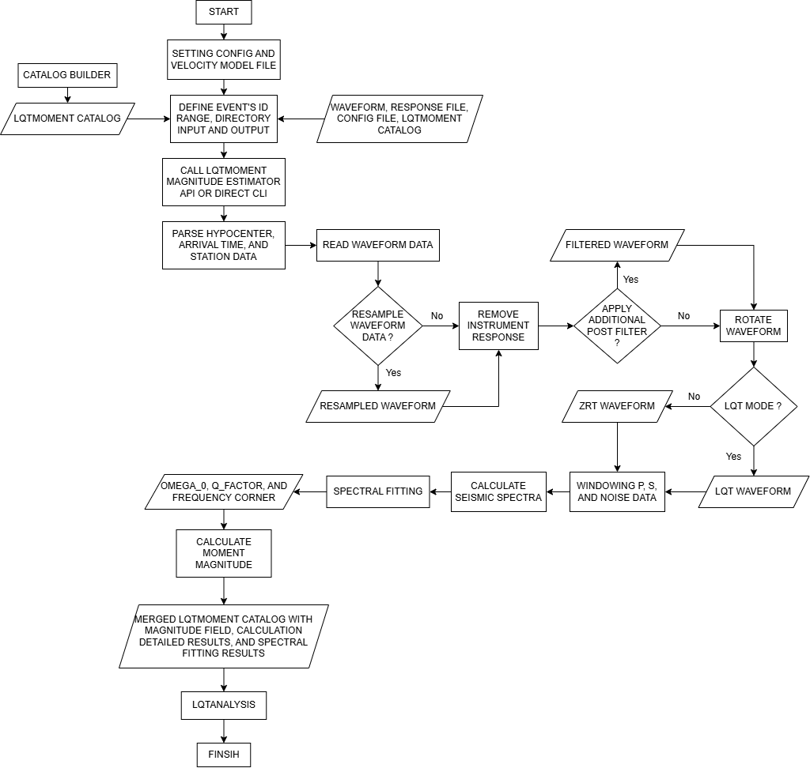

Figure 1 lqtmoment flowchart for moment magnitude calculation.

**Equations Used in Calculation**