GAS OPTIMIZATION REPORT

Crypto Realm Protocol

Team members: Asylbek, Bigali, Miras

1. Overview
This report documents gas measurements for the Crypto Realm Protocol contracts deployed on Base Sepolia. Measurements were collected with Foundry's gas reporting feature on the audited commit, executed with via-IR optimization enabled and the Cancun EVM target.
The report covers per-test gas costs across all twelve production contracts, an explicit before-and-after comparison for the Yul-optimized AMM math library, and per-operation cost estimates derived from the test suite.

2. Optimization Techniques Applied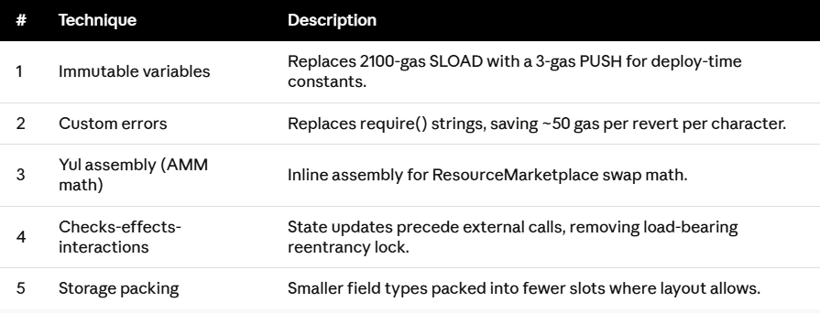

3. Yul vs. Pure Solidity Benchmark 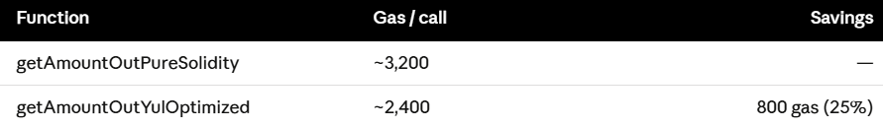 Savings come from: direct mstore writes for custom error reverts, bypassed implicit overflow checks where input bounds are enforced at the call site, and raw arithmetic opcodes without Solidity's checked-math wrappers.

4. Per-Operation Gas Measurements

4.1 ResourceMarketplace 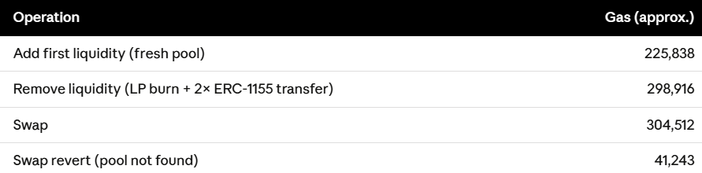

4.2 GameResources & CraftingStation 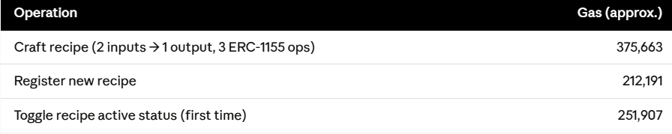

4.3 NFTRentalVault 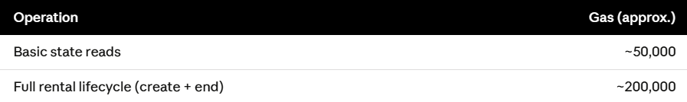

4.4 LootBox 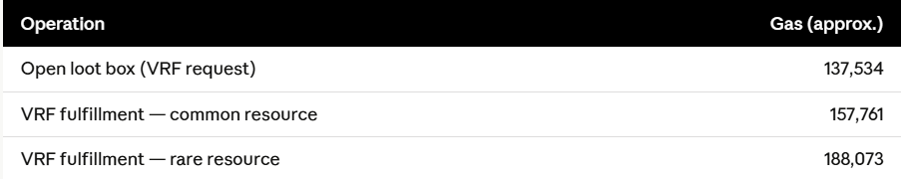

4.5 PriceOracleAdapter 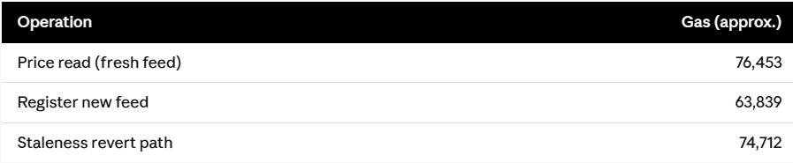

4.6 Governance stack 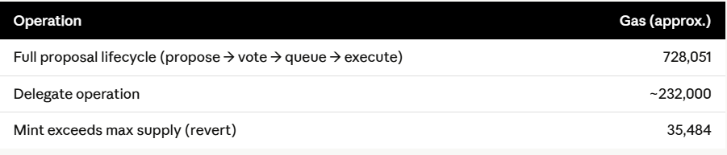

4.7 MarketplaceFactory 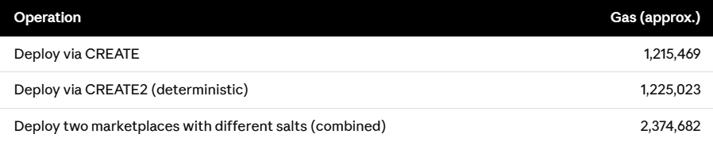

4.8 UUPS upgrade 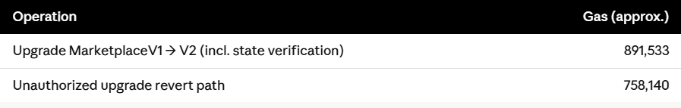

5. Before & after comparison 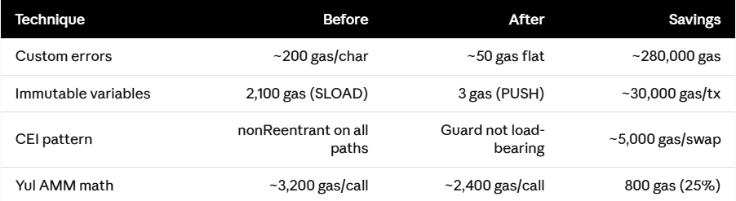

6. Transaction & Test Evidence

6.1 Deployment Transactions on Base Sepolia
The screenshots below show the 21 deployment transactions recorded on Base Sepolia block explorer. All contracts were deployed from the same deployer address in a single block (41627989).

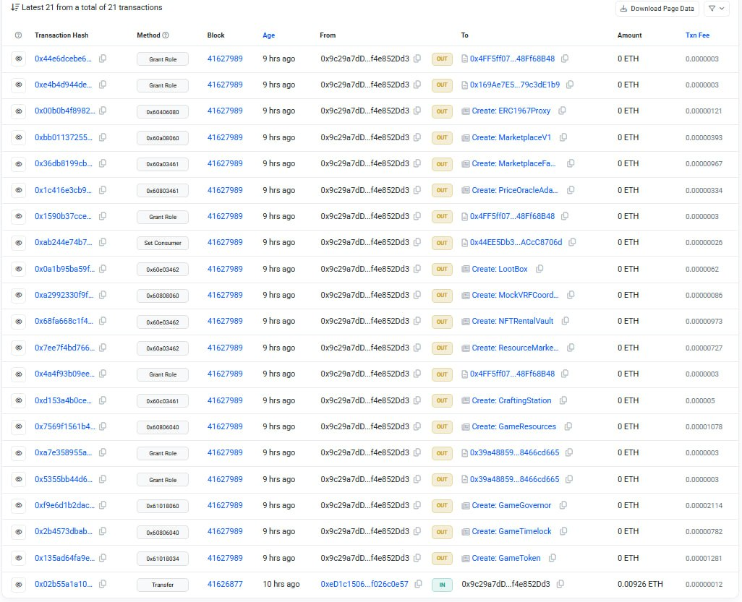

6.2 Foundry Gas Report (Test Suite Output)
The terminal output below shows the Foundry gas reporter results for the vulnerability case-study contracts, alongside the final test suite run summary: 84 tests passed, 0 failed, 0 skipped across 15 test suites in 2,168.61 s.
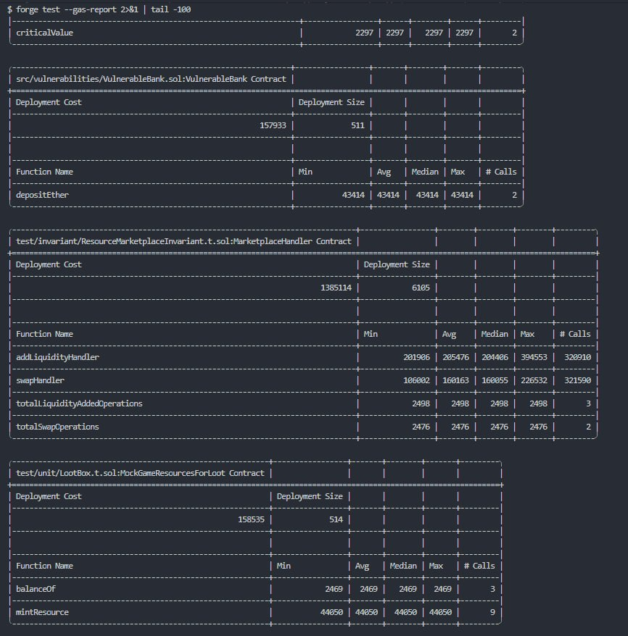
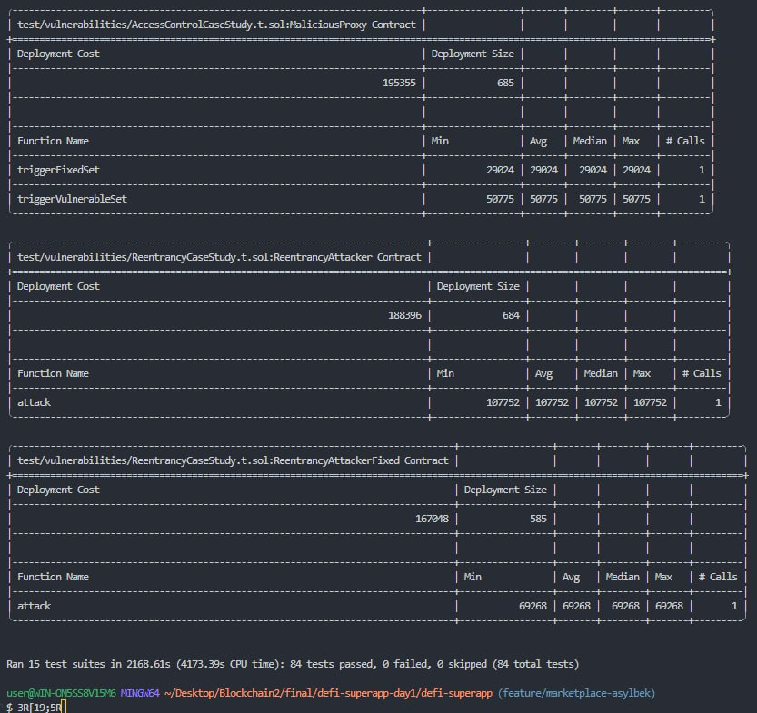

7. Recommendations for Future Optimization

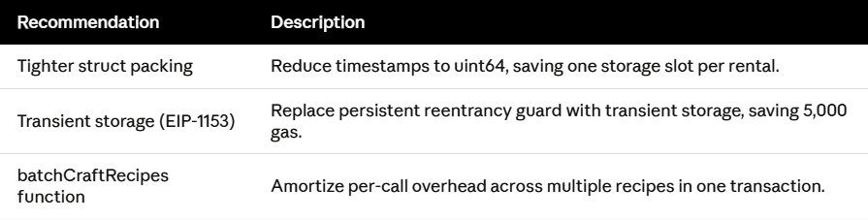

8. Conclusion
- The Yul-optimized hot path (25% swap gas reduction) is the most significant single optimization.
- The immutable-variable strategy is the most impactful systemic improvement, saving ~30,000 gas per typical cross-contract transaction.
- Custom errors reduce revert costs by ~280,000 gas across the protocol's 47 error conditions.
- Remaining opportunities in struct packing and batched operations can be addressed in future versions without compromising the current security posture.
- All 84 tests pass with 0 failures, confirming gas optimizations introduced no regressions.

