ASTANA IT UNIVERSITY
Assignment 4
Research Implementation, Data Analysis and Interpretation
Code Comprehension and Debugging Challenges in Prompt-Driven Software Development: The Relationship Between Reliance on Generative AI Assistants and Performance Among Novice Software Engineering Students
Students: Sagym Mukhammedzhan, Sarsenbek Beknazar, Nugmash Bigali
Group: SE-2427
Course: Research Methods and Tools

1. Final Research Question and Objectives
Research Question: How is the level of reliance on generative AI coding assistants related to code comprehension performance and debugging strategies among novice Software Engineering students?
Objectives. (1) Measure how often and in what ways novice students use AI assistants when writing and fixing code. (2) Assess code comprehension and debugging performance using short code-reading and bug-finding tasks. (3) Identify which debugging strategies students use. (4) Examine whether higher AI reliance is associated with differences in comprehension scores and debugging strategies.
The Research Question and the four objectives are unchanged from Assignment 3. Recruitment was opened to other IT programmes without prior instructor approval (Section 2.4), but all ten analysed participants study Software Engineering.

2. Implemented Methodology

2.1 Design
The study was a cross-sectional survey combined with a standardised performance assessment, with a qualitative coding component for debugging strategies. Each participant answered a questionnaire on AI use, completed a code-reading test and bug-finding tasks, and described their debugging approach. The unit of analysis was the individual student. Because no condition was manipulated, the study can show association only.

2.2 Comparison and reference
The study has no control group. Findings are interpreted by comparing participants across levels of reliance: the rank association across the full range of the reliance score, and the low-reliance tertile as the reference group for the moderate and high tertiles. A zero correlation is the reference for the primary test.

2.3 Chronological implementation log
Table 1. Implementation log
Date | Activity | Evidence
28 Sep 2026 to 19 Oct 2026 | Research question and methodology prepared in Assignments 2 and 3. | Assignment 2 and 3 reports
2 Nov 2026 | analysis.py extended with regression, kappa, bootstrap intervals, permutation test and sensitivity checks; invalid-value test run on synthetic data only. | analysis.py; Appendix D
2 Nov 2026 | Instruments written; code-reading answers and bugs verified by executing each snippet (build_instruments.py). Google Form generated with Apps Script and published. | instruments/ folder; Appendix A
1 Nov 2026 | Instructor gave verbal approval for data collection. Approval for the wider sample (Computer Science, Big Data Analysis, Cybersecurity) was not obtained. | Verbal approval; no written record
2 Nov 2026 to 5 Nov 2026 | Data collection. Link shared in a Telegram group. Responses by day are in the collection log. | Appendix C
5 Nov 2026 | Form closed, responses exported (52), prepare_data.py run (10 eligible). | preparation_log.txt
5 Nov 2026 | Codebook fixed (eight decision rules), then independent strategy coding by two coders. Agreement was 10 of 10, so no disagreements had to be resolved. | Coder files (private)
5 Nov 2026 | analysis.py run on the main, no-help and SE-only files. | results_* folders

2.4 Deviations from Assignment 3
Table 2. Deviations from the Assignment 3 methodology and their effect on interpretation
Assignment 3 plan | What was done | Reason | Effect on interpretation
First- and second-year SE students | First- and second-year students of SE, Computer Science, Big Data Analysis and Cybersecurity | To reach the planned sample. The instructor's approval for the wider sample was not obtained. | All 10 analysed participants study Software Engineering, so the analysed sample matches the planned population and the widening did not change the analysis. The SE-only rerun is identical to the main analysis (Section 7).
Supervised 60-minute session | Unsupervised online form of about 20-25 minutes | Practical access to students across groups | Use of AI, the internet or running code could not be prevented, so scores may be inflated. Item H1 records self-reported help, and a rerun excludes those participants.
Fixed time limit per task | Suggested 10 minutes per section, not enforced | Google Forms cannot enforce section limits | Time on task varied and was not measured.
Open bug-finding task scored against a key | Three snippets with one bug each; participant selects the faulty line | Objective automatic scoring | Measures bug location only, not repair.
Strategy reported after the task | Primary strategy coded from ST1 (usual behaviour); ST2 (steps in the task) kept as supporting text | AI was not allowed during the tasks, so reprompt_ai could never appear in task reports | Strategy reflects reported habit, not behaviour observed during the task.
Random code issued to each participant | Participant invents a 4-digit code | The form is anonymous and has no administrator | Duplicates are detected only if the same code is reused, so some repeats may remain.
Questionnaire items adapted from cited instruments | R1-R3 written by the team | No source instrument was selected | The scale has no external validation; alpha is the only evidence of consistency.
Exclude anyone in a professional development role | Excludes paid developers; internships are not counted | Internships are common and part of study | Some participants may have workplace AI experience.
Raw data accessible only to the research team (Assignment 3, 6.4) | Responses stored in Google Forms and analysed locally. During data checking, the second coder's file (free-text answers and codes of the 10 analysed participants, with their self-made participant codes) was shared with an AI assistant (Claude) to check its format. | Format check before merging the two coder files. | The AI assigned no strategy codes and changed no data. The study description did not mention AI processing and the sharing goes beyond "research team only", so it is reported as a deviation.
Fisher exact test or descriptive report when expected counts are below 5 | Monte Carlo permutation test (10,000 permutations) plus descriptive report | Suitable for a 3 x 4 table | Same purpose: a valid p-value when the chi-square approximation is unreliable.
40 to 60 participants | 10 analysed (52 form responses; 21 of the 31 respondents in year 1 or 2 were excluded as paid developers) | Recruitment through one Telegram group over four days | Very low power: at n = 10 only |rho| of about .65 or more reaches p < .05. Results are interim and exploratory.
Pilot with three to five volunteers | No pilot was run; the form has no pilot question | Not carried out before launch | Wording, timing and the paid-developer item were not tested in advance. The pilot exclusion could not be applied.
Content review of the test items by two SE instructors | Not done; the answer key was checked by running each snippet (build_instruments.py) | Not carried out | Content validity rests on the team's own review and the execution check.
Repeated code: keep the first record | Identical repeats are removed; repeats with different answers are kept as separate people (code suffix -b); 2 cases | Participants chose their own codes, so one code can belong to two people. Rule fixed before analysis. | One person may be counted twice.

2.5 Procedure
Another researcher could repeat the study by following these steps:
- Generate the form from build_instruments.py and create_form.gs.
- Participants open the link, read the study description and give consent. Those who decline are sent straight to submission.
- Participants enter a self-made 4-digit code and the eligibility and background items (D1-D4).
- Participants answer the reliance items (R1-R3), the tools item (R4) and the usual-strategy item (ST1). This comes first so the tasks do not influence self-report.
- Participants complete six code-reading questions (C1-C6), then three bug-finding tasks (B1-B3), in a fixed order and without AI, internet or running code.
- Participants describe how they searched for the bugs (ST2) and report any outside help (H1).
- The researcher exports the responses and runs prepare_data.py locally, which scores the tasks and applies the exclusions.
- Two coders classify strategies independently using the codebook, then resolve disagreements.
- The researcher runs analysis.py on the main file and on the two sensitivity files.

2.6 Tools and versions
Python 3.14.2, pandas 2.3.3, NumPy 2.3.5, SciPy 1.18.1 and matplotlib 3.10.8 on Windows (version 10.0.26300). Google Forms and Google Apps Script were used for collection. Random seed: 42.

3. Data Source, Sample and Preprocessing

3.1 Data inventory
Table 3. Data inventory
Item | Description
Source | Primary data from an anonymous Google Form answered by AITU students
Collection period | 2 Nov 2026 to 5 Nov 2026
Records | 52 raw; 10 eligible; 10 analysed
Sampling | Convenience sample invited through a Telegram group
Inclusion | Age 18 or older, AITU student, consent given, first or second year, enrolled in SE, Computer Science, Big Data Analysis or Cybersecurity
Exclusion | Other programme or year, paid software developer, repeat submission with identical answers
Files shared | Cleaned data without free text (responses.csv), codebook, scripts and logs. Raw export and free-text answers are kept private.
The planned sample was 40 to 60. A two-sided test at alpha = .05 with 80% power requires about 50 participants to detect rho = .40 (Fisher z approximation with a 1.06 Spearman adjustment; the team's own calculation). The final sample of 10 gives limited power: at n = 10 only a rank correlation of about |rho| = .65 or larger reaches p < .05, so small and moderate associations could not be detected.

3.2 Data dictionary
Table 4. Data dictionary
Field | Type | Values | Meaning | Role
participant_code | string | P + 4 digits | Anonymous self-made code | Identifier, duplicates
year_of_study | integer | 1, 2 | Year of study | Control
prog_experience | integer | 0, 1 | Programming experience before university | Control
programme | category | 4 programmes | Study programme | Sample description, SE-only check
ai_write | integer | 1-5 | AI use for writing code (R1) | Reliance item
ai_fix | integer | 1-5 | AI use for fixing errors (R2) | Reliance item
ai_explain | integer | 1-5 | AI use for explaining code (R3) | Reliance item
reliance | float | 1-5 | Mean of the three items | Predictor
comp_correct | integer | 0-6 | Correct code-reading answers; Don't know scores 0 | Outcome (raw)
comp_prop | float | 0-1 | comp_correct / 6 | Outcome
bug_found | integer | 0-3 | Bugs correctly located; Don't know scores 0 | Outcome (raw)
bug_prop | float | 0-1 | bug_found / 3 | Outcome
strategy | category | 4 codes | Final primary debugging strategy | Categorical outcome
strategy_coder1, strategy_coder2 | category | 4 codes | Independent codes before resolution | Cohen's kappa
used_help | integer | 0, 1 | Reported outside help during tasks (H1) | Sensitivity filter

3.3 Cleaning record
Table 5. Records before and after cleaning
Step | Removed | Remaining
Raw form submissions | - | 52
No consent | 7 | 45
Not in an eligible IT programme | 1 | 44
Not in year 1 or 2 | 13 | 31
Paid software developer (including unanswered) | 21 | 10
Repeated codes with different answers, kept as separate people (suffix -b) | 0 removed (2 kept) | 10
Repeat submission with identical answers (first kept) | 0 | 10
Out-of-range values set to missing (analysis.py) | 0 | 10
Incomplete reliance items | 0 | 10
Flagged, kept in the main analysis: reported outside help | 7 flagged | 10
Tasks were scored by comparing each answer with a key verified by execution, and the Likert labels were converted to numbers 1-5. Outliers were inspected, not removed. All steps are reproducible from preparation_log.txt and cleaning_log.txt of the real run. The form had no pilot question, so no pilot exclusion could be applied. Of the 31 respondents in year 1 or 2, 21 (68%) were excluded as paid software developers. This share is high and may include respondents who counted an internship or part-time work as a developer job despite the instruction; the item was not tested in a pilot.

3.4 Privacy
No names, student IDs, emails or grades were collected. The form was set not to collect email addresses or require sign-in. The self-made code is not linked to identity. Raw responses are stored in Google Forms and on team computers and are deleted after assessment, with one exception described in Table 2 (the second coder's file was shared with an AI assistant for a format check). Only aggregated results and a cleaned file without free text are shared.

4. Exploratory Analysis

4.1 Sample
Table 6. Sample characteristics
Characteristic | Category | n (%)
Programme | Software Engineering | 10 (100%)
 | Computer Science | 0 (0%)
 | Big Data Analysis | 0 (0%)
 | Cybersecurity | 0 (0%)
Year | 1st / 2nd | 3 (30%) / 7 (70%)
Prior experience | Yes / No | 6 (60%) / 4 (40%)
Reported help | Yes / No | 7 (70%) / 3 (30%)
All ten analysed participants study Software Engineering, so the sample cannot be compared across programmes. Seven of ten are in the second year, and six report programming experience before university. Seven of ten reported some outside help during the tasks, which is the main concern for the scores (Section 7.2). In the tools item (R4), one participant chose ChatGPT and nine chose Other, so the named tools do not show which assistants are used.

4.2 Reliance and performance
Table 7. Descriptive statistics
Variable | n | Mean | SD | Median | Q1 | Q3 | Min-Max
ai_write | 10 | 2.90 | 1.60 | 3.00 | 1.25 | 4.00 | 1.00-5.00
ai_fix | 10 | 2.90 | 1.52 | 3.00 | 1.50 | 3.75 | 1.00-5.00
ai_explain | 10 | 3.00 | 1.56 | 3.00 | 1.50 | 4.00 | 1.00-5.00
reliance | 10 | 2.93 | 1.45 | 3.33 | 1.50 | 3.92 | 1.00-5.00
comp_prop | 10 | 0.63 | 0.25 | 0.75 | 0.50 | 0.83 | 0.17-0.83
bug_prop | 10 | 0.37 | 0.33 | 0.50 | 0.00 | 0.67 | 0.00-0.67
Table 8. Frequency of AI use by purpose (number of participants)
Response | Writing code | Fixing errors | Explaining code
1 Never | 3 | 3 | 3
2 Rarely | 1 | 0 | 0
3 Sometimes | 2 | 4 | 3
4 Often | 2 | 1 | 2
5 Almost always | 2 | 2 | 2
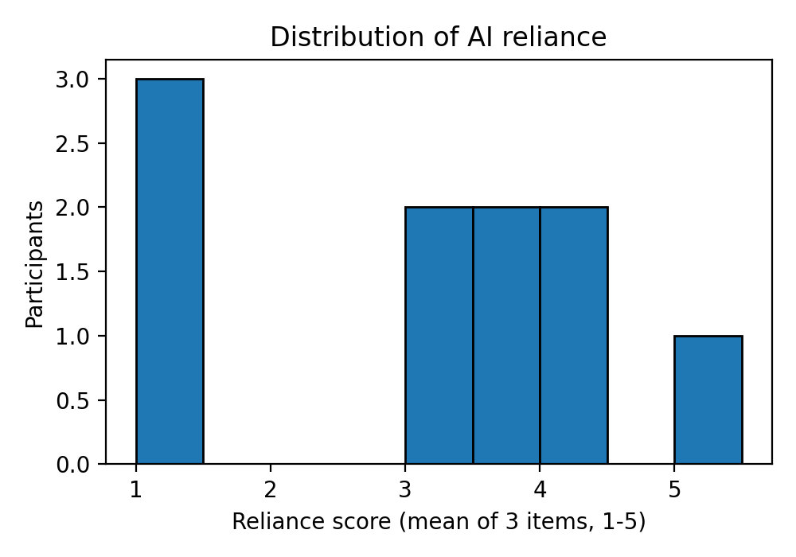
Figure 1. Distribution of the AI reliance score.
Reliance is spread over the scale but not evenly. Three participants answered "Never" to all three items (composite 1.0, 30%), none scored between 1 and 3, and one scored 5.0 (Figure 1). The composite has a mean of 2.93 (SD 1.45) and a median of 3.33, so the distribution is bimodal rather than skewed to one end. Use is similar for writing code (mean 2.90), fixing errors (2.90) and explaining code (3.00); for each purpose three or four participants answered Often or Almost always (Table 8). Code-reading scores have a median proportion of 0.75 (IQR 0.50-0.83) and bug-finding a median of 0.50 (IQR 0.00-0.67). No participant reached the maximum on either test (highest 5 of 6 and 2 of 3), so there is no ceiling effect in the strict sense, but scores cluster at these values and four of ten found no bug (floor). The Shapiro-Wilk test did not reject normality for reliance (W = 0.863, p = .083) but rejected it for code-reading (W = 0.815, p = .022) and bug-finding (W = 0.713, p = .001), which supports rank-based methods. These are descriptions, not explanations.
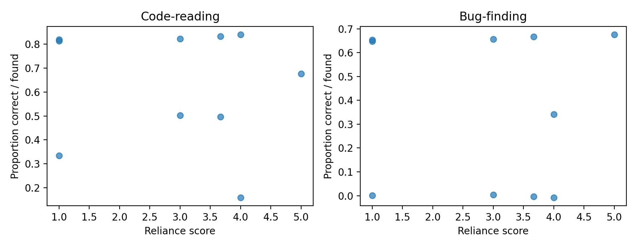
Figure 2. Reliance score against code-reading and bug-finding performance.
Figure 2 shows no clear pattern. High code-reading scores (0.82-0.84) appear at low, middle and high reliance, and so do low scores (0.17-0.50). In bug-finding, participants at the lowest reliance found either two bugs or none, and zeros also occur at reliance 3.0, 3.67 and 4.0. Points overlap because scores take few distinct values. The main data-quality issue is that seven of ten participants reported outside help, so the scores may not reflect unaided performance.

4.3 Debugging strategies
Table 9. Primary debugging strategy by reliance group (counts)
Group | manual_tracing | print_or_debugger | reprompt_ai | other
Low | 0 | 0 | 0 | 3
Moderate | 0 | 1 | 1 | 1
High | 0 | 1 | 1 | 2
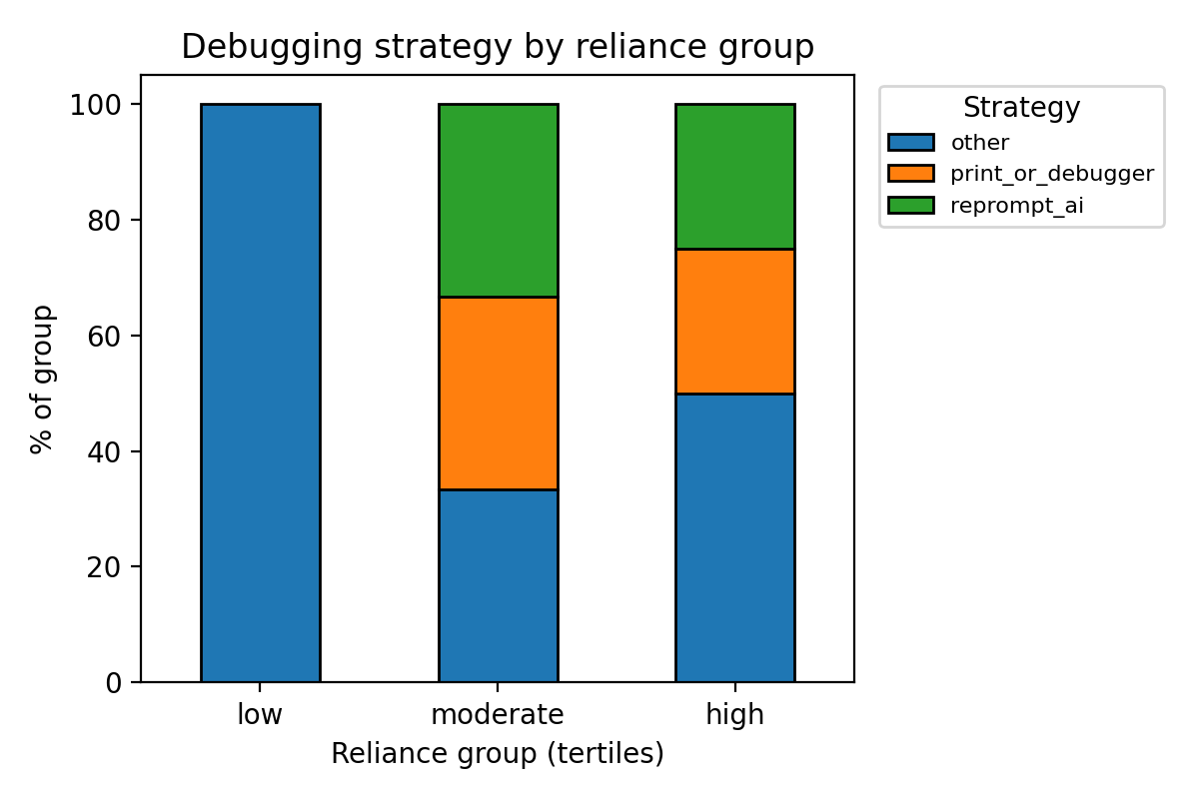
Figure 3. Debugging strategy by reliance group.
Overall, six participants were coded other, two print_or_debugger, two reprompt_ai and none manual_tracing (Table 9, Figure 3). All three low-reliance participants were coded other, the moderate group has one of each of three strategies, and the high group has two other, one print_or_debugger and one reprompt_ai. The category other is large because many answers to the usual-strategy question were uninformative or off-topic (for example, a refusal, "don't know" or unrelated text), and the codebook assigns such answers to other (rule 6). Other therefore cannot be read as a different debugging approach used by low-reliance students. Example answers are not quoted because they are very short and free text is not shared.

5. Main Analysis

5.1 Methods and parameters
Table 10. Analysis specification
Objective | Method | Parameters | Why suitable
1 | Descriptive statistics; Cronbach's alpha | Reliance = mean of R1-R3 | Summarises ordinal items and checks internal consistency
2 | Median, IQR, Shapiro-Wilk | alpha = .05 | Bounded scores from short tests are rarely normal
3 | Frequencies, Cohen's kappa, chi-square, Cramér's V, permutation test | Tertile groups; 10,000 permutations; seed 42 | Categorical data; permutation stays valid when expected counts are small
4 | Spearman's rho with bootstrap CI; Kendall's tau | 5,000 resamples, two-sided, seed 42 | Rank-based and suited to ordinal scores with no normality assumption
4 | OLS regression with year and experience controls | Reported with 95% CI, R², VIF and residual plots | Checks whether the association remains after controls
Decision rule: an association is called statistically significant when p < .05, and is always reported with its confidence interval. Effect size is read using conventional guides for correlation: about .10 small, .30 moderate, .50 large. Because two outcomes are tested, a borderline result near .05 is treated with caution. A non-significant result is reported as inconclusive and not as proof of no association. The methods follow Spearman (1904) for rank correlation, Cohen (1960) for inter-coder agreement, Cronbach (1951) for internal consistency and Shapiro and Wilk (1965) for the normality test.
Assumptions: Spearman requires paired ordinal or continuous data and a monotonic relationship. Regression assumes linearity, independent errors and roughly constant residual variance; residual plots and VIF were inspected. Scores are bounded, so regression serves as a supporting analysis.
There is no train/test split or prediction model, so data leakage does not apply. Task answers cannot influence reliance answers because the reliance items come first.

5.2 Reliance measure
Cronbach's alpha for R1-R3 was 0.918, above the usual .70 threshold, so the three items behave as one scale in this sample. With ten respondents and three items the estimate is imprecise, and a high alpha shows that the items agree, not that the scale measures AI reliance validly.

5.3 Association between reliance and performance
Table 11. Spearman correlations between reliance and performance
Outcome | n | rho | p | 95% bootstrap CI | tau | tau p
Code-reading | 10 | -0.18 | 0.621 | -0.76 to 0.53 | -0.14 | 0.621
Bug-finding | 10 | -0.09 | 0.814 | -0.72 to 0.59 | -0.06 | 0.838
Both correlations are small and negative, with p values far above .05, and both confidence intervals include zero. The data are compatible with no association and also with moderate associations in either direction, so the result is inconclusive and is not evidence of no relationship. With n = 10, only |rho| of about .65 or larger would have reached p < .05.
Table 12. Regression of performance on reliance with controls
Outcome | Term | B | SE | t | p | 95% CI
Code-reading | Intercept | 0.231 | 0.325 | 0.71 | 0.504 | -0.56 to 1.03
 | Reliance | -0.029 | 0.062 | -0.47 | 0.653 | -0.18 to 0.12
 | Year of study | 0.307 | 0.182 | 1.69 | 0.142 | -0.14 to 0.75
 | Prior experience | -0.055 | 0.183 | -0.30 | 0.774 | -0.50 to 0.39
Bug-finding | Intercept | -0.397 | 0.321 | -1.24 | 0.263 | -1.18 to 0.39
 | Reliance | -0.061 | 0.061 | -1.00 | 0.358 | -0.21 to 0.09
 | Year of study | 0.523 | 0.179 | 2.91 | 0.027 | 0.08 to 0.96
 | Prior experience | 0.090 | 0.181 | 0.50 | 0.637 | -0.35 to 0.53
R² = 0.335 (adjusted 0.002) for code-reading and R² = 0.643 (adjusted 0.464) for bug-finding, with n = 10 in both models. The largest VIF was 1.33, so collinearity is not a concern. In both models the coefficient for reliance is small and its interval includes zero, so reliance is not associated with either score after year of study and experience are controlled. In the bug-finding model, year of study has a coefficient of 0.52 (p = .027): second-year students found more bugs. This is one of eight coefficients, there are only three first-year students, and no correction for multiple tests was made, so it is an exploratory observation. The residual plots (Figure 4) show one large negative residual (about -0.5) in each model and too few points to judge linearity or constant variance. The outliers were inspected and not removed.

Figure 4. Residuals against fitted values for the code-reading (left) and bug-finding (right) regressions.

5.4 Strategy and reliance
Chi-square = 3.056, df = 4, p = .549, Cramér's V = 0.391, permutation p = .606 (10,000 permutations), with 100% of expected counts below 5. Because the chi-square approximation is unreliable here, the conclusion rests on the permutation p-value and the descriptive table: no difference in strategy between reliance groups was detected. With ten participants and many uninformative answers the test has almost no power, and the moderate V is a descriptive value from 10 observations.
Table 13. Performance and strategy profile by reliance group
Group | n | Reliance range | Median code-reading | Median bug-finding | Most common strategy
Low | 3 | 1.00-1.00 | 0.83 | 0.67 | other (3 of 3)
Moderate | 3 | 3.00-3.67 | 0.50 | 0.00 | none (one each: other, print_or_debugger, reprompt_ai)
High | 4 | 3.67-5.00 | 0.75 | 0.50 | other (2 of 4)
Performance does not rise or fall steadily across the groups: the moderate group has the lowest medians (code-reading 0.50, bug-finding 0.00), the low group the highest, and the high group lies between them. The groups are very small (3, 3 and 4), and two participants with the same score of 3.67 are split between the moderate and high groups by participant code, so the medians are descriptive only. This table combines the quantitative and qualitative evidence, as planned in Assignment 3, Part 5.5.

5.5 Answers to the objectives
Table 14. Direct answer to each objective
No. | Objective | Answer supported by evidence
1 | How often and in what ways students use AI | Reliance is mixed: the composite has a mean of 2.93 (SD 1.45) and a median of 3.33 (Tables 7-8). Three of ten never use AI for any of the three purposes, while three or four of ten use it often or almost always for each purpose. Use is similar for writing (mean 2.90), fixing (2.90) and explaining code (3.00). The named-tools item was not informative (nine of ten chose Other).
2 | Comprehension and debugging performance | Median code-reading proportion 0.75 (IQR 0.50-0.83) and median bug-finding proportion 0.50 (IQR 0.00-0.67) (Table 7). No participant answered every item correctly and four of ten found no bug. Seven of ten reported outside help, so scores may overstate unaided ability.
3 | Debugging strategies used | Six strategies were coded other, two print_or_debugger, two reprompt_ai and none manual_tracing (Table 9, Figure 3). Many other codes reflect uninformative answers, so the real strategy profile is largely unknown.
4 | Association of reliance with scores and strategies | No association was detected: rho = -0.18 (95% CI -0.76 to 0.53) for code-reading and -0.09 (-0.72 to 0.59) for bug-finding, and the adjusted coefficients for reliance were also near zero (Tables 11-12). Strategy did not differ detectably between reliance groups (permutation p = .606; Table 13). With n = 10 the result is inconclusive.

6. Results and Discussion

6.1 Observation, interpretation and conclusion
Table 15. Separating evidence from inference
Observation (what the data show) | Interpretation (possible meaning) | Conclusion (what can be claimed)
Reliance and scores are weakly negatively correlated (rho = -0.18 and -0.09), with intervals that include zero; adjusted coefficients are also near zero. | A real association may exist but be too small or too noisy to detect with 10 participants. Unsupervised tasks (7 of 10 reported outside help) may hide differences, and scores cover a narrow range. | No association was detected. The study neither supports nor rules out a relationship.
Strategy codes do not differ detectably between reliance groups; 6 of 10 are other. | Many usual-strategy answers were uninformative, so other mixes real alternatives with no answer. Reported habit may also differ from behaviour. | The strategy comparison is descriptive only. No claim is made about how reliance relates to strategy.
Year of study is associated with bug-finding (B = 0.52, p = .027), unlike reliance. | Second-year students have more programming practice, but this is one of eight coefficients and only three participants are first-year. | An exploratory observation to check in a larger sample, not a finding.
These results do not support the claim that higher AI reliance goes with lower, or with higher, comprehension in this sample. They also do not show that there is no link: the sample was far below the planned size, scores are bounded and cluster at a few values, and most participants reported outside help. Two unexpected features are reported rather than hidden: many strategy answers were uninformative, and 21 of 31 first- and second-year respondents were excluded as paid developers.

6.2 Comparison with published studies
The studies below differ from this one in participants and setting, so comparisons are limited to direction and concept. The summaries are based on the published abstracts.
Table 16. Comparison with related work
Study | Participants and setting | Related point | Comparison with our result
Mozannar et al. (2024) | 21 programmers completed coding tasks with GitHub Copilot and labelled their own sessions afterwards; observational user study, not a student survey. | A taxonomy of programmer activities with a code assistant, used to show inefficiencies and time costs. | Not directly comparable: they observed behaviour while the tool was in use; we measured reported frequency of use and scores on tasks done without the tool. Our data say nothing about time use.
Vaithilingam et al. (2022) | 24 participants, within-subjects: Copilot against IntelliSense on Python tasks. | Copilot did not necessarily improve completion time or success, and users had trouble understanding, editing and debugging generated code. | Consistent in direction with our null association: using an AI tool was not automatically linked to better performance. They manipulated tool access; we did not, so effects cannot be compared.
Gardella et al. (2026) | Controlled study of novices in AI-assisted and human pair programming | Participants performed better with Copilot than with a human partner and reported lower workload, while a one-week retest was used to look at learning. | Not comparable in effect: performance was measured with AI available, ours without it and in relation to habitual reliance. Their better immediate performance does not conflict with our result.
Barke et al. (2023) | Observational study of programmers interacting with a code-generating model | Modes of interaction with such tools | Concept only: they observed 20 participants and built a theory of interaction; our strategy coding was too uninformative to describe modes of interaction.
Mailach et al. (2025) | Programming beginners in a CS2 course using a chatbot on assignments: 129 conversations (756 prompts), compared with beginners who did not use one. | Conversations with prompts for debugging or testing were linked to higher success. | Closest population (beginners), but they analysed actual prompts and graded work, while we used self-reported frequency. Our ten participants cannot confirm or contradict their pattern.
In answer to the Research Question: among ten first- and second-year Software Engineering students at AITU, no association was detected between AI reliance and code-reading or bug-finding scores, or between reliance and the coded debugging strategy. The result describes association only and is inconclusive because of the sample size. Studies that gave participants an AI tool (Vaithilingam et al., 2022; Gardella et al., 2026) tested performance with the tool available, so they neither confirm nor contradict this result.

7. Reliability, Validity and Limitations

7.1 Reliability and robustness checks
Table 17. Robustness results
Check | Code-reading | Bug-finding | Changed or stable?
Main: Spearman, composite of three items (n = 10) | rho = -0.18, p = 0.621 | rho = -0.09, p = 0.814 | Reference
Composite without ai_explain | rho = -0.19, p = 0.593 | rho = -0.14, p = 0.691 | Stable: same small negative direction
Median split, Mann-Whitney, rank-biserial r | r = -0.16, p = 0.737 | r = -0.12, p = 0.817 | Stable: same direction, no significance
Excluding reported outside help (n = 3) | rho = -0.50, p = 0.667 | rho = 0.00, p = 1.000 | Not interpretable: only 3 participants
Software Engineering only (n = 10) | rho = -0.18, p = 0.621 | rho = -0.09, p = 0.814 | Identical to the main analysis: all 10 participants study SE
Inter-coder agreement before resolution was Cohen's kappa = 1.000 (n = 10), with 0 disagreements to resolve (10 of 10 identical codes). The two coders worked independently with a fixed codebook. This high value is weak evidence that the codebook is reliable: with ten short answers, most of them uninformative and clearly other, agreement is easy, and kappa from so few observations is unstable.
The sign and size of the correlation were stable under the alternative composite and the median split (rho between -0.09 and -0.19), and none was near significance. The no-help rerun (n = 3) cannot be interpreted, and the SE-only rerun is identical to the main analysis because all participants study SE. Task conditions may still affect the main finding, because 7 of 10 reported outside help, but the no-help sample is too small to show whether the result changes without it.

7.2 Threats to validity and limitations
Table 18. Limitations, mitigation and caution
Threat | Effect | Mitigation or caution
Unsupervised online tasks (internal) | Seven of ten participants reported outside help, so scores may be inflated and may hide any link with reliance. | Instruction, H1 item and no-help rerun (n = 3, not interpretable); help may still be under-reported.
Self-reported reliance (construct) | Social desirability may lower reported AI use | Anonymous, neutral wording; frequency is not measured behaviour
Convenience sample (external) | Volunteers from one university may not represent other students | Conclusions limited to the sample; no generalisation
Cross-sectional design (internal) | Cannot show direction: weaker students may rely on AI more, or the reverse | Association language only; year and experience controlled
Short test (construct) | Six and three items give coarse scores; no participant reached the maximum and four of ten found no bug (floor). | Rank methods; distribution reported; no fine conclusions
Unvalidated three-item scale (construct) | Reliance may be measured imperfectly | Alpha reported; alternative composite tested
All programmes except SE absent (external) | All analysed participants study Software Engineering; results do not describe other programmes. | Scope limited to SE; the SE-only rerun is identical to the main analysis.
Strategy from self-report (construct) | Stated habit may differ from what students really do | Two coders; interpreted as reported habit
Very small sample (statistical conclusion) | n = 10: only |rho| of about .65 or more could reach p < .05, and intervals are very wide. | Results called interim and exploratory; intervals reported; no claim of no effect.
Uninformative strategy answers (construct) | 6 of 10 strategies were coded other, many from short or off-topic answers, so strategy is largely unmeasured. | Strategy comparison kept descriptive; kappa interpreted with caution.
Paid-developer exclusion (selection) | 21 of 31 respondents in year 1 or 2 were excluded; the item may have been misread and was not piloted. | Reported openly; no generalisation beyond the remaining participants.
Participant-chosen codes (data quality) | 10 consenting respondents used codes that look like placeholders; two repeated codes were kept as separate people. | Rule fixed before analysis; identical repeats removed; possible double counting acknowledged.

7.3 What cannot be concluded
This study cannot show that AI reliance causes better or worse comprehension. It does not measure long-term learning, because it covers one point in time. It does not measure the quality of AI use or AI-generated code, and it cannot be generalised to experienced developers or other universities. It also says nothing about programmes other than Software Engineering, and with ten participants it cannot detect small or moderate associations.

8. Conclusion
In this interim study of ten first- and second-year Software Engineering students at AITU, no association was detected between reliance on generative AI coding assistants and code-reading or bug-finding scores (rho = -0.18 and -0.09, with wide intervals that include zero), or between reliance and the coded debugging strategy (permutation p = .606). The result is inconclusive rather than negative: the sample was far below the planned 40 to 60, seven of ten participants reported outside help, and six of ten strategy answers were coded other, many of them uninformative. The alternative composite and the median split gave the same small negative direction, while the no-help check (n = 3) cannot be interpreted. The most important limitation is the small, unsupervised sample; a larger supervised sample is needed before drawing conclusions.

References

Barke, S., James, M. B., & Polikarpova, N. (2023). Grounded Copilot: How programmers interact with code-generating models. Proceedings of the ACM on Programming Languages, 7(OOPSLA1), 85-111. https://doi.org/10.1145/3586030
Cohen, J. (1960). A coefficient of agreement for nominal scales. Educational and Psychological Measurement, 20(1), 37-46.
Cronbach, L. J. (1951). Coefficient alpha and the internal structure of tests. Psychometrika, 16(3), 297-334.
Gardella, N., Prather, J., Leinonen, J., Denny, P., Pettit, R., & Riggs, S. L. (2026). Fast and forgettable: A controlled study of novices' performance, learning, workload, and emotion in AI-assisted and human pair programming paradigms. arXiv. https://doi.org/10.48550/arXiv.2604.18538
Mailach, A., Gorgosch, D., Siegmund, N., & Siegmund, J. (2025). “Ok Pal, we have to code that now”: Interaction patterns of programming beginners with a conversational chatbot. Empirical Software Engineering, 30(1), Article 34. https://doi.org/10.1007/s10664-024-10561-6
Mozannar, H., Bansal, G., Fourney, A., & Horvitz, E. (2024). Reading between the lines: Modeling user behavior and costs in AI-assisted programming. Proceedings of the CHI Conference on Human Factors in Computing Systems. https://doi.org/10.1145/3613904.3641936
Shapiro, S. S., & Wilk, M. B. (1965). An analysis of variance test for normality (complete samples). Biometrika, 52(3-4), 591-611.
Spearman, C. (1904). The proof and measurement of association between two things. The American Journal of Psychology, 15(1), 72-101.
Vaithilingam, P., Zhang, T., & Glassman, E. L. (2022). Expectation vs. experience: Evaluating the usability of code generation tools powered by large language models. Extended Abstracts of the 2022 CHI Conference on Human Factors in Computing Systems. https://doi.org/10.1145/3491101.3519665

Appendices

Appendix A. Instruments
Participant form (Google Forms), as shown to participants: consent; D1-D4 (programme, year, prior experience, paid developer job); R1-R3 (frequency of AI use for writing code, fixing errors and explaining code, 1-5); R4 (AI tools used); ST1 (usual first steps when code does not work); C1-C6 (six code-reading questions with "Don't know"); B1-B3 (three bug-finding tasks, select the faulty line); ST2 (steps used to find the bugs); H1 (outside help). Scoring: one point per correct answer, "Don't know" and wrong answers score 0; reliance = mean of R1-R3. Codebook: four codes (manual_tracing, print_or_debugger, reprompt_ai, other) and eight decision rules, applied to ST1; full text in codebook.md. Form link (closed to responses): https://docs.google.com/forms/d/e/1FAIpQLSerWIRhFPq1cA0r86ipscXyF1svdQG3dlyl-PlBgfzTje2Asg/viewform. The full item text is in instruments_en.md in the submitted folder, without the answer key.

Appendix B. Configuration and environment
Python 3.14.2; pandas 2.3.3; NumPy 2.3.5; SciPy 1.18.1; matplotlib 3.10.8; Windows (version 10.0.26300); random seed 42. requirements.txt: pandas>=2.0, numpy>=1.24, scipy>=1.10, matplotlib>=3.7. Installed with: py -m pip install -r requirements.txt.

Appendix C. Data documentation and collection log
Table C1. Collection log
Date | Channel | Total responses so far
2026-11-02 | Telegram group | 3
2026-11-03 | Telegram group | 45
2026-11-05 | Telegram group | 52
No responses arrived on 4 Nov. Real-run logs: data/prepared/preparation_log.txt (52 raw, 10 eligible; 0 identical repeats; 2 repeated codes with different answers kept as separate people; 7 flagged for outside help) and results_main/cleaning_log.txt (10 analysed; no out-of-range values; alpha 0.918; kappa 1.000). Code and outputs: https://github.com/bgl96395/code-comprehension-ai-reliance (public repository; it holds no raw responses, coder files or free text).

Appendix D. Pipeline test on synthetic data
These runs used synthetic files invented only to test the code. They are not study data and are not evidence about the Research Question. The invalid-value test (Likert 7, test score 9, unknown strategy) was handled as intended: all three values were set to missing. D.4 Cleaning log of the synthetic test file, produced by analysis.py (results_test). SYNTHETIC: it describes the test file only; the Cronbach's alpha of -0.281 and the other values below are not study results.
Raw records: 46
Duplicate participant codes removed: 1
ai_write: out-of-range (not 1-5) set to missing: 0
ai_fix: out-of-range (not 1-5) set to missing: 0
ai_explain: out-of-range (not 1-5) set to missing: 0
comp_correct: out-of-range (not 0-6) set to missing: 0
bug_found: out-of-range (not 0-3) set to missing: 0
year_of_study: values not in (1, 2) set to missing: 0
prog_experience: values not in (0, 1) set to missing: 0
strategy: codes not in codebook (set to missing): 0
strategy_coder1: codes not in codebook (set to missing): 0
strategy_coder2: codes not in codebook (set to missing): 0
Incomplete reliance questionnaire (excluded from reliance analyses): 1
Analysed participants: 44
Cronbach's alpha: -0.281
Strategy x reliance group: chi2=5.436, df=6, p=0.4892; Cramer's V=0.249; permutation p=0.5215 (10000 permutations); share of expected counts below 5: 100%; n=44 | WARNING: chi-square approximation unreliable; use the permutation p-value / report descriptively.
Cohen's kappa (coder 1 vs coder 2): 0.823 (n=45)
Outputs written to: results_test

Appendix E. Team contributions and AI assistance
Table E1. Team contributions
Member | Contribution
Sagym Mukhammedzhan | Read the literature and wrote the literature descriptions; checked the answer key, the report and the results; created the Google Form and instruments, obtained instructor approval for data collection, closed the form and exported the responses, extended analysis.py and wrote the handoff instructions.
Sarsenbek Beknazar | Analysis pipeline (analysis.py), data preparation and analysis, independent strategy coding (coder 1), report completion
Nugmash Bigali | Created the GitHub repository, worked on Assignment 3, devised and checked the survey questions, distributed the form, and did the independent strategy coding (coder 2).
AI assistance. Claude was used to help extend analysis.py, draft the instruments, form script and data-preparation script, to look up bibliographic details, and to draft this report from the aggregated results of the real analysis run. It assigned no strategy codes: both sets of codes were assigned by team members working independently. All statistical results come from running the listed scripts on the collected data. The team verified AI-assisted text and literature summaries.

