Elmer Alton Glendenning

Glendennings seemed to have been well established in Portland at the turn of the century with Venetia, the oldest child likely having played the role of "host" as each new family member moved south. Venetia's address was Falmouth Foreside which is just north of Portland and between Portland and Freeport. Falmouth Foreside still exists although it may be considered part of the Portland metropolitan area.

We do not know the year that Dad went to the USA or where he went first or what he did. Other brothers and sisters known to have lived in Portland, at least for a while, included Venetia (Mrs R. L. Doring), Margaret (Mrs Lucas Marsen), Frank, Raymond and Guy. Aunt Maude and Uncle Jim Cormier also worked in the USA, I believe in Lincoln, New Hampshire.

The family must have valued education; Uncle Chip took a business course, Uncle Guy studied but did not finish dentistry, Aunt Margaret was a nurse. Dad may have taken some technical courses; I remember some technical books at home.

My guess, and it is only a guess, is that Dad first worked in the woods in Maine and New Hampshire. Walter thought that Dad worked in the woods near Skowhegan and Millinocket, Maine. I believe that he also worked in or near Berlin, New Hampshire.

Dad, and presumably his brothers, also lumbered in New Hampshire prior to 1910. Because they took their horses, they must have yarded and hauled logs. I believe that they also cut lumber. John recalled Dad telling about a "record" of lumber cut (marked on a camp wall) that stood for many years. Ken thinks that Uncle George Watling, Mum's
brother, also worked in the woods with Dad and recalls Uncle George telling about the "record" set by Dad and his crew. George (Elbridge) Watling told Ken that both his father,

George, and James A. Watling worked in the woods with Dad. Ramsay MacLean, of Upper Black River, worked with Dad in New Hampshire. I recall John saying that he thought that Ramsay had been yarding with a horse or a team and, and did not install a bridle to slow down the sled on a steep hill, and the logs got away from him and dragged a horse down the hillside killing it. From my reading of lumbering on the hills in New Hampshire, this would not have been an unusual event. According to Herbert Daley, Herb Daley, Dad’s first cousin, also worked with Dad in New Hampshire and, perhaps, in Portland.

Prior to 1910, Elmer and his brother, Frank, operated a business in Portland under the name Glendenning Bros. & Co. (All Kinds of Team Work). Robert Glendenning told me that Uncle Guy also worked in the cartage business; whether he was a partner is not known. They operated from 24 Hammond Street, Portland, Maine. Walter, and others, remember Dad telling about delivering ice to homes on a regular basis. Delivering meant that they opened the door and put the ice in the icebox inside the house. Although I always thought it was only Dad and Uncle Frank in the trucking business, other brothers may have also been involved.

According to Lillian, Dad continued to send money to his parents from the USA until he was 30 years old.

In August 1993, while in Portland, I visited Hammond Street. The area was primarily commercial and fronts on Back Cove. It is in East Portland which is known as Munjoy Hill. This section of the city had completely been rebuilt and there was no trace of #24 Hammond Street. Uncle Frank Glendenning lived nearby at 72 Wilmot Street. We do not know where Dad lived.
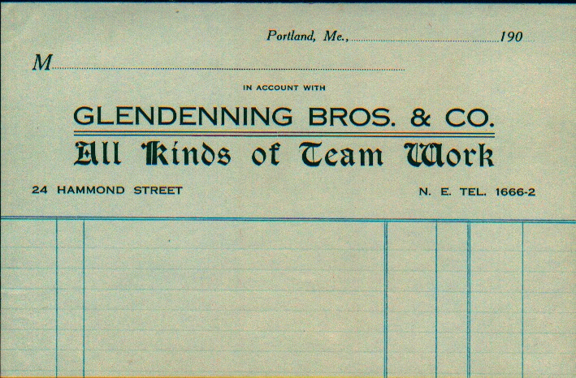

Wausau, Wisconsin

We have no record of when Dad went to , Wisconsin, however, on January 25, 1910 he mailed a letter from to Jeannie A Glendenning in Portland. A postcard picture dated July 18, 1910 shows work being done at a dam in Rothschild, Wisconsin. He also gave , Wisconsin, as his address when he made an entry in Mum's autograph album on September 18, 1910, a month before they were married. In fact, Dad=s is the only entry in the album prior to the wedding which makes me think that he may have given it to Mum as a memento from . He may well have simply stopped in Portland for a few days on his way back to the wedding.

Quite a number of dams were built in Wisconsin at this time. Some were built to improve the rafting of logs; others were built for the generation of power. Rothschild is a few miles south and east of .

Add new found photos

