The Family Chronicle
No. 112 February 23, 2006

First Cousins

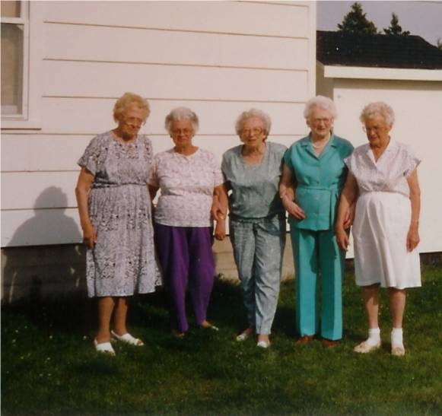

Venetia (Glendenning) Russell, Marjorie (Watling) Young, Edith (MacKenzie) Shickel, Mildred (MacNaughton) MacKay, Ruth (MaNaughton) Lewis (Photo taken at a Glendenning Reunion in Point Aux Carr – date not known) One might have guessed they were cousins even if one did not know.

Riddles and flails

I was reading about PEI manufacturers of early agricultural equipment and came across terms not heard very often these days.

Flails were used to knock seeds and grain (oats, wheat, barley) from their stalks or from their pods (peas and beans). A flail, as I recall, was a small pole perhaps 5 feet long with another pole, perhaps 2-3 feet long tied to one end with a rope or piece of wire. The only time I remember seeing one in use was when Uncle Jim Watling used one to “flail” some beans. Dried bean stocks were put into a jute bag and tied then the flail was used to batter it about to knock the beans from their pods.
Winnowing was a way of separating dust and chaff from seeds. A piece of canvas or a sheet was placed on the ground. With a breeze, a bucket of beans was held at high and gently tipped so that the beans dropped to the canvas. Beans being heavy dropped straight down while the chaff and dirt blew beyond the canvas. I remember winnowing peas and beans.

Threshers were machines used to strip grain from the straw.

Fanners were used to clean the dust, dirt and chaff from grain and other seeds.

Riddles were found in threshers and fanners; they were screens placed horizontally in the thresher or fanner; Riddles shook so that smaller seeds dropped through the holes when passing over and larger seeds and chaff kept on going. Riddles could be changed depending on the kind of seeds to be separated.

Babbet was used for bearings. One could not just go out and buy a new set of bearings when needed; instead, one melted babbet, not unlike solder, and poured it around the shaft. I remember once seeing the old stationery engine owned jointly by Dad and Uncle Jim being repaired this way. I do not remember the detail, but remember Walter and Uncle Jim removing the bearing cap, taking out the old bearing, melting the babbet and poured it, presumably into a mould for the shaft.

The Class of ‘34

I am pleased to have a copy of the REGISTER for the Little Branch School , District 71/2, for the school year ending June 1934; the teacher was Donald J. McLean who held a Second Class License, had taught for four years and was paid $380.00 by the District and $120 in the form of an annual government Grant. Following is a list of students who registered that year but not all attended both terms:

Cameron, Edith
Cameron, Iona
MacDougall, Douglas
Cameron, Wilna
Glendenning, John
Watling, Marjorie
Fowlie, Dorothy
Glendenning, Elinor
Harper, Thomas
MacDougall, Stella

MacLean, Allan
MacLean, Ernest
MacLean, Guy
Fowlie, Marjorie
Harper, Charles
Harper, William
Cameron, Blanche
MacLean, Catherine
Watling, Winfield
Adams, Melvin

Fowlie, Bertha
Fowlie, Elizabeth
Glendenning, Kenneth
MacLean, Hugh
Adams, Eunice
Adams, Wilfred

Godfrey, Nellie
Godfrey, Robert
Harper, Helen
MacDonald, John
MacLean, Jennie
MacLean, Ian
Glendenning, Norman
MacDougall, Burville
MacDougall, George
MacDougall, Harold
MacDougall, Margaret
Watling, Roy
Williston, Lois
Adams, Clifford

Adams, Gordon
Adams, Walter
Godfrey, Dorothy
Adams, Elmer
Adams, Edwin
Fowlie, Theodore
MacLean, Frances
Fowlie, Byron
Fowlie, Constance

School visitors included Mrs. R. Harper, Mrs. Sam Fowlie, Mrs. Sinclair Williston, Mrs. Alfred MacLean, F. F. Fowlie,
Mrs. James Watling and Isobel Cameron.

Douglas MacDougall, Marjorie Watling, Helen Harper and Lois Williston had perfect attendance during the first term but no one had perfect attendance during the second

The Family Chronicle (Copyright©) is an occasional newsletter published by Don Glendenning and posted on the family website. It is intended to share information about my family, community and the times in which I grew up. While every effort is made to be accurate, errors are likely to occur. Comments, enquiries and information may be sent to 62 Queen Elizabeth Drive, Charlottetown, PEI, C1A 3A9. Tel: 902 892 5859. Email: dglende@auracom.com Web: www.glendenning.net/don

