The Family Chronicle
No. 124 November 5, 2006
____________________________________________________________________

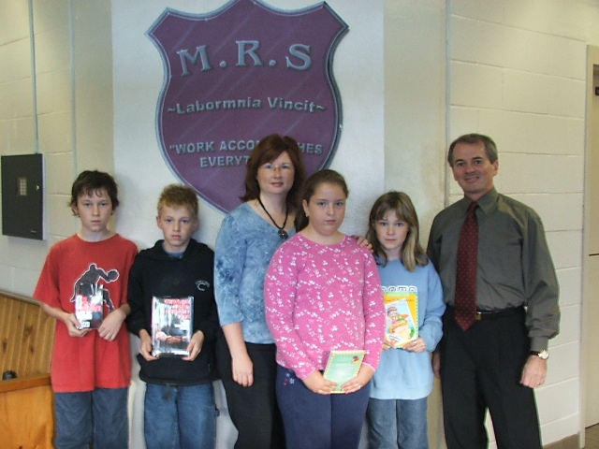

From left to right: Eric Williston, Matt Kingston, Amanda Manuel (Glendenning Family), Emma MacDonald, Sarah Duffy and Andrew Clark, Principal. Photo by Daria Fallon

Book Grant to Miramichi Rural School

A second grant in the amount of $200 was made from the Glendenning Fund to the Miramichi Rural School for the purchase of books for the school library. The students shown above made the selection and went to a local bookstore to make the actual purchase.

Readers with Miramichi roots may be interested to know that:

-Eric Williston is a son of Stymiest and Kathy Williston and a Grandson of David & Catherine Williston,
-Matt Kingston is a son of Leslie and Ricky Kingston
-Amanda Manuel is a Granddaughter of
Elmer and Jane Glendenning and
represented the Glendenning Family,
-Emma MacDonald is a daughter of Randy and Beverly MacDonald and a grand-daughter of Alfred & Edith MacDonald.
-Sarah Duffy is a daughter of Bruce and Jane Duffy.

Pot Pourri

Annie F. M. Ellis taught at the Little Branch School during the 1924-25 school year.

Readers who know The Abbot by Sir Walter Scott will remember that the story was set in Scotland and was about Edward Glendinning, Abbot of Ambrosia and his brother Halbert Glendinning, Knight of Arenel.

Thanks to Doreen (Nicol) for pointing me to the Ellis Island Website. On checking arrivals at the Port of New York, I find that Aunt Louise (Mrs. Chipman Glendenning) arrived there with Clinton and Mildred in tow in 1919 from La Fundicion, Peru and Uncle Chip arrived from Morocha, Peru a year later.

Also found an entry for Uncle Guy Glendenning arriving from Portland, Maine in 1915. Uncle Guy’s son, Bobby, told me that Uncle Guy was training in Portland to be a dentist, where he had completed high school, when his brother, Chipman, wrote and said there was work for him in South America at $250 per month. His military record shows that he enlisted in the Army on July 3, 1915 so, presumably he returned from South America to enlist.

I found the names of many other Glendennings and many Watlings but was not able to trace a family connection.

Little Branch School

A note from Edna (MacDougall) Cameron tells me that teachers included “Helen Smith from Fredericton, who came after Marguerite Bell Macdonald, and taught for two years, then married Alex Williston of Bay du Vin.”

Lowell Williston

The Chatham Tri- Weekly Gazette, Vol. 25 No. 144, 1934 reported that

“Lowell Williston, son of Mr. and Mrs. George Williston of Bayside suffered a very sever injury on Friday last, while out in a hayfield.

His foot came in contact with a mowing machine and so badly lacerated that he was rushed to the Hotel Dieu Hospital here where upon examination it was found necessary to amputate the injured member.”

The Family Chronicle (Copyright©) is an occasional newsletter published by Don Glendenning and posted on the family website. It is intended to share information about my family, community and the times in which I grew up. While every effort is made to be accurate, errors are likely to occur. Comments, enquiries and information may be sent to 62 Queen Elizabeth Drive, Charlottetown, PEI, C1A 3A9. Tel: 902 892 5859. Email: dglende@auracom.com Web: www.glendenning.net/don

