The Family Chronicle
No.153 February, 2008
____________________________________________________________________

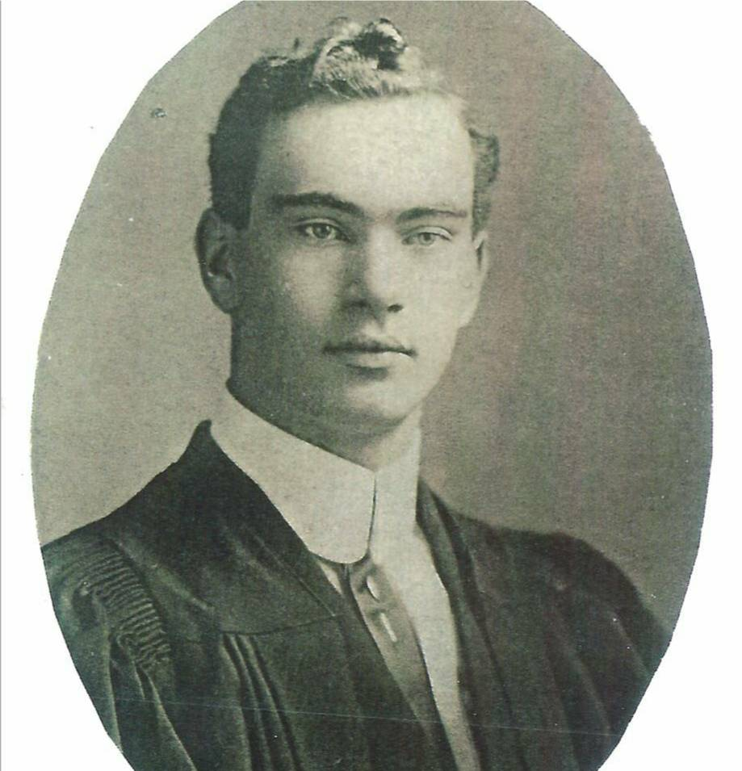
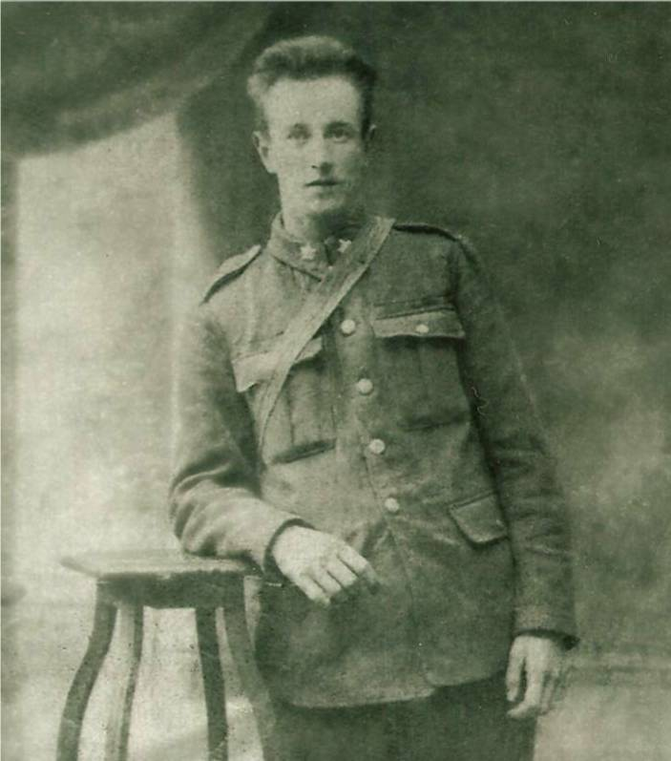
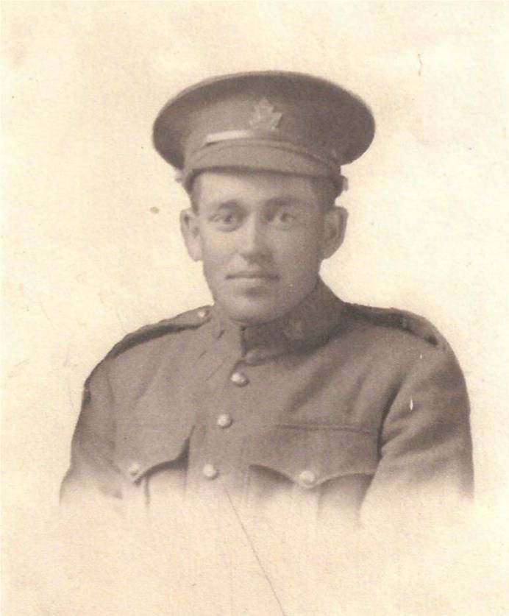
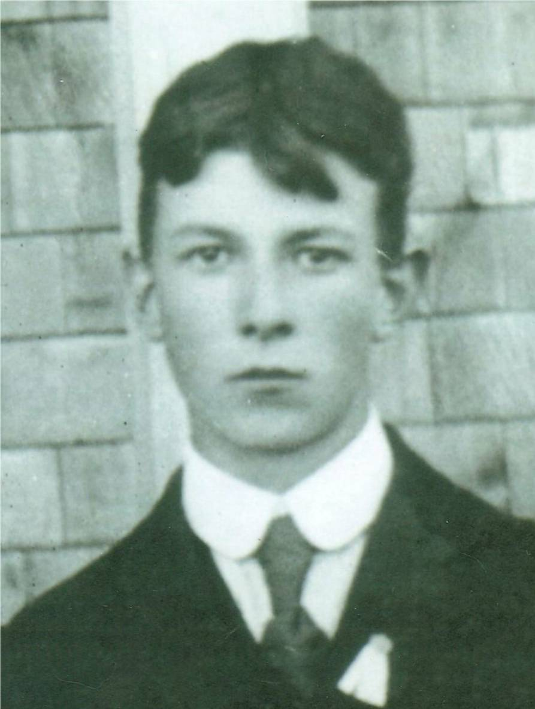

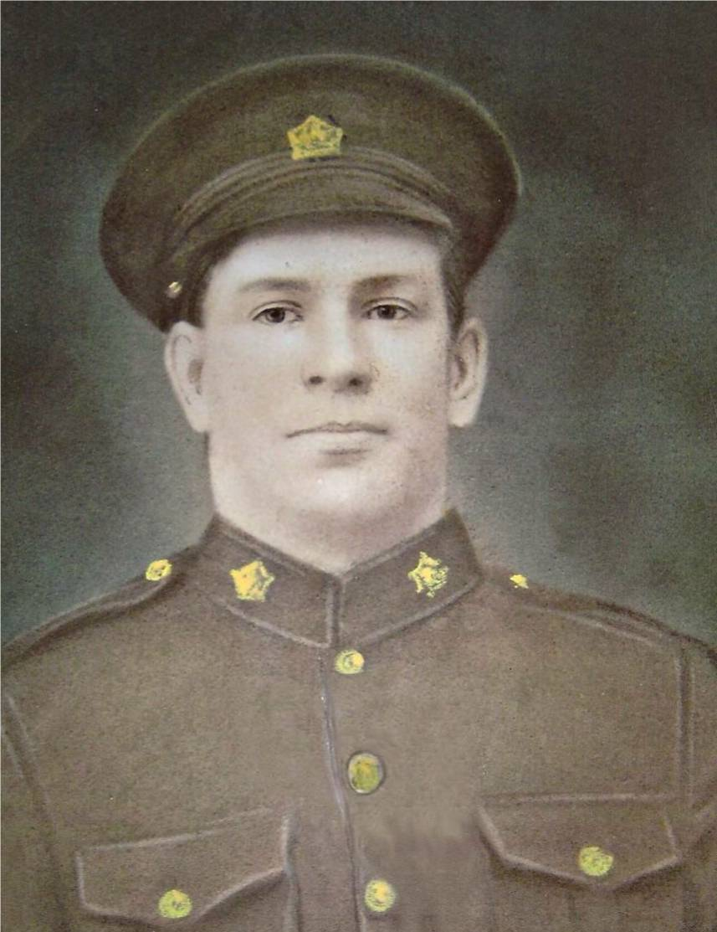
BLACK RIVER VETERANS OF WW1

Forty six young men from Black River volunteered for overseas duty during WW1; five did not return. (Thanks to Cameron MacDonald for this list.)

Gnr. Stephen John Dick, #522059, son of Alexander and Selina (Weaver) Dick, January 18, 1895-October 1, 1918, 1st Brigade, Canadian Field Artillery, buried in Haynecourt British Cemetery, about 6 miles northwest of Cambrai, France, age 23.

Pte. Joseph Ward Finno, #23515, son of James and Isobel (MacDonald) Finno , September 28, 1895-November 9, 1918, First Field Bakery, Canadian Army Service Corps, buried in Terlincthun British Cemetery, Wimille, near Bolougne, France, age 23. Terlincthun Cemetery was near a rest camp and medical treatment complex; it is likely that Joe was wounded earlier and taken to the hospital.

Pte. J. Archibald Mills, #794113, son of John Alexander and Mary (MacNaughton) Mills, November 19, 1893-April 9, 1917, 42nd Battalion, Canadian Infantry (Quebec Regiment), buried in Nine Elms Military Cemetery near Vimy Ridge, France, age 24. Archie was one of 80 Canadians killed on April 9, the first day of the Battle of Vimy Ridge.

Csm. Archibald A. Watling, #22802), son of Malcolm and Elizabeth (Cameron) Watling, December 4, 1894-July 14, 1917, 19th Canadian Infantry (Quebec Regiment, wounded in France and died in England, buried Brookwood Cemetery about 30 miles from London, age 23.

Pte. Ernest Alfred Williston, #70038, , son of Luther and Catherine (Cameron) Williston, April 10, 1890-Sept 28, 1916, 26th Battalion, Canadian Infantry (new Brunswick Regiment), buried in Courcelette British Cemetery, near Albert, France, age 24. Courcelette was the scene of heavy fighting in September 1916.

Complete list

Adams, George
Adams, James
Adams, William
Cameron Leslie
Cameron, Arch. M.
Dick, Stephen J.
Finno, Joseph
Fowlie, Fred F.
Gibson, Ernest
Gibson, Ward
Godfrey, Andrew
Godfrey, Arch
Godfrey, Frank
Godfrey, Robert
Godfrey, Samuel
Kelly, Hugh
Macdonald, Basil
MacDonald, Campbell
MacDonald, Ernest
MacDonald, Fred J.
MacDonald, Herb
MacDonald, Herb A.

MacDonald, Robert
MacDonald, Thomas
MacDonald, Walter
Macdonald, William,
MacLean, Arch
MacLean, Frank
MacLean, Fred
MacLean, Garvie
MacNaughton, Alex
MacNaughton, J. Archie
McKnight, John G.
McLean William
McLean, George
McLean, Thomas
McRae, James R.
Mills, J. Archie
Mills, W. Roy
Palmer, James
Sullivan, David
Watling, Arch
Watling, Ernest
Watling, William G.
Watling, William J.
Williston, Ernest

Observations:
- www.collectionscanada.gc.ca provides on –line access to various military records
- I had trouble finding information about Joseph Finno; in some records he is listed as Joseph Finns; I’ve reported this to Archives Canada
- For the five who died overseas, I was able to see their Attestation Papers (Enlistment papers) on line
- Readers will note that Stephen Dick died just five weeks before the War ended; Joseph Finno died just two days before the war ended but I think that he was convalescing from wounds received earlier.
- All five on the front page had served in the 73 Regiment and attended one or two summer camps of a couple of weeks each prior to enlistment.
- Stephen Dick and Joseph Finno gave Black River as place of birth, Ernest Williston Archie Watling gave Chatham as place of birth, and Archie Mills gave Hardwicke as place of birth.
- Archie Mills gave his sister, Katherine Mills later Kathryn Mills Watling) of Loggieville as his next of kin
- Uncle Guy Glendenning was wounded at Cambrai on the date that Stephen Dick was killed

The Family Chronicle (Copyright©) is an occasional newsletter published by Don Glendenning and posted on the family website. It is intended to share information about my family, community and the times in which I grew up. While every effort is made to be accurate, errors are likely to occur. Comments, enquiries and information may be sent to 62 Queen Elizabeth Drive, Charlottetown, PEI, C1A 3A9. Tel: 902 892 5859. Email:don@glendenning.net Web: www.glendenning.net/don

