The Family Chronicle
No. 154 March 20, 2008
____________________________________________________________________

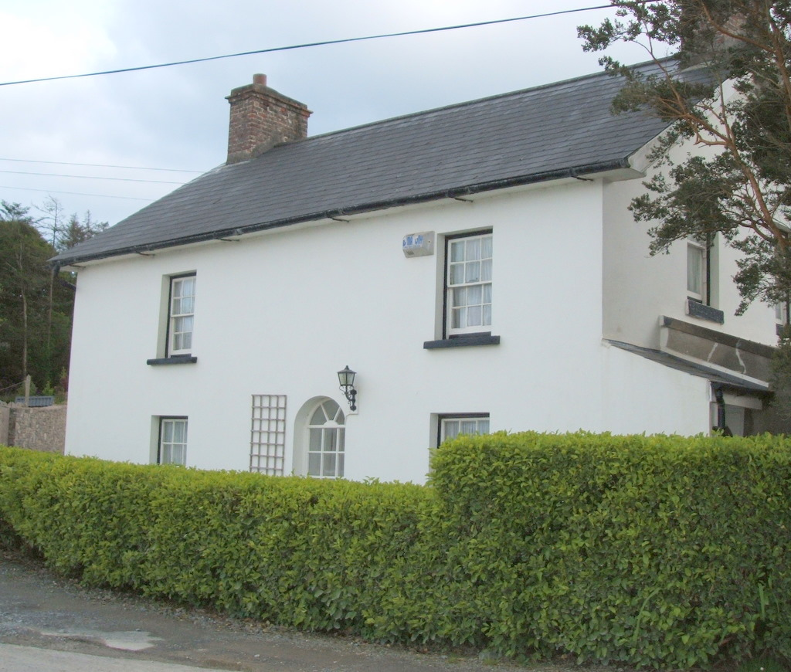
Believed to be the school where my Great Great Grandfather, William Harley, taught in Courtmacsherry, County Cork, Ireland (Courtesy of Cousin Kelsie Erskine)

Miramichi Glendennings

Thanks to Irma Downing for the following information taken from the 1911 census of the Miramichi:

Glendinning, William M Head M Apr
1884 27 1901
Glendinning Ethel F Wife M Feb 1881
30 1901
Glendinning Kenneth M Son S
Apr 1904 7 1901
Glendinning Wyona F Daughter S Aug
1905 5 1901
Glendinning Marjorie F Daughter S
Sep 1906 4 1901
Glendinning Lorne M Son S Mar 1908
3 1901
Glendinning Jean F Daughter S Jun 1909
2 1901

I have no other information about these Glendinnings but my neighbour tells me that there is a Glendinning buried in the Anglican Cemetery at Chatham Head.

Alabama

Thanks to Robert Stevens, a Harley descendant and cousin, I learned that Uncle Frank Glendenning went to Portland in 1898, and, in the year 1900 he was a teamster and boarding with his second cousin, Henry Stevens.

Robert also provided an undated registration form which shows Uncle Frank to be 41 years old (he was born in 1876) working as a labour foremen at Plant No.1, US Nitrate Company in Sheffield, Alabama. His employer was the J. G White Engineering company, the same company my father worked for in Langley Field, Virginia. Uncle Frank’s permanent address was 543 Forest Ave, Portland Maine

We know that my Father and Mother were in Mussel Shoals, Alabama, (the same area) in 1919 I am wondering now if Dad may have worked on the construction of the Nitrate plant rather than the Wilson Dam.

Telling A Horse’s Age

The following poem, source and date unknown, is believed to have been written by Jimmy Whelan

To tell the age of any horse,
Inspect the lower jaw, of course;
The six front teeth the tale will tell,
And every doubt and fear dispel.

Two middle “nippers” you behold
Before the colt is two weeks old,
Before the eight weeks two more will come;
Eight months the “corners” cut the gum.

The outside grooves will disappear
From the middle two in just one year;
In two years, from the second pair;
In three, the “corners too, are bare.

At two the middle “nippers” drop,
At three the second pair can’t stop;
When four years old the third pair goes;
At five a full new set he shows.

The deep black spots will pass from view,
At six years, from the middle two;
The second pair at seven years,
At eight the spot each “corner’ clears.

From middle “nippers”, upper jaw
At nine the black spots will withdraw;
The second pair at ten are white,
Eleven finds the “corners” light.

As time goes on the horsemen know
The oval teeth three-sided grow,
They no longer get, project before,
Till twenty, when we care no more.

Agricultural Society #103

Mention was made recently about Agricultural Society #103. My father was Secretary Treasurer for nearly 20 years and brother, Walter, for about 15 followed by Harry Watling. In conversation with Barbara Watling, she told me that Harry had turned in the books to the local Agricultural Agent. Vernon Taylor, Agricultural Representative for the Miramichi, in turn said that he had forwarded Society books to the NB Archives in Fredericton. Since then, I have confirmed that NB Archives has Society records that are likely the ones in question.

A Record Setting Event

Something occurred in my life recently that is a first, or at least I cannot remember it ever happening before. It is possible that I made an error – not a mistake but only an error. I know that many readers, especially the ones who know me, will be surprised to hear of this. I do remember, and my memory is still quite good, of thinking that I made a mistake many years ago. It turned out that it was not a mistake, not even an error, so I put it out of my mind. This matter deals with a conclusion that is different from the original conclusion. Watch my next chronicle for further details.

The Family Chronicle (Copyright©) is an occasional newsletter published by Don Glendenning and posted on the family website. It is intended to share information about my family, community and the times in which I grew up. While every effort is made to be accurate, errors are likely to occur. Comments, enquiries and information may be sent to 62 Queen Elizabeth Drive, Charlottetown, PEI, C1A 3A9. Tel: 902 892 5859. Email: don@glendenning.net Web: www.glendenning.net/don

