The Family Chronicle
No. 182 February 2, 2009
____________________________________________________________________

Black River Picnic

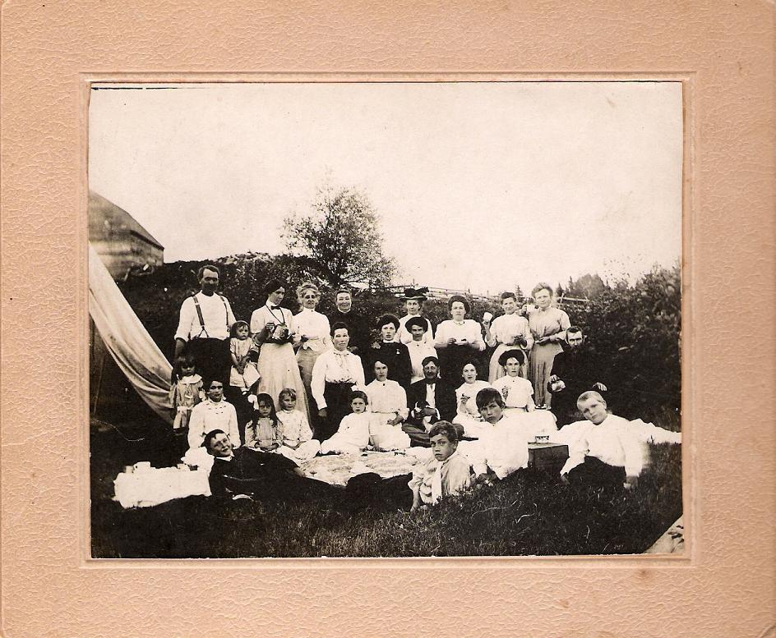
Barry Mackenzie commented that “As for the picnic group, a few faces look familiar. I believe Bessie Edge is standing third from the right in the back row. Also, the gentleman in the chair with the long black beard on the far right looks like Donald M. Watling (James TD and Dick's father) to me. Any ideas on others? I see a John W. MacNaughton look-alike as well on the far left”

WW!

In reviewing some notes recently, I noted that my Uncle Guy Glendenning was wounded at Cambrai, France on the same day, October 1, 1918, that Stephen Dick was killed.

Stephen was in the artillery. An undated clipping reads “On the first of October the Canadians faced 100,000 Germans in a desperate battle before Cambrai and Stephen and two of his chums met instant death by the landing of a shell.”

Uncle Guy was a machine gunner and received gunshot wounds to the chest at Ypres on June 4; wounded at Hill 70 on April 14, 1917; wounded again at Cambrai on October 1, 1918, and was mentioned in Haig's dispatches of November 8, 1918.

Heads Up in the Hold

Recently someone gave me a ”heads up” on an upcoming event. It is a word I don’t hear very often but it reminded me of the summer of 1946 when I worked loading pulp and pitprops on the “boats” on the Miramichi.

Steamers were loaded, as I recall, at Ritchie’s, O’Brien’s, and the Newcastle wharf in Newcastle, Milbank Wharf where the ferry docked and the railway wharf in Chatham... Pulp was ground up in pulp mills to make paper; pitprops, usually from 5-8 feet in length, were shipped to coal mines to brace walls and ceilings and prevent cave-ins.

Mostly I worked in the field loading pulp onto trucks that had a specially designed rack to allow a sling to be attached when they reached the wharf. We usually started work 15 minutes before the men on the boats.
At the wharf, a sling load of “props” was hoisted and swung over the vessel, then lowered it into the hold. Men in the hold would then move the individual pieces in under the decks until the holds were filled. None of the pieces were light but I especially remember the weight of some 8-foot props that were soggy and mildewed.

There was always a danger that the sling would unhook or break, or that a loose prop would plummet down into the hold, therefore, as the sling was about to swing over the hold, the stevedore would call out “heads up in the hold”. On hearing that, we would scramble away from the opening where the props were about to be lowered.

New Watling Information

Chronicle #169 recounted a second marriage of Jubal (the original Jubal and the one who married Susan Leach)

Jubal and his second wife had a son Charles who married Sarah Jane Bell and had five children: William Ambrose, Edith, John, May and Elsie.

I’ve recently learned that Ambrose died in Vancouver in 1968.

Spruce Gum

Occasionally when walking in my woods I see, and sometimes chip off, spruce gum. When spruce trees are injured, sap seeps out; when the sap hardens it is known as spruce gum. Generally it takes about four years for it to harden enough to be chewable. I remember my older brothers bringing home spruce gum when they would be working in the woods.

Aboriginals used spruce gum for medicinal purposes but also to repair their birch bark canoes. In the early 18-1900’s, spruce gum was manufactured in both eastern Canada and eastern USA. Canadian manufacturers included Row’s of St. Stephen, NB and Melanson’s of Church Point, Nova Scotia.

Spruce Gum has a very unique taste. Whereas, commercial gum can be chewed and chewed and chewed, Spruce gum quickly gets hard when being chewed.

Upper Crust

Settlers Sayings reports the following origin of Upper Crust

“Wheat flour was considered better than flour made from other types of grain, and it was often more expensive. Housewives who wished to impress others used the best flour for the upper crust of their pies because it could be seen and admired. The phrase “upper crust” refers to someone or something that is rich and fancy.

The Family Chronicle (Copyright©) is an occasional newsletter published by Don Glendenning and posted on the family website. It is intended to share information about my family, community and the times in which I grew up. While every effort is made to be accurate, errors are likely to occur. Comments, enquiries and information may be sent to 62 Queen Elizabeth Drive, Charlottetown, PEI, C1A 3A9. Tel: 902 892 5859. Email: don@glendenning.net Web: www.glendenning.net/don

