The Family Chronicle
No. 187 April 14, 2010
____________________________________________________________________

WW1 Letters

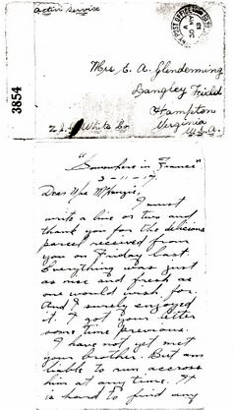

Letter dated 3-11-17 from Guy W. Glendenning to Mrs. John MacKenzie (Aunt Tine) thanking her for a parcel. From the envelope, it seems that Aunt Tine sent the envelope to her sister, Jane Glendenning, married to Guy’s brother, Elmer, who was living at Langley Field Virginia, USA. At the time of writing, Guy had been in the trenches for nearly a year.

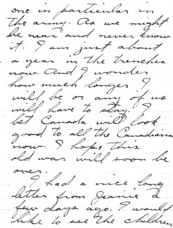
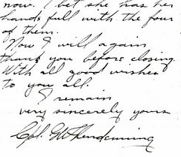

The Family Chronicle (Copyright©) is an occasional newsletter published by Don Glendenning and posted on the family website. It is intended to share information about my family, community and the times in which I grew up. While every effort is made to be accurate, errors are likely to occur. Comments, enquiries and information may be sent to 62 Queen Elizabeth Drive, Charlottetown, PEI, C1A 3A9. Tel: 902 892 5859. Email: don@glendenning.net Web: www.glendenning.net/don

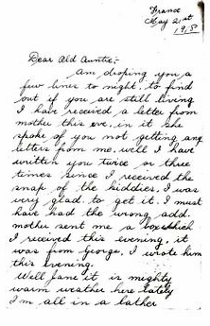
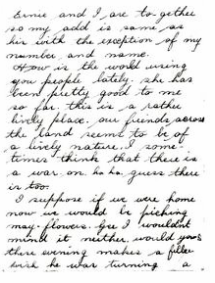

A letter from Jimmie (James) Adams to Jane Glendenning. My mother, Jane, was one of the youngest members of her family; Jimmie was the son of her oldest sister. Technically, my mother was Jimmie’s aunt although they were nearly the same age. The “Ernie” mentioned in the letter would be Ernest Watling, my mother’s brother and also an Uncle of Jimmie Adams.

From the Editor

The WW1 letters were part of a collection of photographs and letters belonging to my Mother. Jane (Watling) Glendenning

In an earlier Chronicle I mentioned that I had two Uncles and an Aunt who served overseas in WW! In addition, there were a number of cousins. All were held in very high regard in my home.

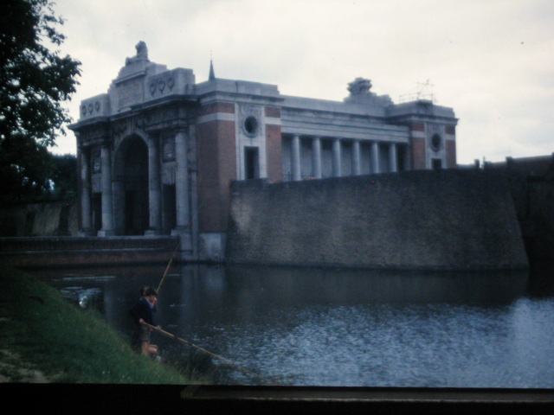
The Menin Gate memorial contains the names of 54,896 officers and men from all the overseas British and Commonwealth forces who fell in the Ypres Salient before 16th August 1917.
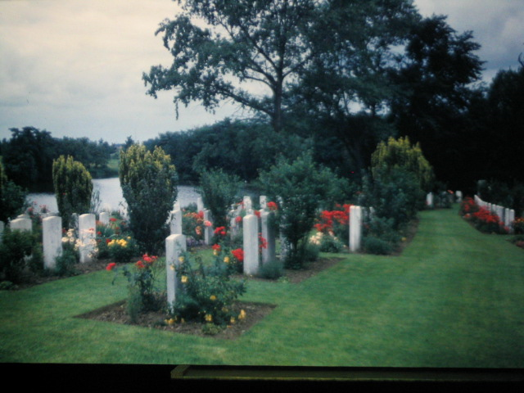
WW1 Cemetery somewhere in Belgium

